**MedCap with Early Heat Illness Detection**

ECE4012 Senior Design Project

MedCap

Dr. Erick Maxwell

Matthew Allen, mallen72@gatech.edu  
Michael Balourdas, mbalourdas3@gatech.edu  
Nicole Barcori, nbarcori3@gatech.edu

Miheer Bavare, mbavare3@gatech.edu  
Tyler Nguyen, tnguyen341@gatech.edu  
Raj Patel, raj1995@gatech.edu

Submitted

April 26, 2017

**Table of Contents**

**Executive Summary** iii

1. **Introduction** 1
   1. Objective 1
   2. Motivation 1
   3. Background 2
2. **Project Description and Goals** 3
3. **Technical Specification** 4
4. **Design Approach and Details**
   1. Design Approach 5
   2. Codes and Standards 13
   3. Constraints, Alternatives, and Tradeoffs 14
5. **Schedule, Tasks, and Milestones** 14
6. **Project Demonstration** 15
7. **Marketing and Cost Analysis** 17
   1. Marketing Analysis 17
   2. Cost Analysis 17
8. **Current Status** 21
9. **References** 22

**Appendix A** 24

**Appendix B** 25

**Appendix C** 26

**Appendix D** 27

**Appendix E** 29

**Executive Summary**

Heat-related fatalities among athletes have more than doubled since 1975. The Centers for Disease Control (CDC) estimates that there is an average of more than 9,000 heat illnesses among high school athletes annually, making it the leading cause of death and disability among high school athletes [1, 2]. The MedCap is an athletic cap fitted with sensors capable of measuring core temperature and mean arterial pressure which are connected to an embedded microcontroller housed on the hat. The MedCap aims to detect an early heat illness related event. The data from these sensors would be transmitted to a smartphone application using the Bluetooth communication protocol. If an early heat illness event is detected, the mobile application shall alert the user. The data shall then be stored in a cloud database and remain available as historical data.

This cap will be marketed to recreational athletes who want to monitor their body metrics and be alerted about potential heat illness. Additionally, the historical data can be used by the medical research field to better understand the physiological parameters and patterns of heat illness.

The sensors monitor core temperature and mean arterial pressure. The software is also capable of capturing the ambient heat index in order to use it as an additional data point. This data shall be compiled and used by a software algorithm to calculate whether the wearer is experiencing an early heat illness event. The algorithm shall compare real-time sensor data to predetermined temperature and artery pressure thresholds based on wearer characteristics (e.g. age, height, weight).

MedCap aims to reduce deaths due to heat-related events by identifying early heat illness events and notifying the user. Once the user is notified, he or she will be able to take steps to cool down including drinking water and leaving the direct sunlight.

**MedCap with Early Heat Illness Detection**

**1. Introduction**

Team MedCap developed a wearable device capable of detecting and alerting for early heat illness. The hat is accompanied by a data processing framework and user interface design to store, analyze, and present health data to the user. The team originally requested $180.25(see Table 5) to create a prototype of the product.

* 1. **Objective**

The team designed a hat that captures relevant data metrics from the human body in order to detect early heat illness in recreational athletes. An infrared thermometer measures the body’s core temperature from the ear cavity, and a pulse oximeter measures mean arterial pressure directly on the ear lobe. These two measurements are combined with the heat index of the area in a weighted average to provide a reliable means of detecting heat related health issues in near real-time. The measurements are gathered by a microprocessor and sent via a Bluetooth communications device to a smartphone nearby. The smartphone then sends the data to a cloud data analytics framework and the analytics store and return processed data back to the smartphone. The phone then displays the data graphically as well as in tabular form via a mobile web application.

* 1. **Motivation**

Heat-related illness is responsible for thousands of hospital visits annually by young athletes. In fact, the leading cause of death and disability in high school athletes is due to heat-related illnesses. Heat-related fatalities that occurred during sports have more than doubled since 1975. The largest demographic group for heat-related illnesses is the youth. The youth account for approximately 47.6% of all heat-related illnesses. In fact, the Centers for Disease Control (CDC) estimates that there is an average of more than 9,000 heat illnesses among high school athletes annually [1, 2].

Heat illness manifests itself in three ways, in order of increasing severity: heat cramps, heat exhaustion, and heatstroke. Severe heat illness is largely preventable given enough warning and assuming precautionary measures are taken, however the market for a suitable wearable device which detects early heat illness is sparse.

* 1. **Background**

Wearable technology is rapidly becoming an integral part of modern society. Companies like Apple and Fitbit have developed wrist devices that contain a variety of functions from messaging and checking email to monitoring sleep cycles and heart rate. Professional sports teams in particular have embraced the idea of wearable technology to monitor and improve performance among their athletes. The most popular wearable device manufacturer on the market is currently Fitbit [3]. The Fitbit Charge 2 base model monitors heart rate, sleep patterns, cardio fitness levels, and provides call and text alerts.

Another, less popular wearable device is the LightBEAM Smart Hat. This hat monitors heart rate, steps taken, and number of calories burned and can transmit that information to a smartphone app or even another wearable such as a smart watch; it is also hand washable and weather tolerant [4].

A different Smart Hat website shows plans for the design of a smart helmet for cyclists. The planned functionality includes a display with GPS and proximity sensing, as well as heart rate and temperature monitoring. It also has safety features such as brake lights and impact protection [5].

The key building blocks for the development of this technology are the: sensors, microprocessor, communications platform, data analytics framework, and user interface. The team has conducted research in these areas in order to gain an understanding of the current state-of-the-art technologies under each category. This information has been used to select the most appropriate and efficient platforms for the MedCap project.

**2. Project Description and Goals**

The main objective of the MedCap is to provide the ability to detect a heat related illness early in recreational athletes. The system consists of several sensors attached to a microprocessor housed in an everyday baseball hat. The sensors include an analog front end pulse oximeter, infrared thermometer and an accelerometer. Features include:

* Real-time dynamic sensing of chosen physiological parameters
* Risk evaluation for a heat-related illness
* UI interface that allows for real time data and risk monitoring

1. **Technical Specifications**

The MedCap requires many design components which can be grouped into four major subsystems: Processing and Communications, Infrared Thermometer, Analog Front End Pulse Oximeter, and Data Processing and Software. The features listed in Tables 1-3 below show quantitative measurements, while Table 4 displays qualitative choices for the Data Processing and Software components of the design.

|  |  |
| --- | --- |
| **Feature** | **Specification** |
| Microcontroller Voltage [6] | 2.1-3.6 V |
| Microcontroller Operating Frequency [6] | 16 MHz |
| Microcontroller Flash Memory [6] | 128 kilobits |
| GPIO Availability [6] | 0-7 pins |
| Battery Module [7] | 2-3 V |
| Bluetooth Frequency Range [8] | 2.400-2.485 GHz |

**Table 1.** Processing and Communications Specifications

|  |  |
| --- | --- |
| **Feature** | **Specification** |
| Resolution (bits) [9] | 10 |
| Output Channels [9] | 1 |
| Operating Voltage Range [9] | 3-5 V |
| Cord Length [9] | 24 in. |

**Table 2.**Pulse Sensor (PPG) – SEN-11574

|  |  |
| --- | --- |
| **Feature** | **Specification** |
| Operational Voltage [10] | 2-3 V |
| Outside Temperature Range [10] | -40 to 80 Celsius |
| Object Temperature Range [10] | -70 to 380 Celsius |

**Table 3.** Infrared Thermometer - MLX 90164

|  |  |
| --- | --- |
| **Feature** | **Specification** |
| Data Transfer from App to Cloud Service | JSON |
| Data Transfer from Microcontroller to App | Bluetooth |
| UI/UX Components | Ionic Built-In Components |
| Cloud Data Storage | Amazon DynamoDB |
| Heat Index Data | AccuWeather API |

**Table 4.** Data Processing and Software Specifications

1. **Design Approach and Details**
   1. **Design Approach**
      1. ***Product Design***

The MedCap is based on the classic baseball cap-style hat design. Sensors go from the user’s ear to the encasing on the bill. Wires will go through the cloth of the hat and into a compartment just above the bill, containing the battery, microprocessor, and accelerometer.

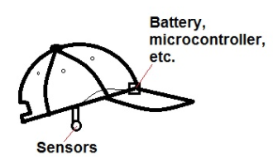

**Figure 1.** Side view of MedCap prototype concept.

* + 1. ***Sensors***

The system detects and evaluates conditions for heat illness using three sensors. The first sensor is the SEN-11574 (see Appendix A) Pulse Sensor for pulse oximetry. This sensor uses a filter and an amplifier to normalize the signal around a reference point. This makes the peaks and troughs easier to identify. The goal of the SEN-11574 is to take the photoplethysmography technique which is normally used to measure oxygen saturation in the skin, and instead use it to measure mean arterial pressure [9]. The SEN-11574 is clipped directly to the earlobe. This is to ensure accurate local temporal artery pressure measurements.

The other sensor is an infrared thermometer, the Spark fun MLX90614 (see Appendix B) [10]. This sensor is mounted in parallel with the SEN-11574 and directed into the ear. Having the MLX90614 taking temperature readings in the ear canal allows for non-invasive core temperature readings.

After the two sensors were mounted, their ends were soldered to wires and connected to a microprocessor located on the brim of the hat. The wires were electrically taped and shielded using electrical shrink wrap. This is to isolate the circuit as much as possible from the body, reducing the risk of an unexpected wire-body coupling.

The MedCap will be used in the field, giving rise to the need for dynamic physiological measuring from devices. To combat movement artifacts as much as possible, an accelerometer is included in the brim along with the microprocessor; the team has chosen the three axis accelerometer, LIS3DH (see Appendix C). The LIS3DH controls the rate at which the microcontroller will pull data from the sensors. If the LIS3DH detects that the user has stopped moving, the microprocessor will pull data and begin the signal processing and data beaming.

The final parameter used in the device is local heat index. The heat index is pulled using locality services on the paired Bluetooth phone and is used in the evaluation of a heat-related event.

* + 1. ***Microcontroller and Communications***

The team has selected the RFduino Simblee DIP as the microcontroller for the MedCap. The RFduino is approximately the size of a quarter and can handle between 2.1V and 3.6V. It has a Bluetooth 4.0 Low Energy module built in. Additionally, the RFduino has seven GPIO ports which can be used to connect to the sensors monitoring the user [6].

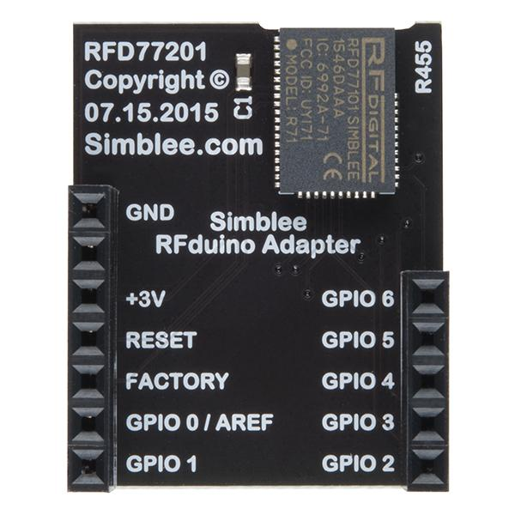

**Figure 2.** Top view of the RFduino microcontroller showing the available pins (e.g. GPIO) [6].

The microcontroller is powered by a 3V LiPo battery which is easily accessible by the end user. The hardware modules are dual inline package and therefore can are wired and soldered together in order to make electrical connections.

The microcontroller and the associated hardware (e.g. battery module) reside inside the bill of the MedCap. Since the RFduino microcontroller and the battery module are both about the size of a quarter [6, 7] they should be able to easily fit within the lining of the cap. The wires are all insulated and all the electronics are covered in waterproof plastic in order to protect the hardware from the user’s perspiration. The battery module has a power switch that is electrically extended to reach the outside of the hat, so the user can control when the MedCap is operating.

The microcontroller was programmed using the RFduino IDE. It was programmed in a language which is similar to C/C++ [11]. The program samples the accelerometer in order to determine when the user is not moving. Movement causes extreme inaccuracies in the measurements which is avoided by taking measurements only when the user is not moving. The program then samples sensors signals every 30 seconds the user is not moving, and the data istransferred through the built in Bluetooth module to the user’s cell phone. The Bluetooth module has to pair will the user’s cell phone before any communication can occur. Once the cap and the cell phone are paired, the data is then transmitted using Bluetooth protocol from the microcontroller to the cell phone.

* + 1. ***Data Processing***

After receiving packets of sensor readings from the MedCap, the Bluetooth paired smartphone uploaded the data packets to the Amazon DynamoDB database tables allocated for preprocessed data storage. After the data sets were available in the database, the data analytics platform, powered by Amazon EC2 Compute services, performed calculations on the captured data. The algorithm was a weighted average of the three gathered metrics: mean arterial pressure, core temperature, and relative heat index. The varied weights allowed for highly correlated metrics to have a greater impact on the prediction of heat illness. The metric offering the greatest correlation to heat illness is the mean arterial pressure, and the second most correlated factor is body core temperature. The heat index carries the least weight since an increase in heat index does not directly correlate with an increase in likelihood of heat illness.

Before utilizing the weighted function to determine heat illness, the data must first be converted to likelihoods based on the acceptable thresholds. Since each of the three variables has acceptable thresholds, the recorded values were measured based on these thresholds, and the severity of each value will be recorded as a number within a discrete range. The function relating the raw data to finalized heat illness likelihood is as defined in Equation 1:

$$weights: 0<w_{3}<w_{2}<w_{1}< 1$$

$$m_{1}: mean arterial pressure$$

$$m_{2}: core temperature$$

$$m_{3}: heat index$$

$$\sum_{i=1}^{3}{w_{i}}*m_{i}$$

**Equation 1.** Definition of the weighted average to calculate likelihood of heat illness.

* + 1. ***User Interface***

The mobile application was built using Ionic, a free and open-source framework designed by Drifty Co. to allow developers to build native applications using Javascript, and were targeted for both Android and iOS markets. The application leveraged open source Ionic Bluetooth libraries to gather data from the microcontroller and sensors. Upon receiving this data, the data was transferred to a cloud service via API requests. The data was processed using the data analytics provided by the cloud service and sent back to the application. The application consumed this data and presented it in an informative, easy to use, and intuitive manner to the user as shown in Figure 3.

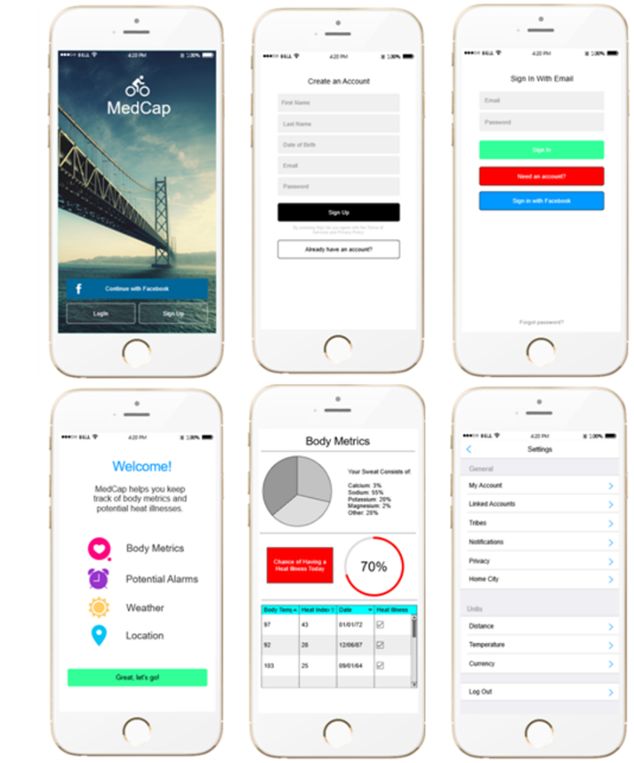

**Figure 3.** Candidate UI diagrams for MedCap.

The mobile application development process consisted of three stages:

1.Frontend – Bluetooth Integration and UI

2.Backend – Connection with Cloud Services

3.User Profile – Facebook or Email Login

* + 1. ***Critical Path***

The critical path, as shown in the PERT chart in Appendix E, was almost identical to the entirety of the PERT chart itself, with one exception. The critical path separated when testing and building the hardware and software components, respectively. Equal time wasallotted for the hardware and software branches of the chart, however practical variance in either branch defined the critical path as the longer of the two branches. In the case that one of the two branches required more time, the 40 day buffer period before the Capstone Expo was used as contingency to ensure sufficient completion time.

* + 1. ***Success Criteria***

The user shall wear the MedCap and obtain body metrics, open the MedCap mobile application on a mobile phone, and remain within ten meters of the device to listen for any warning notifications.The communication protocol has the ability to reach 100 meters to accommodate long-range activities. Based on power consumption, the batteries shall last 9 hours. As with other standard commercial devices, the operating temperature range shall be between 0°C and 70°C. These are the input requirements of the system. The system shall analyze the data gathered from the user by taking PPG measurements and from the PPG waveform the analysis platform shall estimate systolic and diastolic blood pressure by contour analysis [12]. Changes in blood pressure will correlate to changes in mean arterial pressure and be used along with core temperature measurements and local heat indices to determine whether a heat stress event is imminent.

The system shall then output visual and audible indicators of the user’s level of heat stress, placing the data in distinct green (good/stable), yellow (warning), and red (danger) regions. The system shall notify the user of a dangerous level of heat stress by additionally giving audible signals from the mobile phone. A graph shall also be displayed in the MedCap mobile application to track trends in levels of heat stress, and a database shall be populated with historical data for analysis.

The MedCap mobile application shall have adjustable thresholds to allow the user to adjust the green, yellow, and red heat stress regions for various levels of alerting. These thresholds shall be predefined and set to default expected values with the option for the user to adjust the alerting sensitivities and the thresholds of the three stress regions.

If time permits we will accomplish the following tasks. The MedCap itself will be able to directly alert the user after two-way communication is available between the mobile phone and the cap. Also, the data on the cloud will be encrypted for safety. A login to access the data will be protected with two factor authentication. Additionally, the Bluetooth pairing will be restricted so that only the cap and smartphone can transmit data.

If the team were to bring this device to market, it would require FDA approval as a Class II medical device.

* 1. **Codes and Standards**

IEEE 802.15.1 is the standard which governs Bluetooth wireless communication between the embedded processor and mobile device. Bluetooth networks can include one master device and up to seven slave devices. Also, Bluetooth networks traditionally have a 100 meter range for data transfer. Unlike other wireless protocols (e.g. Zigbee) Bluetooth does not occupy the WiFi signal. This allows data to be received from the MedCap through Bluetooth and transferred to the data processing cloud through the WiFi/4G network communication [8].

* 1. **Constraints, Alternatives, and Tradeoffs**

There were two communication technologies that were considered in order to transmit data between the microprocessor and the external mobile device. These two communications were Bluetooth and Zigbee. Zigbee is able to transmit data over longer distances while Bluetooth traditionally limited to 100m. Bluetooth connects to smartphones through Bluetooth module that is pre-installed in most current smartphones. Zigbee connects to the smartphone through the WiFi adapter. If Zigbee is occupying the WiFi connection, the software will not be able to relay the data up to the cloud for data processing and storage through the WiFi communication. Bluetooth, on the other hand, can receive data from the MedCap while leaving the WiFi network open to transmit data to the cloud. Due to the connectivity constraints Zigbee would place on the design, Bluetooth was chosen even with its limited communication range.  
 A tradeoff between the physical size of the microcontroller hardware and the amount of data the MedCap can collect from the wearer arises due to the available space in an athletic hat. While the algorithm will be more accurate with more input parameters, there is not enough space in the hat for the sensors nor are there are enough I/O pins in a small microcontroller for these sensors to connect to the microcontroller. Because smaller size is more important than a surplus of sensor readings, only a few sensors will be used.

1. **Schedule, Tasks, and Milestones**

The Gantt Chart in Appendix D gives a specific timeline for the tasks accomplished by the team over this previous semesters. Task lengths were assigned according to the estimated complexity. Project deliverables such as presentations and papers were completed collaboratively by all team members. Research has been completed by each individual group member, and two sub-teams were to make development, testing and prototyping modular. One sub-team was responsible for designing and building the cap hardware system, and the other team was responsible for most of the software development, including UI development and data processing.

The PERT chart in Appendix E gave the critical path, which was estimated to be 165 days. This timeline allowd for significant delay in part delivery and testing and also included Christmas holiday. The most difficult part of the design was the correct choice of sensor for detecting early heat illness. None of the team members had background in biology or medicine, so choosing an appropriate sensor required significant front-end research.

1. **Project Demonstration**

The MedCap was designed to detect early heat illness while the wearer is participating in physical activity. The following steps were followed using either a prototype or the final product. In order to create the appropriate conditions for testing, the user did the following:

1. The user turned the MedCap on.
2. Then the user put the MedCap on his or her head with the bill facing forward and pulled the cap down until it touches the ears. Also, the user ensured the ear piece fit snug to the ear lobe and sat across the ear opening. This ear fitting allowed for accurate readings.

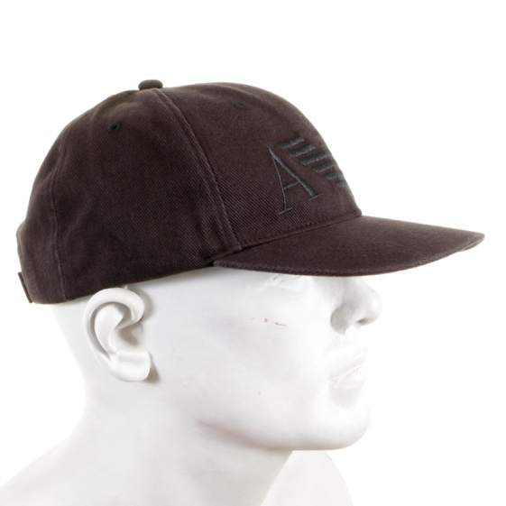

**Figure 4.** Model shows proper fit of a baseball cap [13].

1. Either the user or a spectator enabled the Bluetooth connection on his or her cellphone, paired with the MedCap, and opened the mobile application.
2. The user then participated in an outdoor physical activity. An example activity would be a recreational soccer game.

In order to see results, the user had to participate in enough activity such that his or her vital signs (core temperature and arterial pressure) rose to the point the algorithm determined an early heat illness warning. When this occurred, the mobile application alerted the user. During the time the mobile application was receiving data, it stored these readings in a database that the user can access later. This historical data can be used at a later time.

The project specifications were met when the user’s vital signs exceeded the limit, the user exhibited symptoms of early heat illness, and the mobile application notified the user of the early heat illness. Symptoms of early heat illness include fatigue, nausea, headache, cramps, drenching sweats, dizziness and fainting [14]. Additionally, the project specifications can fail to be met if the user experiences a heat illness event but the mobile application does not notify the user before it occurs. The other requirement is that historical data is stored. When the user was able to navigate the mobile application and display the historical data, then this specification was met.

1. **Marketing and Cost Analysis**
   1. **Marketing Analysis**

The market for wearable devices is growing rapidly, but is still relatively small and dominated by only a few products that do not have the same functionality as the MedCap. The MedCap will be marketed to athletes who are concerned about the possibility of heat illness. This device will be unique because there are no other retail products with the capability to warn an athlete about impending heat stroke. The LightBEAM SmartHat costs $99.90 but it only provides fitness data [4]. Typical consumer wearable devices range from about $90 to about $500 for very high-end models with extensive functionality.

* 1. **Cost Analysis**

The total component cost for a single MedCap prototype is approximately $180.25. Table 5 displays detailed information about the cost per component. The most expensive items are the RFduino processor and the accelerometer, while the least expensive items are the watch batteries to power the device.

|  |  |  |  |
| --- | --- | --- | --- |
| **Production Description** | **Quantity** | **Unit Price** | **Total Price** |
| Cap | 1 | $10.00 | $10.00 |
| RFduino Simblee DIP | 1 | $30.00 [6] | $30.00 |
| RFduino Battery Shield | 1 | $17.00 [7] | $17.00 |
| USB Programming Module | 1 | $26.00 | $26.00 |
| Watch Battery | 2 | $7.00 | $14.00 |
| Infrared Thermometer | 1 | $20.00 | $20.00 |
| Pulse Oximeter | 1 | $8.25 | $8.25 |
| Accelerometer | 1 | $30.00 | $30.00 |
| AWS Subscription | 1 | $25.00 | $25.00 |
| **Total Costs** |  |  | $180.25 |

**Table 5.** Component Costs for Prototype

Table 6 shows development costs for MedCap, calculated for labor costs of $40 per hour. The assembly of all hardware and software components on the final cap required the largest time commitment due to sizing and fitment constraints for the user and for the peripheral devices on the cap.Conversely, the Bluetooth integration required the least time commitment as the microcontroller encompassed the communications technology and would simply require setup.

|  |  |  |
| --- | --- | --- |
| **Project Component** | **Hours** | **Labor Cost** |
| **Product Design** |  |  |
| Assembly | 100 | $4,000.00 |
| Testing | 40 | $1,600.00 |
| **Microcontroller/Communication** |  |  |
| Algorithm Coding | 45 | $1,800.00 |
| Sensor Integration | 35 | $1,400.00 |
| Bluetooth Integration | 25 | $1,000.00 |
| Testing and Debugging | 40 | $1,600.00 |
| **Sensors** |  |  |
| Signal Extraction | 20 | $800.00 |
| Signal Filtering | 50 | $2,000.00 |
| Testing | 40 | $1,600.00 |
| **Data Processing and User Interface** |  |  |
| Data Processing | 30 | $1,200.00 |
| App Development | 50 | $2,000.00 |
| Testing | 40 | $1,600.00 |
| **Total Labor** | 515 | $20,600.00 |

**Table 6.** Development Costs of Prototype

The fringe benefit is calculated as 30% of the total labor, and the overhead is calculated as 120% of the material, labor, and fringe costs. The total development cost of the prototype is $59,312, and all total cost information is displayed in Table 7.

|  |  |
| --- | --- |
| **Item** | **Amount** |
| Parts | $180.25 |
| Labor | $20,600.00 |
| Fringe Benefits, % of Labor | $6,180.00 |
| Subtotal | $26,960.25 |
| Overhead, % of Matl, Labor & Fringe | $32,352.30 |
| **Total** | $59,312.55 |

**Table 7.** Total Development Costs of Prototype

The production cycle for MedCap will yield 5,000 units over 5 years, to be sold at a price of $400 per unit. The parts production will be purchased with a 40% discount, reducing the parts cost from $180.25 to $108.15. Additionally, advertising accounts for 6% of the sale price, while the profit margin is 8.07% of the sale price; the expected revenue is $2,000,000 for the 5 year production run.Table 8 displays the details for the 5,000 unit production cycle.

|  |  |
| --- | --- |
| **Expense or Income Component** | **Dollar Amount** |
| Parts Cost | $108.15 |
| Assembly Labor | $20.00 |
| Testing Labor | $10.00 |
| Total Labor | $30.00 |
| Fringe Benefits, % of Labor | $9.00 |
| Subtotal | $147.15 |
| Overhead, % of Material, Labor, & Fringe Benefits | $176.58 |
| Subtotal, Input Costs | $323.73 |
| Sales Expense | $24.00 |
| Amortized Development Cost | $20.00 |
| Subtotal, All Costs | $367.73 |
| Profit | **$32.27** |
| ***Selling Price*** | $400.00 |

**Table 8.** Price and Profit per Unit (Assuming 5,000 Unit Production Cycle)

1. **Current Status**

The MedCap has been completed and a prototype was developed. Team MedCap won the ECE Award at Capstone Expo.

1. **References**

[1] M. Kinney, Hear-related deaths among athletes still on the rise, Theham.net, Aug. 2015. [Online]. Available: http://www.cnhinews.com/sports/article_19696d9c-4b55-11e5-8518-076ca3ac0074.html. [Accessed Jan. 17, 2017].

[2] E. Brady, Heat-related illness still deadly problem for athletes, USA TODAY, Aug. 2011. [Online]. Available: http://usatoday30.usatoday.com/sports/2011-08-15-heat-stroke-still-causing-death-in-athletes_n.htm. [Accessed Jan. 17, 2017].

[3] Fitbit, Inc., *Fitbit Charge 2 Specs*,fitbit, 2016. [Online]. Available: <https://www.fitbit.com/shop/charge2?activeFeature=specs>. [Accessed Oct. 22, 2016].

[4] LifeBEAM, *Smart Hat*,lifebeam, 2016. [Online]. Available: [http://lifebeam.com/shop/smarthat/](http://lifebeam.com/shop/smart-hat/). [Accessed Oct. 22, 2016].

[5] Smart Hat, *Smart Hat*,smarthat, 2014. [Online]. Available: <http://www.smarthat.info/>. [Accessed Oct. 22, 2016.]

[6] SparkFun Electronics, *RFduino - Simblee DIP*, Sparkfun, n.d. [Online]. Available: <https://www.sparkfun.com/products/13768> [Accessed: 12 Nov. 2016].

[7] SparkFun Electronics, *RFduino - CR2032 Coin Battery Shield*, Sparkfun, n.d. [Online]. Available: <https://www.sparkfun.com/products/13216> [Accessed: 12 Nov. 2016].

[8] *IEEE Standard for Information Technology-Telecommunications and Information Exchange between Systems-Local and Metropolitan Area Networks-Specific Requirements-Part 15.1: Wireless Medium Access Control (MAC) and Physical Layer (PHY) Specifications for Wireless Personal Area Networks (WPANs)*, IEEE Standard 802.15.1, 2002.

[9] Pulse Sensor - SEN-11574, Sparkfun, n.d. [Online]. Available: https://www.sparkfun.com/products/11574. [Accessed: 17 Jan. 2017].

[10] *Infrared Thermometer - MLX90614 - SEN-09570 - SparkFun Electronics*, Sparkfun,2016. [Online]. Available: https://www.sparkfun.com/products/9570. [Accessed: 14 Nov. 2016].

[11] Arduino, *Getting Started with Arduino and Genuino products*, Arduino, Aug. 2016. [Online]. Available: <https://www.arduino.cc/en/Guide/HomePage> [Accessed: 12 Nov. 2016].

[12] M. Elgendi, On the Analysis of Fingertip Photoplethysmogram Signals, Current Cardiology Reviews, vol. 8, no. 1, Feb. 2012, pp. 14-25. [Online]. Available: PMC, doi:10.2174/157340312801215782 [Accessed Jan. 17, 2017].

[13] Togged, *Armani Jeans Navy Baseball Cap*, Togged, n.d. [Online]. Available: <http://www.togged.com/item/5388/armani-jeans-navy-baseball-cap-06481-xe-ajm2267> [Accessed: 12 Nov. 2016].

[14] M. Ratini, *Understanding Heat-Related Illness -- Symptoms*, WebMD, March 2015. [Online]. Available: <http://www.webmd.com/first-aid/understanding-heat-related-illness-symptoms> [Accessed: 12 Nov. 2016].

[15] SparkFun Triple Axis Accelerometer Breakout - LIS3DH SEN-13963, Sparkfun, n.d. [Online]. Available: https://www.sparkfun.com/products/13963. [Accessed: 17 Jan. 2017].

**Appendix A – SEN-11574 Schematic (Pulse Sensor) [9]**

**­­­**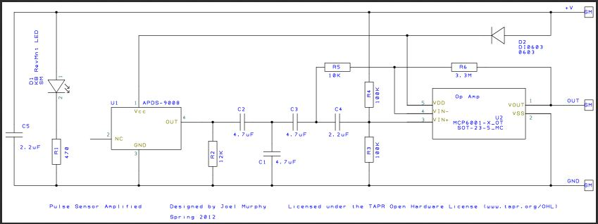

**Appendix B – MLX90614 Pinout (Infrared Thermometer) [10]**

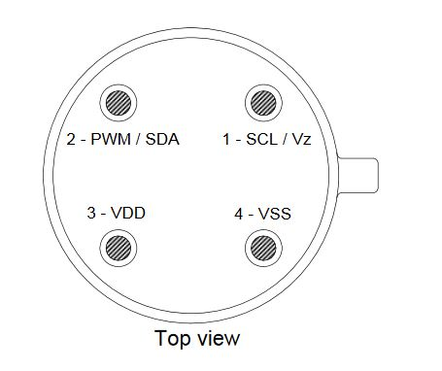

**Appendix C –LIS3DH Pinout (Accelerometer) [15]**

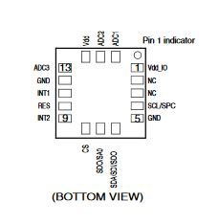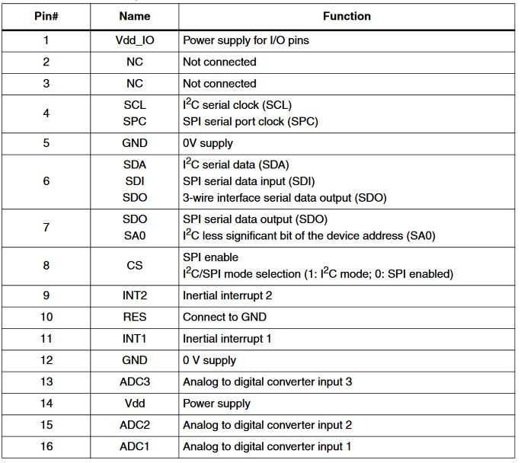

**Appendix D - Project Gantt Chart**

See next page for project Gantt Chart

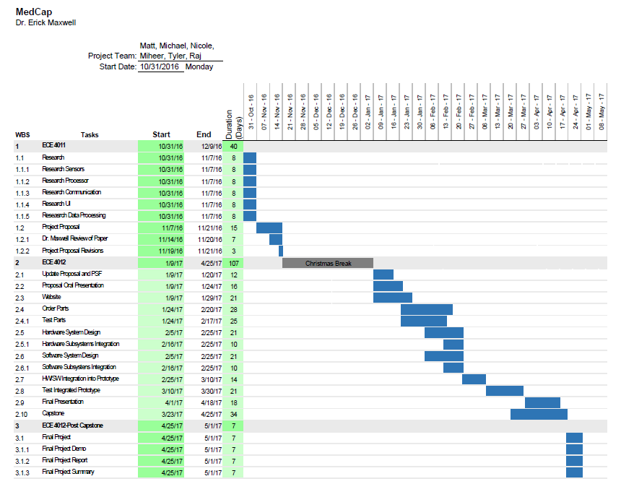

**Appendix E - PERT Chart**

See next page for project PERT Chart

