Motion Tracking and Analysis of Basketball Free Throws using Inertial Motion Measurement

ECE4012 Senior Design Project

Free Throw Form Analytics  
Dr. Erick Maxwell

Edison Carrick, [ecarrick3@gatech.edu](mailto:ecarrick3@gatech.edu)  
Adam Jackson, [ajackson76@gatech.edu](mailto:ajackson76@gatech.edu)  
Kyle Kizirian, [kkizirian3@gatech.edu](mailto:kkizirian3@gatech.edu)  
Patrick Miller, [pmiller38@gatech.edu](mailto:pmiller38@gatech.edu)  
Mickeal Taylor, [mtaylor81@gatech.edu](mailto:mtaylor81@gatech.edu)

Submitted  
1/26/17

# Table of Contents

Table of Contents ii

Executive Summary iii

1. Introduction 1

1.1 Objective 1

1.2 Motivation 1

1.3 Background 1

2. Project Description and Goals 2

3. Technical Specifications 2

4. Design Approach and Details 3

4.1 Design Approach 3

4.1.1 Hardware 3

4.1.2 Inertial Measurement Units 3

4.1.3 Microcontroller 4

4.1.4 Battery 4

4.1.5 Software 5

4.1.6 Data Analysis 6

4.1.7 User Interface 6

4.2 Codes and Standards 6

4.3. Constraints, Alternatives, and Tradeoffs 7

5. Schedule, Tasks, and Milestones 7

6. Project Demonstration 7

7. Marketing and Cost Analysis 8

7.1 Marketing Analysis 8

7.2 Cost Analysis 9

7.2.1 Parts and Materials 9

7.2.2 Development Cost and Profits 9

8. Current Status 11

9. References 12

Appendix A 13

Appendix B 14

Appendix C 16

# 

# 

# Executive Summary

The Smart Sleeve is a device worn on the arm that tracks the user’s motion and provides feedback on the consistency of their basketball free throw form. The system consists of attached inertial measurement units (IMUs) and a cloud based service. The system tracks the user’s motion and the cloud service collects data and provides the user feedback on the variations of their form.

The device will allow for players to more precisely practice their shot, allowing for faster muscle memory development and reducing the amount a player shoots with bad form. By allowing the player to receive shot feedback without the need for a coach, he or she will be able to practice more conveniently. The Smart Sleeve technology is applicable to many sports beyond basketball, and could potentially redefine how athletes practice in the future.

The sleeve will have four IMUs and a microcontroller that transfers measurement data wirelessly. Data will be analyzed and stored to present to the user and tell them how a recent shot compares to shots the player has previously taken.  The user can then use this information to adjust their shot to more closely match their good form shot and allow them to practice more efficiently.

There are currently no available wearable devices that will track a player’s specific form and help them improve their shot. This new technology will be available with a price tag of $400 and will change the way amateurs and professionals practice. The base technology can be expanded into other sports where a consistent and repeated motion is performed like baseball, bowling, darts, and golf.

**Motion Tracking and Analysis of Basketball Free Throws using Inertial Motion Measurement**

# 1. Introduction

The Smart Sleeve (SS) is an affordable sports motion tracking system that provides feedback on the user’s free throw shooting form. The system consists of a wearable motion tracking sleeve and a laptop. The team requests $300 to fund the prototype of SS system.

## 1.1 Objective

The objective of the SS is to create a motion tracking sleeve which will track data for a free throw shooter, and help them improve their form. The technology for this device can also be extrapolated to other sports with repeated motions.

## 1.2 Motivation

The purpose of practice is to create muscle memory so that in high stress situations, such as a game, the player performs without the need to “think”. When shooting a free throw in basketball, shot consistency is vital. There is no benefit, and possibly even detriment, to practicing if the player is practicing incorrectly. Practicing without feedback can allow for the player to unintentionally introduce bad habits into his or her shot. Today, a basketball coach can watch a player while practicing and provide feedback, but a coach can only provide feedback to one player at a time. Tomorrow, there could be a device to provide feedback to an unlimited number of players whenever they can practice. The Smart Sleeve is the device to pave the way to allow players to practice accurately and conveniently.

The impact a device that can provide convenient feedback to a player could be applicable for all levels of skill; and the technology application does not stop at basketball. Every sport, to an extent, has localized motions that need to be consistent and accurate. The underlying technology could apply to the tennis serve, dart throw, baseball pitch, and even full body activities such as bowling.

## 1.3 Background

There are currently no devices on the market that are wearable free throw tracking devices. Current technologies that analyze motion do so with an external camera. The use of inertial measurement devices for this is therefore also not widespread. There has been some interest into the use of these devices for tracking other sports, but this has not hit the commercial market yet.

# 2. Project Description and Goals

The goal of the Smart Sleeve is to be a system that gives the user feedback on their basketball free throw shooting form. The prototype will be fitted for young adult, moderately active males.

The system shall:

* be a wearable sleeve,
* fit average young adult males,
* transmit data from the sleeve wirelessly,
* not restrict normal arm movement in any considerable way,
* start and stop shot recording with the press of a button,
* be built with a wireless enabled microcontroller package,
* display an RGB LED that provides device status indication (e.g. low battery, recording, etc.),
* be powered using a rechargeable lithium ion battery,
* operate for a minimum of 3 hours,
* operate from -20°C to 60°C,
* save form data locally for future comparison,
* allow users to select a primary comparison form,
* provide feedback to users on a laptop

The system will:

* allow the user to visually compare free throw forms,
* operate in real time,
* save data to the cloud for the user to access from any device,
* provide feedback accessible on any browser

# 3. Technical Specifications

Table 1contains device specifications for analyzing free throw data collected during a practice session up to three hours in duration, which can be viewed in real time after completing any number of attempts.

Table 1. Device Specifications

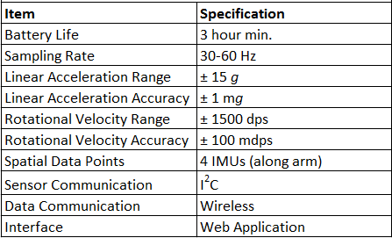

# 4. Design Approach and Details

## 4.1 Design Approach

There are two main components of this design: the hardware used to collect and transmit inertial data, and the software used to analyze the data and provide feedback to the user.

### 4.1.1 Hardware

The hardware system is comprised of three main components: the inertial measurement units, the wireless communication capable microcontroller, and the battery pack. These components are small and lightweight enough so as to have no impact on the user’s movement. This system collects and transmits time-based acceleration and rotational data to an external web server to be processed. A testing rig simulating an arm will be built for hardware integration and calibration. This will ensure all hardware components operate correctly and transmit data reliably.

### 4.1.1.1 Inertial Measurement Units

The system will consist of four inertial measurement units placed along the user’s arm. A possible configuration of sensor placement is shown in Figure 1. STMicroelectronics LSM9DM1 inertial measurement unit provides 3 axes of linear acceleration data up to ±16 g and 3 axes of rotational velocity data up to ±2000 dps communicated to the microcontroller using an I2C bus. The unit operates with a supply voltage of 1.9-3.7 V [1].

ArmPlacement.png

Figure 1. The Anticipated IMU Placement on the Arm

### 4.1.1.2 Microcontroller

The microcontroller will only serve as means of organizing and transmitting data to an external server via an onboard Wi-Fi chip. The Adafruit Feather HUZZAH has the necessary Wi-Fi communication chip as well as I2C bus protocol support. It operates at a 3.3V logic level and can comfortably support the power requirements of the IMUs [2]. The controller will utilize a push button to start and stop tests, as well as an LED indicator light to provide status and system feedback.

### 4.1.1.3 Battery

The battery must be capable of supporting the system for a minimum of three hours per training session. This battery must provide a voltage that is safe for 3.3 V systems. The UnionFortune Polymer Lithium Ion 850 mAh battery PRT-00341 operates at a nominal voltage of 3.7 V and is specifically made for microcontroller applications [3]. The selected Adafruit microcontroller also includes a 100 mA Lithium-Polymer charger that charges a connected battery when the controller is connected to a power source via USB. The system can be recharged after use simply by connecting the microcontroller to USB while the battery is connected. Each sensor requires less than 20 mA, and the Wi-Fi chip on the microcontroller will not exceed 250 mA, so the 850 mAh battery is more than enough supply for a training session. The slim battery measures 1.75” X 1.37” and will fit comfortably with the microcontroller. A possible configuration for the microcontroller and battery combination is shown in Figure 2.

BackpackDiagram.png

Figure 2. A Diagram Outlining a Possible Microcontroller and Battery Placement System.

### 

### 4.1.2 Software

The software consists of two main components: data analysis and user interface. The results of data analysis are displayed in a web application to provide feedback to the user. The system level overview can be observed in Figure 3. The database solution Firebase has the ability to store sensor data and host the web application for free, allowing for a simple and efficient development environment that does not impact the development cost.

SystemDiagram.png

Figure 3. The System Level Overview Outlining the Flow of Data and Major Software Components

### 4.1.2.2 Data Analysis

Given a sampling rate and the six components of inertial measurement, a positional trajectory in space can be calculated as a function of time. These trajectories can only be generated in reference to a known starting point, which is not provided by an inertial measurement unit [ref]. This is the greatest challenge of motion tracking using inertial measurements, as the relationship between the sensors cannot be obtained from the sensors themselves. The system will use a “zero position” configuration to reset the trajectory calculation. With the aid of a calibration tool similar to a ruler, the sleeve can be adjusted to position the IMUs on the sleeve to match the distances specified for the analysis software. With these conditions, the data can be used to calculate various form parameters such as release height and elbow joint velocity. Each parameter contributes to the consistency of the free throw form, and the collection will be used to compare the current shot to historical form data.

### 4.1.2.3 User Interface

The primary purpose of this system is to provide feedback to the user while they practice shooting free throws. The first time the system is used, there will be no baseline of comparison. After the system has collected form data, the user will be encouraged to select a shot as their “best shot” to establish a baseline for comparison. Further feedback will be through a comparative system, displaying the current shot against the baseline. Metrics for this comparison have not yet been explored, and may depend on the user (i.e. focusing on elbow movement, ball release, etc.). Additionally, the screens and options of the user interface have not yet been designed due to the complexity of the movements and the unknown data formats from the IMUs.

## 4.2 Codes and Standards

Inter-Integrated Circuit (I2C) is the selected communication standard for the interface between sensors and the microcontroller.

Wi-Fi communication will use the IEEE 802.11n standard for wireless communication between the microcontroller and the web server.

UL 2054 provides codes for safe usage of wearable battery packs.

## 4.3. Constraints, Alternatives, and Tradeoffs

An alternative to Wi-Fi communication is Bluetooth communication. Bluetooth communication is cheaper and requires less power, but requires a local signal and additional hardware to receive and log the data. Wi-Fi can be used anywhere with a wireless internet connection and can store data using cloud storage.

An alternative to external web server data processing is processing using a phone App. This would localize the processing to the user’s own phone, but a phone has limited computing resources. For users with less powerful phones, this would lead to a diminished user experience.

The number of sensors being used along the arm comes with the tradeoff of added weight, power consumption, and cost. The number of sensors must be kept low while still collecting useful data of overall arm motion. Selection of four sensors provides data points along the arm (including one on the hand) without excessive wiring or obstruction of motion.

# 5. Schedule, Tasks, and Milestones

Appendix A lists all the tasks for the duration of the project as well as risk level and owner. Appendix B contains the Gantt chart with legend. The critical path is highlighted in Red. Appendix C contains the PERT chart with critical path labeled in Red. The legend for Appendix C shows each node, task names, and best/average/worst estimates for each tasks.

# 6. Project Demonstration

The system will be designed to be portable and can be used anywhere with Wi-Fi connectivity. The demonstration will consist of one team member wearing the Smart Sleeve shooting basketball free throws and a computer setup to display feedback from the system. The user will shoot several free throws and the computer will display feedback for each shot. The feedback will inform the user how their shooting motion compares to a preset ideal free throw shooting motion. Both the Smart Sleeve and the computer will be turned off and restarted to demonstrate that the feedback from each shot is stored even when the system is turned off. Prior to the demonstration the system will be run continuously and recorded for three hours to prove that the battery can provide power to the Smart Sleeve for at least three hours before needing to be recharged.

# 7. Marketing and Cost Analysis

## 7.1 Marketing Analysis

The target market consists of individuals wishing to improve their basketball free throw shot. With an estimated number of basketball participants over 25 million [4] there is a great demand for training equipment. With only 1% of high school varsity players able to play Division I college basketball [5], even at the high school level there is an immense pressure on players to gain an edge over the competition. There are a few systems which have attempted to use technology to assist free throws. The Pistons, a National Basketball Association (NBA) team, worked with STRIVR Labs to build a system utilizing virtual reality to assist one of its players [6]. The virtual reality system was developed to ease the psychological pressure of free throws, not to assist with free throw mechanics. There are currently no systems that utilize inertial measurements to provide feedback during practice.

## 7.2 Cost Analysis

### 7.2.1 Parts and Materials

The hardware used in development would cost $106.20 [1] [2] [3] [7] as described in Table 2 The miscellaneous category is an estimation of the materials such as wiring, solder, etc. used through the development of one prototype. To mitigate catastrophic failure of any one part, we plan to purchase enough prototype materials to build two sleeves. Having two sleeves would allow development teams to work in parallel on different aspects of the integrated system, or allow continued development in the case that a part fails. The total hardware cost will be $212.40.

Table 2. Prototype Hardware Costs

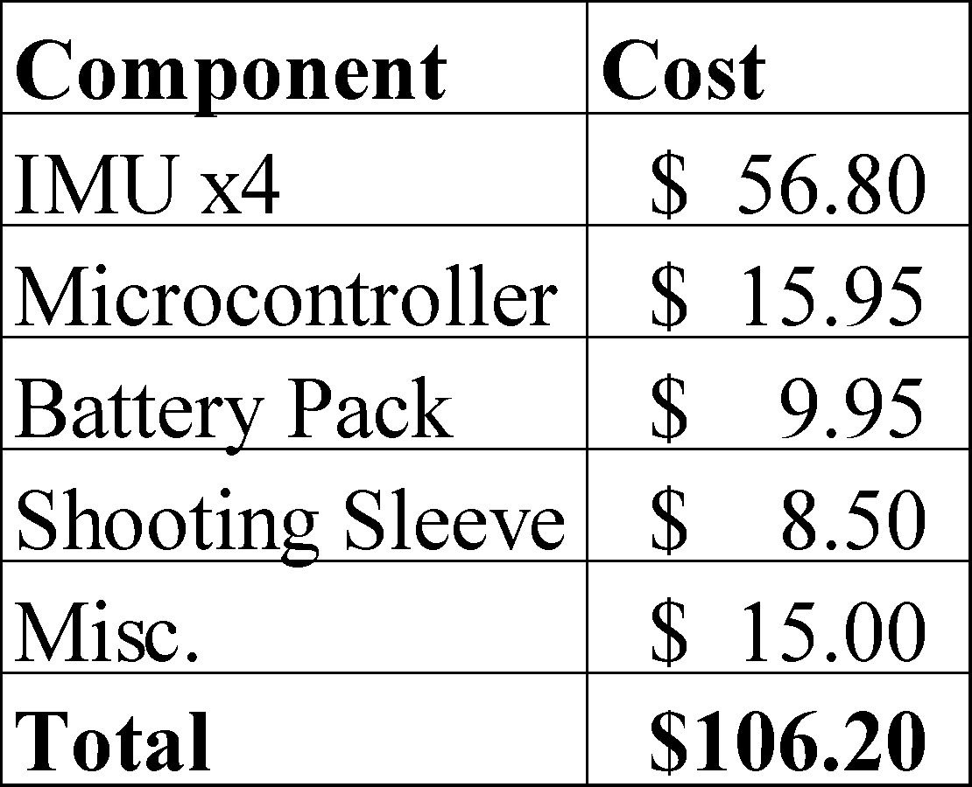

### 7.2.2 Development Cost and Profits

There are five total engineers working on the project, and the total labor in hours is estimated in Table Xii. With an assumed labor cost of $50 per hour and using the total hours from Table 3, the total labor cost would be $4,550 per engineer. Assuming 30% fringe benefits of labor and 120% overhead on materials/labor/fringe benefits, the total development cost of the system is shown in Table 4.

Table 3. Estimated Development Hours per Engineer

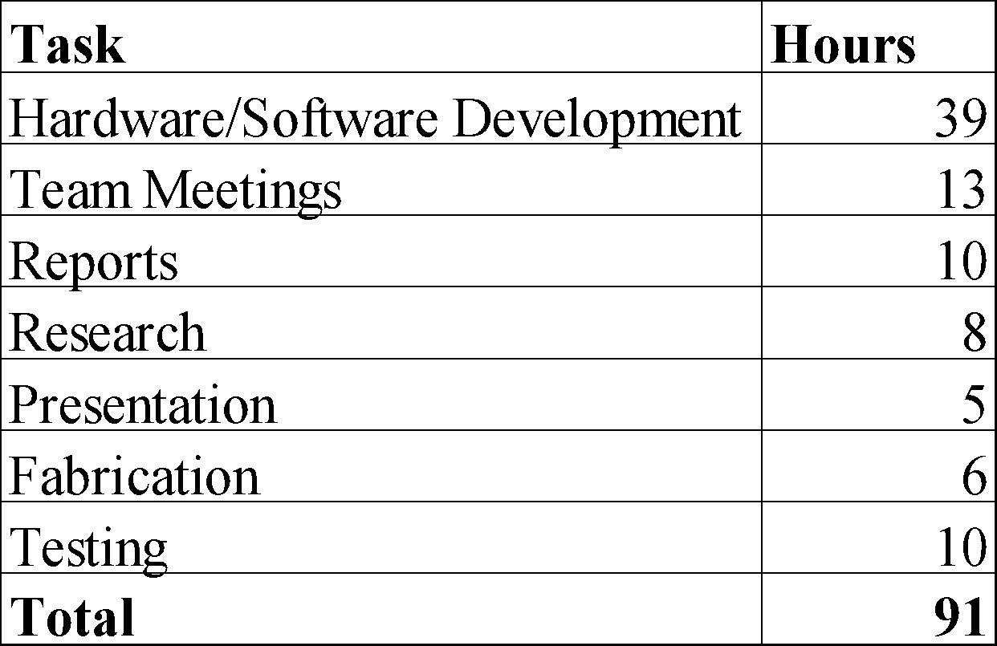

Table 4. Total Development Cost

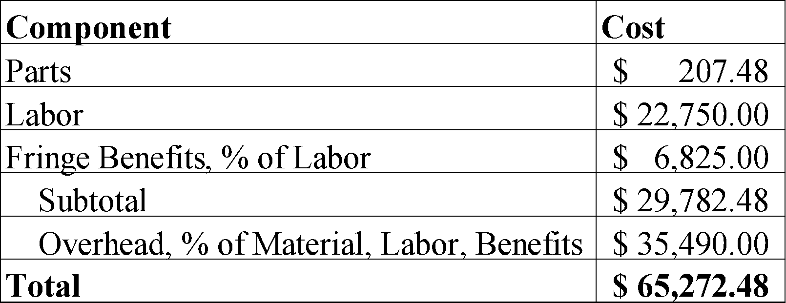

The production run will consist 5000 units sold over a 5-year period at a price of $400 per sleeve. Assembly and test technicians will be employed at $15 per hour to build and finalize the products. Advertising will be 7% of the total input costs which is $21. Total revenue for first production run will be $2,000,000. Selling the sleeves for $400 per unit, a profit of $78 would be made, a 24% profit per unit as outlined in Table 5. This is $390,250 of profit over the five-year period. The high cost per sleeve is due to the estimation of parts cost from the prototype. By using custom hardware breakouts as opposed to development breakout boards, the price per sleeve could be significantly reduced. While development costs could go up, the current amortized development cost per unit is small compared to the parts cost.

Table 5. Profit Per Unit Breakdown

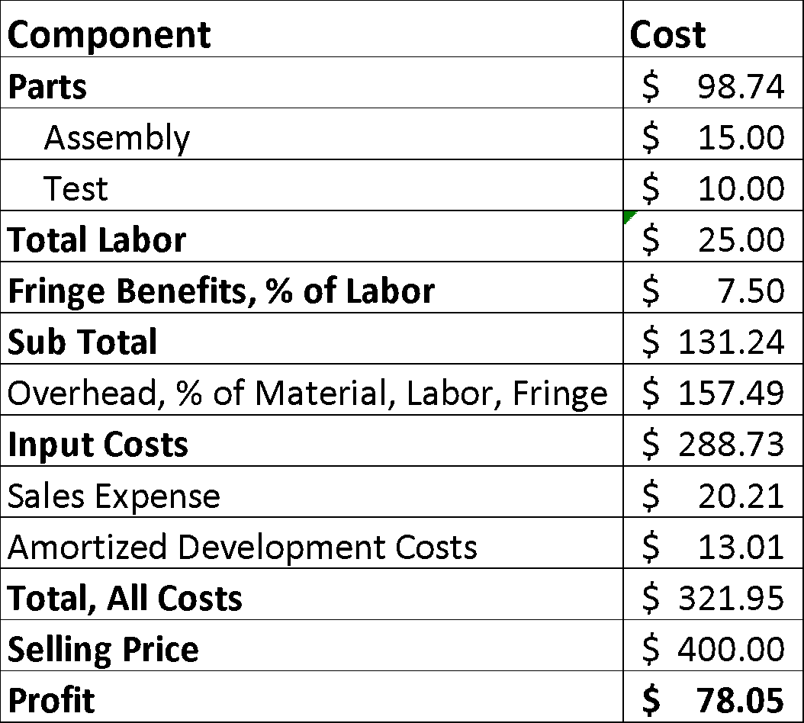

# 8. Current Status

The group is currently finalizing the initial project proposal. This requires that the group have a cohesive idea of the goals of the project. The group recently met to make decisions regarding sensor and microcontroller specifications. The Adafuit ESP8266 microcontroller and Sparkfun SEN-13944 IMU were chosen. The SEN-13944 is an IMU, which offered more degrees of freedom than a traditional accelerometer. The group also concluded a group renaming discussion as our previous team name did not accurately represent our project goals and objectives. We change from “Bowling Form Facilitator” to “Free Throw Form Facilitator.” The group is working on sketches of the design to be used as a reference during the prototype design phase in early February. Members of the group are also researching Firebase, an application framework that makes cloud storage and integration easy and free. Once this proposal is accepted, the group will begin ordering parts, create the software framework for the project, and start forging connections between the microcontroller, the IMU’s, and the software.

# 9. References

|  |  |
| --- | --- |
| [1] | SparkFun, "SparkFun 9DoF Sensor Stick," SparkFun, [Online]. Available: https://www.sparkfun.com/products/13944. [Accessed 20 11 2016]. |
| [2] | Adafruit, "Adafruit Feather HUZZAH with ESP8266 WiFi," Adafruit, [Online]. Available: https://www.adafruit.com/product/2821. [Accessed 20 11 2016]. |
| [3] | SparkFun, "Lithium Ion Battery - 850mAh," SparkFun, [Online]. Available: https://www.sparkfun.com/products/341. [Accessed 21 11 2016]. |
| [4] | B. R. H. Brad R. Humphreys, "The Size and Scope of the Sports Inudstry in the United States," *IASE,* 2008. |
| [5] | "College Basketball & Scholarship Opportunities," Scholaship Stats, [Online]. Available: http://www.scholarshipstats.com/basketball.htm. [Accessed 21 11 2016]. |
| [6] | M. J. Burns, "Andre Drummond turns to virtual reality to improve free throw shooting," *Sports Illustrated,* 28 9 2016. |
| [7] | H2H SPORT, "H2H SPORT Unisex Compression Fit Hand Cover Cooling Arm Sleeves UV Protection," Amazon. [Online]. [Accessed 21 11 2016]. |

# Appendix A

Task Lead List with Risk Levels

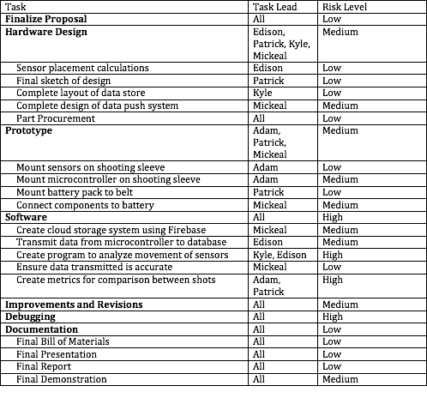

# Appendix B

Project Gantt Chart

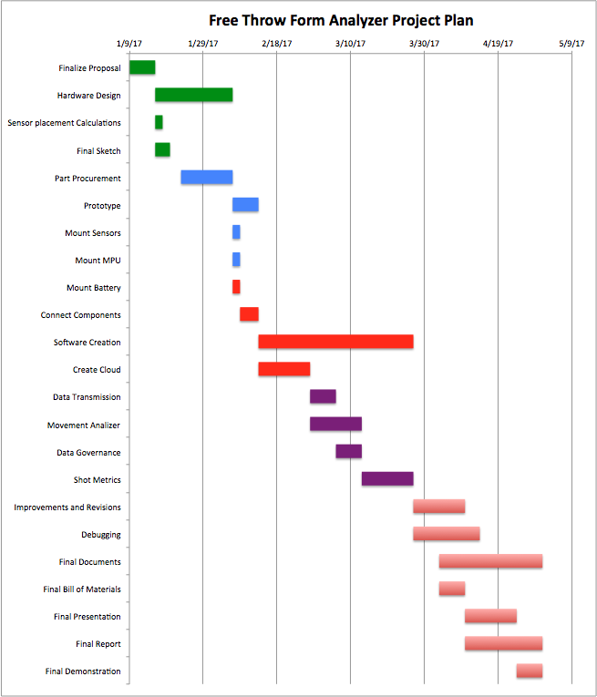

|  |  |  |  |
| --- | --- | --- | --- |
| Task Name | Start | End | Duration (days) |
| Finalize Proposal | 1/9/17 | 1/16/17 | 7 |
| **Hardware Design** | 1/16/17 | 2/6/17 | 21 |
| Sensor placement Calculations | 1/16/17 | 1/18/17 | 2 |
| Final Sketch | 1/16/17 | 1/20/17 | 4 |
| Part Procurement | 1/23/17 | 2/6/17 | 14 |
| **Prototype** | 2/6/17 | 2/13/17 | 7 |
| Mount Sensors | 2/6/17 | 2/8/17 | 2 |
| Mount MPU | 2/6/17 | 2/8/17 | 2 |
| Mount Battery | 2/6/17 | 2/8/17 | 2 |
| Connect Components | 2/8/17 | 2/13/17 | 5 |
| **Software Creation** | 2/13/17 | 3/27/17 | 42 |
| Create Cloud | 2/13/17 | 2/27/17 | 14 |
| Data Transmission | 2/27/17 | 3/6/17 | 7 |
| Movement Analyzer | 2/27/17 | 3/13/17 | 14 |
| Data Governance | 3/6/17 | 3/13/17 | 7 |
| Shot Metrics | 3/13/17 | 3/27/17 | 14 |
| **Improvements and Revisions** | 3/27/17 | 4/10/17 | 14 |
| **HW/SW Debugging** | 3/27/17 | 4/14/17 | 18 |
| **Final Documents** | 4/3/17 | 5/1/17 | 28 |
| Final Bill of Materials | 4/3/17 | 4/10/17 | 7 |
| Final Presentation | 4/10/17 | 4/24/17 | 14 |
| Final Report | 4/10/17 | 5/1/17 | 21 |
| Final Demonstration | 4/24/17 | 5/1/17 | 7 |

# Appendix C

Project Pert Chart

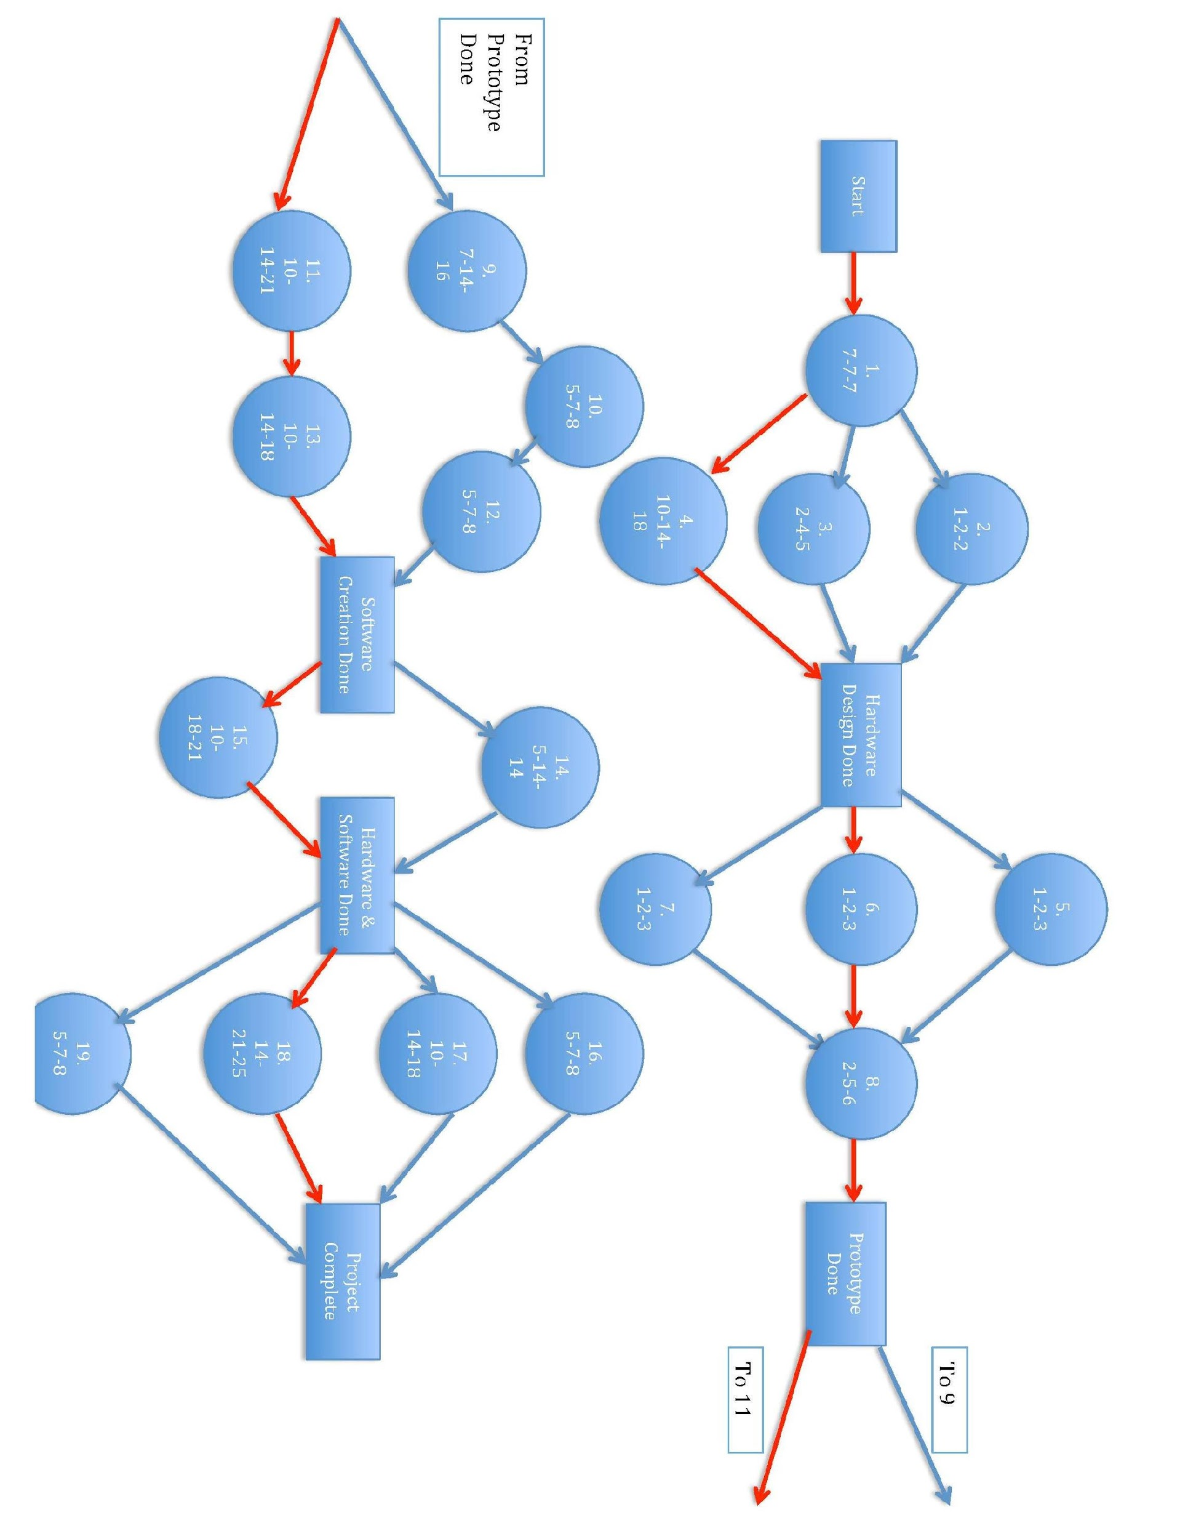

|  |  |  |  |  |
| --- | --- | --- | --- | --- |
| Node | Task | Best | Average | Worst |
| **1** | Finalize Proposal | 7 | 7 | 7 |
|  | **Hardware Design** | 13 | 21 | 25 |
| **2** | Sensor placement Calculations | 1 | 2 | 2 |
| **3** | Final Sketch | 2 | 4 | 5 |
| **4** | Part Procurement | 10 | 14 | 18 |
|  | **Prototype** | 5 | 7 | 9 |
| **5** | Mount Sensors | 1 | 2 | 3 |
| **6** | Mount MPU | 1 | 2 | 3 |
| **7** | Mount Battery | 1 | 2 | 3 |
| **8** | Connect Components | 2 | 5 | 6 |
|  | **Software Creation** | 30 | 42 | 47 |
| **9** | Create Cloud | 7 | 14 | 16 |
| **10** | Data Transmission | 5 | 7 | 8 |
| **11** | Movement Analizer | 10 | 14 | 21 |
| **12** | Data Governance | 5 | 7 | 8 |
| **13** | Shot Metrics | 10 | 14 | 18 |
| **14** | Improvements and Revisions | 5 | 14 | 14 |
| **15** | HW/SW Debugging | 10 | 18 | 21 |
|  | **Final Documents** | 28 | 28 | 28 |
| **16** | Final Bill of Materials | 5 | 7 | 8 |
| **17** | Final Presentation | 10 | 14 | 18 |
| **18** | Final Report | 14 | 21 | 25 |
| **19** | Final Demonstration | 5 | 7 | 8 |