**Coke Light Up Interactive Packaging**

ECE4011 Senior Design Project

LIT

Dr. James Kenney

Dr. Jasmeet Kaur

Coca Cola Company

Fan Chen fchen63@gatech.edu

Varun Malhotra varun.doom@gmail.com

Hamim Nigena hamimnigena@gatech.edu

Alex Plager japlager@gmail.com

Mitcham Tuell mitchamtuell@gatech.edu

Submitted

October 3rd, 2017

**Executive Summary** **3**

**1. Introduction** **4**

Objective 4

Motivation 5

Background 6

**2. Project Description and Goals** **6**

**3. Technical Specifications** **7**

**4. Design Approach and Details** **8**

4.1 Power Source 9

4.2 Switch 9

4.3 Lighting (LEDs) 10

4.4 Flexible PCB 11

4.5 Water Resistance 11

4.6 Alternatives and Tradeoffs 11

**5. Schedule, Tasks, and Milestones** **12**

**6. Project Demonstration** **13**

**7. Marketing and Cost Analysis** **13**

7.1 Cost Analysis for Prototyping 13

7.2 Approximate Cost Analysis for Scale Manufacturing 14

**8. Current Status** **15**

**9. Leadership Roles** **15**

**References** **17**

**Appendix** **19**

# 3. Technical Specifications

Table 1 contains specifications for the project.

|  |  |
| --- | --- |
| **Table 1.** Specifications | |
| **Item** | **Specification** |
| Minimum Temperature | 2˚C |
| Maximum Temperature | 35˚C |
| Water Resistance | IPX4 |
| Drop Resistance | 1.5 m |
| Active Duration | 30 sec |
| Storage and Shipping Life | 4 weeks |
| Cost (approximate, 10k scale) | $10 |
| Luminous Intensity | 500 mcd |
| Weight | 20g |
| Form Factor | +2.5mm to bottle radius  +0mm to bottle height |
| Light Interactivity | Wireless, individually controlled |
| Removability | e-Label is easily removable with no tools |

# 

# 

# 

# 

# 4. Design Approach and Details

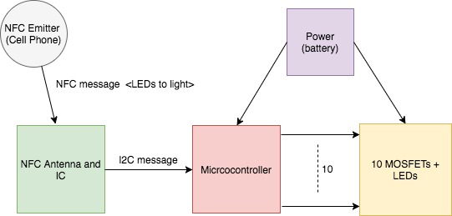

**Figure 1.** A block diagram of the proposed system.

The design involves having a cell phone or other NFC emitter communicate with the bottle and turn on LEDs in different patterns based on user input. The circuit for the design will be mounted on a flexible PCB and stuck to the back of the Coke label.

The design has four main components:

* Power
* NFC Antenna and IC
* Microcontroller
* Lighting (LEDs + MOSFET)

## 4.1 Power Source

|  |  |
| --- | --- |
| **Table 2.** Battery Specifications | |
| **Item** | **Specification** |
| Output Voltage | 3-6 V |
| Current Draw | 200 mA-400 mA |
| capacity | 600 mAh |
| size | Less than 5 * 5 cm, no thicker than 2.5mm |

The power source will supply power to the Microcontroller and the LEDs. The team is looking for a battery with the specifications described in Table 2. The battery will need to be flexible enough to conform to shape of the Coke bottle. The team would like to look into non-rechargeable lithium ion batteries and flexible battery solution from Saralon.

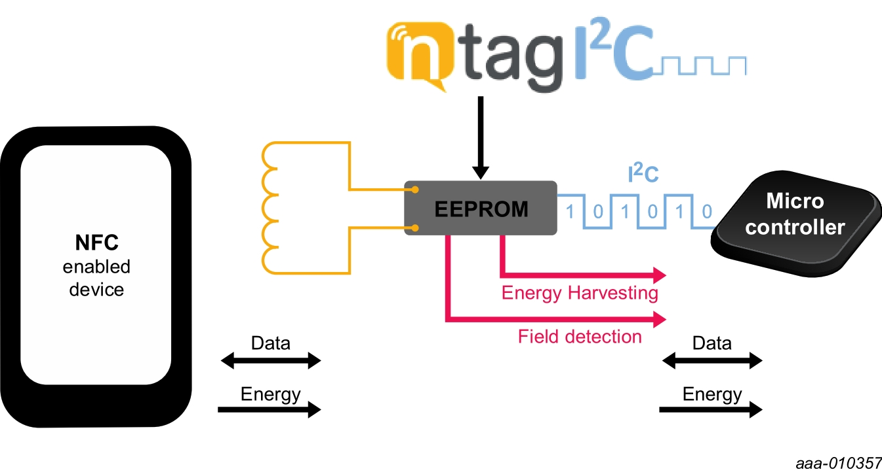

**Figure 2.** Diagram showing how the NTAG IC interacts with NFC signals and a microcontroller.

## 4.2 NFC Antenna and IC

The NFC antenna and IC will be used to detect NFC signals from a base emitter or a cell phone. The NFC antenna is connected to an IC that would convert the data received via NFC into I2C signals to be sent to a microcontroller. The team has identified a product by NXP called the NTAG IC that meets these requirements [1]. Figure 2. demonstrates how the product interacts with NFC signals and an external microcontroller. The NTAG IC is a passive device that harvests energy from the antenna and hence does not need a power supply.

## 4.3 Microcontroller

The microcontroller will interface with the NTAG IC and the lighting system. The inputs into the microcontroller will be I2C commands from the NTAG IC and the output will go into the Lighting system to light the LEDs in various patterns. The microcontroller will need a minimum voltage supply of 1.8 V, which will be supplied by the battery [2]. The microcontroller should have an I2C interface and must have at least 10 GPIOs to interface with the LEDs and MOSFETs. The team will investigate to find a microcontroller that meets these specifications.

## 4.4 Lighting (LEDs and MOSFETs)

The bottle will be lit by approximately ten surface mounted LEDs, for a total luminous intensity of about 500 mcd, which is equivalent to about 5 lumens at maximum viewing angle. The LEDs will be placed in parallel with a single resistor in series limiting the current so as not to damage the LEDs. Red LEDs have a voltage drop of about 1.9V and draw about 20mA when illuminated, for a total of 200mA and 380mW draw. The LEDs will be switched with a MOSFET and driven by the battery.

The LEDs will be arranged in an array so as to be able light up in different patterns as per user input. This could likely take the form of being behind a Coca-Cola logo printed on the label so as to illuminate the logo. The team expects to reach the goal of lighting the bottle for a maximum period of 30 seconds on continuous draw of current.

## 4.5 Flexible PCB

The team intends to work with Dr. Tentzeris on the development and production of prototype flexible PCBs, printed on paper or plastic film. The components will likely be silver epoxied to the board, then the whole assembly laminated to protect it from moisture, shock, and dust. For production scales, the team will provide a PCB CAD file and recommend a manufacturer that is capable of producing the units.

## 4.6 Water Resistance

The team expects to meet the specification of being water resistant (IPX4) by using a laminate coating of the board and all components to protect from the effects of condensation and moisture. The lamination will also likely contribute to shock and dust protection.

## 4.7 Alternatives and Tradeoffs

In the case that the proposed initial design turns out to be unrealistic and does not meet performance standards, the team has prepared a “fallback” design. The RF system would be removed entirely and a simple Force Sensitive Resistor (FSR) would be used to control the flashing of the LED. This design is likely to work more smoothly than the RF antenna design due to simplicity, but will likely result in higher cost due to the expense of FSRs.

The team is investigating to find the most compatible battery solution. In case the team is unable to find a battery that meets both form factor and listed battery specifications, the team will look into AAAA batteries for power. This solution, however, will not meet form factor specs and make it harder for the team to achieve its water resistance specification.

# 7. Marketing and Cost Analysis

## 7.1 Cost Analysis for Prototyping

The design of the interactive light-up bottle consists of a simple circuit consisting of a Li-MnO2 battery, a microcontroller, several red LEDS and transistors, and a few resistors, all mounted on a flexible printed circuit board. The team will be working with Dr. Tentzeris to make the flexible PCBs. The total cost of the material used for one prototype is shown is $51.54 as shown in Table 4. This cost is an approximation and more has been budgeted to include development boards for the microcontroller and NFC antenna, unforeseen costs, and the cost of successive prototypes. The cost provided in this table is for parts to build individual prototypes - the cost will be significantly lower for Coca-Cola when parts are purchased at production scales.

|  |  |
| --- | --- |
| **Table 4.** Components Cost for prototyping | |
| **Item** | **Cost** |
| Li-MnO2 Batteries | $5 |
| Red LED x10 | $0.76 x 10 = $7.60 |
| Dev board for LPC812 MCU | $18.75 |
| LPC812 - 20 pins MCU | $1.63 |
| NTAG I2C demo kit | $18.69 |
| N-channel MOSFET, SMD x10 | $0.15x 10 = $1.5 |
| Flexible PCB | $0, with help from Dr. Tentzeris |
| **Total, one prototype** | **$51.54** |
| **Total, three prototypes** | **$84.63** |
| Shipping & Unforeseen costs | $20 |
| **Grand Total** | **$104.63** |

## 7.2 Approximate Cost Analysis for Scale Manufacturing

Table 4 shows the cost that the team estimates for making individual prototypes at a manufacturing scale of 10,000 units. Clearly the cost for Coca-Cola manufacturing at million-unit scales will be much lower, and this is the cost that is called for the team to meet in the specifications. The team has no expertise in large scale manufacturing and does not have the reputation to receive accurate quotes on ordering large amounts of products. Table 5 is an attempt at calculating the cost of parts at scale by using only the largest volume price given on the distributor website. These unit numbers are significantly smaller than the million-unit scale requested by Coca-Cola, so one can expect the estimate to be somewhat conservative. However, considering the high likelihood of unforeseen design changes and added costs, the team feels that the $9 estimation is sets the project on target to meet the $10 cost specification for 10,000 units.

|  |  |  |
| --- | --- | --- |
| **Table 5.** Approximate Large Scale Components Cost | | |
| **Item** | **Number of units for quote** | **Price** |
| LPC812 Microcontroller | 10,000 | $0.64 [2] |
| Red LED x10 | 48,000 | $0.21 x 10 = $2.10 [3] |
| Li-MnO2 600mAh/3.0V battery | 999 | $3.80 [4] |
| N-channel MOSFET, SMD | 6,000 | $0.147x10= $1.47 [5] |
| Resistor, SMD x10 | 48,000 | $0.011 x 10 = $0.11 [6] |
| Flexible PCB | 1,000 | $0.40 (very approximate) |
| **Total** | **$8.52** | |

# 9. Leadership Roles

The leadership roles and their descriptions are as follows:

Team Lead: (Varun Malhotra, Hamim Nigena) These team members are responsible for general organization of the team and ensuring that deadlines are met.

Coke Contact: (Varun Malhotra) This group member will be responsible for organizing communication with the Coke advisor. They will advise Coke of design decisions, communicate team needs, and progress updates.

Expo Coordinator: (Alex Plager) This team member will be responsible for preparing the product and team for the Design Expo and demonstrating the final design.

Documentation Coordinator: (Mitcham Tuell) This team member will be responsible for managing team and design documents, keeping them updated, centralized, and available.

Webmaster: (Fan Chen) This team member will be responsible for maintaining the project website and ensuring that appropriate documentation is available online.

Parts Sourcing: (Hamim Nigena) This team member will make sure all the parts that the time has decided to use in the design are ordered through the proper channels and are made available to the rest of the team for prototyping

# 10. Responsibilities

Design responsibilities for the team are as follows:

|  |  |
| --- | --- |
| **Team Role** | **Team Members Responsible** |
| Flex PCB Design | FC, MT |
| Microcontroller Programming | VM, AP, HN |
| NFC Antenna and IC Design | MT, HN |
| Battery and Lighting | VM, AP |

# 

# 

# References

1. “NT3H1101/NT3H1201|NXP", *Nxp.com*, 2017. [Online]. Available: https://www.nxp.com/pages/ntag-ic-energy-harvesting-nfc-forum-type-2-tag-with-field-detection-pin-and-ic-interface:NT3H1101_NT3H1201. [Accessed: 30- Sep- 2017]
2. “LPC812M101JD20FP NXP Semiconductors | Mouser Europe", *Mouser Electronics*, 2017. [Online]. Available: http://www.mouser.com/ProductDetail/NXP-Semiconductors/LPC812M101JD20FP/?qs=sGAEpiMZZMsE7cRVS4xF2DcOypJnOd1o. [Accessed: 30- Sep- 2017]
3. “Broadcom/Avago HSMC-C170-T0000”, *Mouser Electronics,* 2017. [Online]. Available: http://www.mouser.com/ProductDetail/Broadcom-Avago/HSMC-C170-T0000/?qs=sGAEpiMZZMseGfSY3csMkUxhMwy8qEyRukk7vOh2v5LuQQ9qbvLioQ%3d%3d
4. “Thin Primary Lithium Batteries”, *Powerstream Technology*, 2017. [Online]. Available: https://www.powerstream.com/thin-primary-lithium.htm
5. “On Semiconductor MCH3484-TL-H”, *Digikey Electronics*, 2017. [Online]. Available: https://www.digikey.com/product-detail/en/on-semiconductor/MCH3484-TL-H/MCH3484-TL-HOSTR-ND/2797188
6. “Panasonic ERA-6AHD150V”, *Mouser Electronics*, 2017. [Online]. Available: http://www.mouser.com/ProductDetail/Panasonic/ERA-6AHD150V/?qs=sGAEpiMZZMvdGkrng054t%252b2w5OgPkZzPc4aw7VJJ4yQ%3d