**Coke Light Up Interactive Packaging**

ECE4011 Senior Design Project

LIT

Dr. James Kenney

Dr. Jasmeet Kaur

Coca Cola Company

Fan Chen fchen63@gatech.edu

Varun Malhotra varun.doon@gmail.com

Hamim Nigena hamimnigena@gatech.edu

Alex Plager japlager@gmail.com

Mitcham Tuell mitchamtuell@gatech.edu

Submitted

December 13th, 2017

# Executive Summary

The Coca-Cola Company helps create moments of happiness in the life of the consumers through beverage products and packages. The objective of this project is to design an interactive light-up feature and contain it on a standard 20oz PET Coca-Cola bottle. The proposed solution allows the user to interact with the product by illuminating 9 red LEDs when in proximity of an NFC enabled phone. The design consists of a microcontroller, NTAG IC, LEDs and an antenna. The circuit is built on a flexible PCB which is mounted behind the Coca-Cola label and laminated with kapton tape for moisture protection. The expected outcome was to demo a functioning prototype of the light-up bottle that would cost less than $10 at 10000 units at the expo, which was achieved.

# Table of Contents

**Executive Summary**2

**Table of Contents**3

**Introduction**4

Objective 4

Motivation 4

Background 5

**2. Project Description and Goals**6

**3. Technical Specifications**6

**4. Design Approach and Details**8

4.1 Hardware Design 9

4.1.1 Power Source 9

4.1.2 NFC Antenna and IC 10

4.1.3 Microcontroller 11

4.1.4 Lighting (LEDs) 11

4.1.5 PCB Schematic and Layout 12

4.2 Software Design 13

4.3 PCB Prototyping and Assembly 14

4.3.1 Three Stage of Prototyping 156

4.3.2 PCB Assembly 15

4.4 Alternatives and Tradeoffs 16

**5. Schedule, Tasks, and Milestones**16

**6. Project Demonstration and Evaluation**18

**7. Cost Analysis**19

7.1 Cost Analysis for Prototyping 19

7.2 Approximate Cost Analysis for Scale Manufacturing 21

**8. Leadership Roles**22

**9. Responsibilities**23

**10. Conclusion**23

**References**25

**Appendix**28

# Introduction

The LIT team has designed a package for Coca-Cola beverage that interacts with users by lighting up when activated. Using $795, the team developed a number of prototypes that demonstrate the proof-of-concept and show that a cost-effective product can be produced for approximately $9 at large scale. See Table 4 for the cost breakdown of the prototypes.

## Objective

The team’s objective was to design and prototype a package for Coca Cola bottle that interacts with the customer through lighting. Said package would allow the customer to have a more complex and interesting interaction with the Coke brand and its beverages, which is desirable from a marketing standpoint. For the sake of the prototypes discussed in the document, these interactions involve an NFC interaction between the user’s phone and bottle, followed by a preprogrammed pattern displayed on the LED array. In order to maximize the user experience, great care was taken to ensure the design does not significantly alter the form factor, weight, or the casual appear of the classic 20oz PET Coca Cola bottle while keeping the design of the package extremely cost sensitive.

## Motivation

Interactive packaging is a new concept in the world of beverage products. Not many companies have incorporated them into their products, meaning the potential for technology to improve the customer experience is largely untapped. Creative packaging opportunities have the ability to create unique connections between the customer and the brand, and they’re in the beginning stages of exploration.

Coca Cola has experimented with other interactive packages (Your name on the Coke bottle campaign), but they have not produced any technologically enabled packaging at scale, and, as a leader in the beverage industry, being the first company to introduce it could have lasting effects on the future of beverage packaging.

## Background

Most of the beverage and food packaging currently in the market consist of materials like plastic and paper. Recent technological advances have allowed beverage manufacturers to consider interactive packaging. One example is Medea Vodka’s interactive vodka bottle which allows consumers to program and display personalized messages [1]. The cost of this bottle is rather high, at $20-30, which is significantly higher than is acceptable for Coca-Cola. However, the team’s prototype, when produced at scale, will be more cost effective while having satisfactory features. Another example is Frito-Lay’s Tostito package that doubles as a breathalyzer and displays the alcohol level in the user’s breath on LEDs [2]. A near-field-communication device is used to connect the package to the Uber application on the user’s smartphones which helps the user locate a nearby ride home if the alcohol level tested is determined as unsafe to drive. These special packaged Tostitos were available during the 2017 Super Bowl season in select venues to promote safe-driving and were not on sale through regular retailers. The cost of the design is unknown, but it is likely to be high since the product was used as a marketing campaign by Frito-Lay and Uber.

# 2. Project Description and Goals

The team’s goal was to design a light-up interactive beverage bottle for use as a promotional campaign for the Coca-Cola company. The bottle must illuminate upon as a response to interaction with the user. The bottle must also be able to withstand the conditions of shipping and storage before it reaches the customer. Critically, the technology added to the bottle must have a very small form factor and be extremely inexpensive at large-scale production costs. The targets of the team included:

* Lights on bottle illuminate on interaction with user, preferably wireless communication from the user’s smartphone.
* The package must withstand the same temperature, shock, water, and duration conditions endured by a standard Coke bottle between manufacture and consumption.
* The team recognized that in order to be economically feasible the product must cost ~30¢ at production scale. The team was unlikely to be able to receive accurate manufacturing quotes at such volumes. Therefore, the team had set a target cost of $10 at ~10,000 unit scale which will be viewed as a proof of concept and a starting point for Coca-Cola engineers.

# 3. Technical Specifications

Table 1 contains specifications for the project.

|  |  |
| --- | --- |
| **Table 1.** Specifications | |
| **Item** | **Specification** |
| Minimum Temperature | 2˚C |
| Maximum Temperature | 35˚C |
| Water Resistance | IPX4 |
| Drop Resistance | 1.5 m |
| Active Duration | 30 sec |
| Storage and Shipping Life | 4 weeks |
| Cost (approximate, 10k scale) | $10 |
| Luminous Intensity | 500 mcd |
| Weight | 20g |
| Form Factor | +2.5mm to bottle radius  +0mm to bottle height |
| Light Interactivity | Wireless, individually controlled lights |
| Removability | e-Label is easily removable with no tools |

# 

# 

# 

# 

# 4. Design Approach and Details

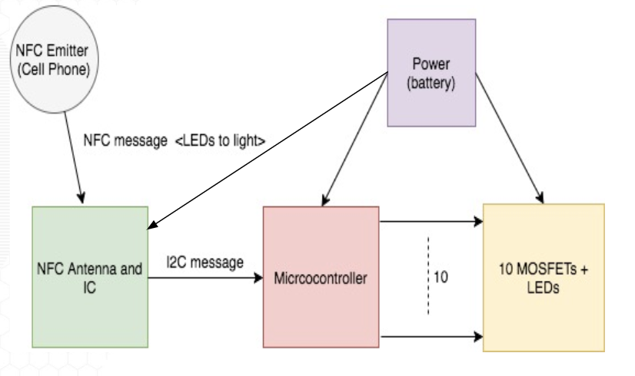

**Figure 1.** A block diagram of the proposed system.

The proposed design had four main components:

* Power
* NFC Antenna and IC
* Microcontroller
* Lighting (LEDs)

The proposed design entailed having a cell phone or other NFC emitter communicate with the bottle and turn on LEDs in different patterns based on user input as described by figure 1. The circuit for the design was proposed to be mounted on a flexible PCB and stuck to the back of the Coke label.

The final design closely followed the proposed design except for a few minor changes:

* 9 LEDs instead of 10: though the lpc812 microcontroller has 20 pins, a lot of the pins were used for programming, power, ground and some could not be programmed as GPIOs. Although the team connected 10 LEDs, the team was only able to control 9 LEDs.
* No MOSFETS: The team was unsure of whether the microcontroller would be able to power 10 LEDs and had hence proposed using MOSFETS to act as switches and drive LEDs. However, the team was able to power 9 LEDs using the microcontroller itself.

## 4.1 Hardware Design

The hardware design of this project included creating a schematic and designing a PCB for the circuit. Both processes were done in Eagle.

## 4.1.1 Power Source

|  |  |
| --- | --- |
| **Table 2.** Battery Specifications | |
| **Item** | **Specification** |
| Output Voltage | 3-6 V |
| Maximum Current Draw | 200 mA |
| capacity | 600 mAh |
| size | 5 * 5 cm, 1.5mm thick |

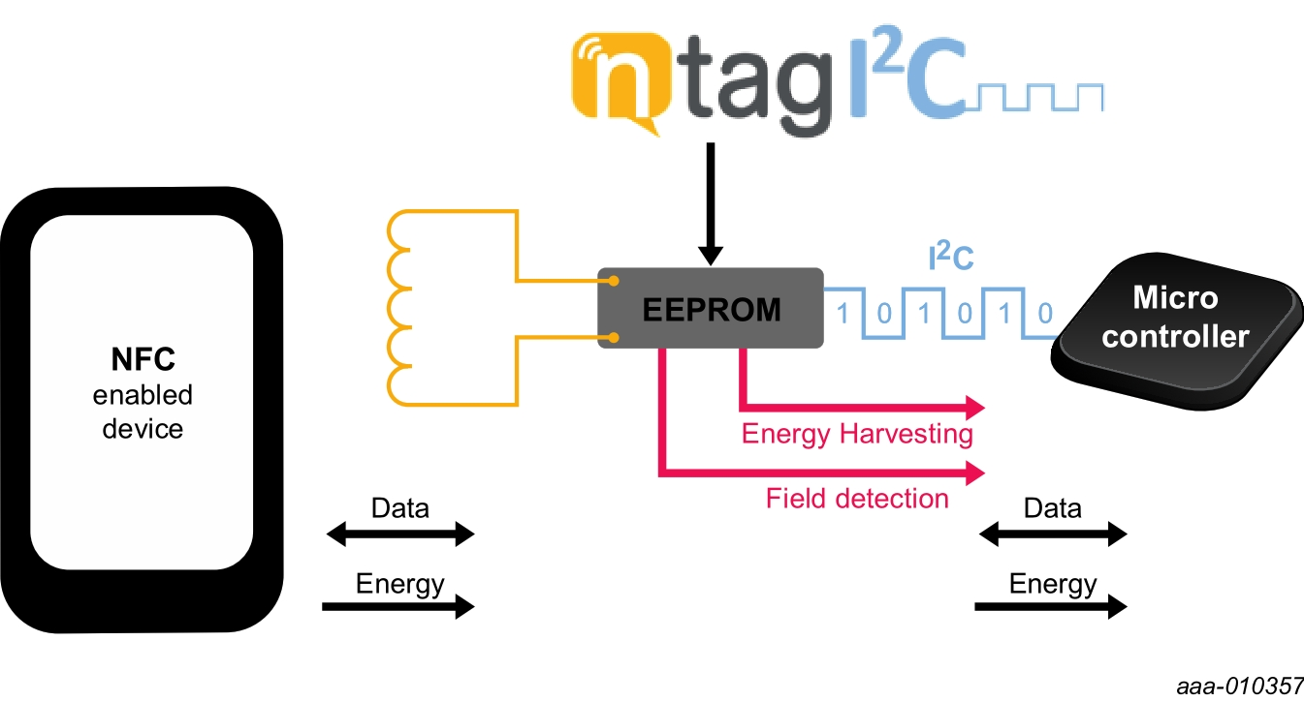The power source supplied power to the microcontroller, NTAG and the LEDs. The team used a lithium Manganese dioxide (Li/MnO2) battery with the specifications described in table 2. The battery was flexible enough to conform to the shape of a Coke bottle. The operating temperature of the battery was -20 ℃ to 60 ℃, and the storage temperature was -25 ℃ to 70 ℃. Both temperature ranges met the temperature specs of the design (2 ℃ - 35 ℃). The team also tested the battery at approximately 2 ℃ and 35 ℃ to validate the functionality.

**Figure 2.** Diagram showing how the NTAG IC interacts with NFC signals and a microcontroller.

## 4.1.2 NFC Antenna and IC

The team decided to use an NFC antenna and IC to detect NFC signals from an Android cell phone. The NFC antenna was connected to the NTAG, which took in data received via NFC as input and output data via I2C signals to be sent to a microcontroller. The team used NXP’s NTAG IC to meet the requirements [3]. The NTAG IC was an 8 pin IC chip that was mounted onto the PCB. The working of the NTAG IC is described in figure 2. An antenna design was provided by NXP with the NTAG IC, which the team used in their design.

## 4.1.3 Microcontroller

The team used NXP’s LPC812 Cortex-M0+ microcontroller to interface with the NTAG IC and the lighting (LEDs). The inputs into the microcontroller were I2C commands from the NTAG IC and the outputs were signals going into the lighting system to light the LEDs in various patterns. The microcontroller came in a 20-pin TSOP package[4]. The microcontroller came with 18 configurable GPIO pins, which were used to control each LED. The microcontroller required a minimum voltage of 1.8 V to operate, which was supplied by the battery [5].

## 4.1.4 Lighting (LEDs)

The lighting consisted of 9 red LEDs. Each LED had a voltage drop of 1.7V and a current draw of 20mA when illuminated [6]. The LEDs used in design were surface mount LEDs in 1206 packaging. Each LED also had a 150 ohm ballast resistor is used in series with the LED, which regulates the current flow through LED to 10 mA.

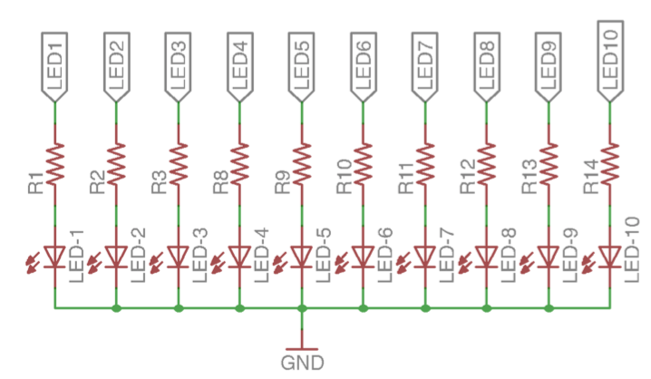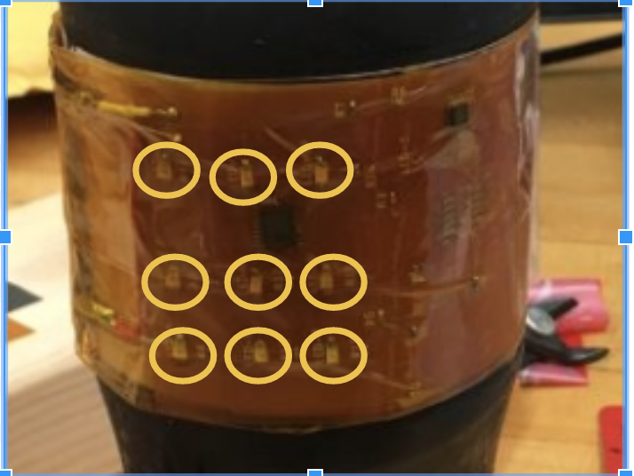

**Figure 3.** Diagram showing the schematic of the LEDs (left) and the arrangement of the 3 X 3 matrix (right).

As indicated by figure 3, the LEDs were arranged in a 3 X 3 array in the layout to demonstrate different patterns of the software.

## 4.1.5 PCB Schematic and Layout

The circuit design and layout was done in eagle.

The circuit consisted of 3 major components: NTAG IC, microcontroller and an SWD programming header, and LEDs. Each LED was connected to a GPIO pin on the microcontroller. The microcontroller was also connected to the 10-pin programming header, which was used to flash firmware onto the microcontroller. Three decoupling capacitors were used at VCC to reduce the noise.

In the layout process, the board was set to be 3.5 by 2 inches. The board was made to be 2 sided and had 36 vias. The width of signal wire was set to be 0.006 inches and the width of the VCC and ground wires was set to be 0.012 inches. The antenna was put on the right side of the board in a vertical position to save the board area and minimize the interference. LEDs were arranged in a 3 X 3 array to demonstrate the different patterns designed.

## 4.2 Software Design

The android application (NTAG I2C) to transmit NFC data was downloaded from google play. The source code for the application is openly available on NXPs website for future development. The firmware for the lpc812 was written in C using the lpcxpresso IDE provided by NXP and the lpc812 was flashed using the LPC-Link2 board. The design process involved writing a test script to test the functionality of all 9 LEDs. The test script blinked all 9 LEDs to indicate that the MCU and the LEDs were mounted and soldered correctly. 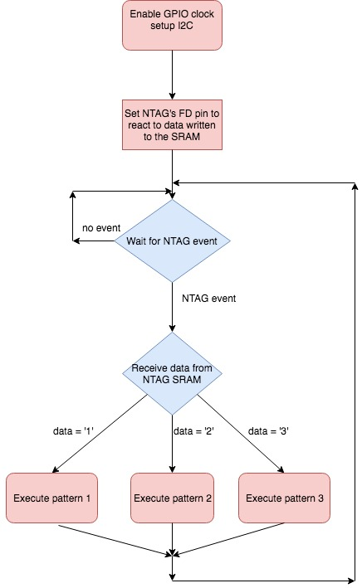

**Figure 4.** Diagram showing the flow chart of the final firmware.

The final firmware flashed onto the lpc812 is described in the flowchart in figure 4 and involved the following steps:

1. Each time NFC data is transmitted via the antenna, the data gets written in the memory of the NTAG.
2. A Field Detection (FD) pin from the NTAG signals the microcontroller that data has been received by the NTAG.
3. Upon receiving an event signal via the FD pin, the microcontroller fetches the data transmitted from the memory of the NTAG using I2C.
4. The data transmitted is then compared against expected values to execute the pre-programmed LED patterns.

The flashing process involved connecting an SWD programming wire to the LPC-Link2 board on one end and the programming header pin soldered onto the board on the other end. After the microcontroller was flashed, the team de-soldered the header pin from the board to allow allow the board to flex easily.

## 4.3 PCB Prototyping and Assembly

The team went through three stages of prototyping and soldered the components on the PCBs. The finished design was then mounted to a Coke bottle. Special care was taken to make the design moisture-proof to condensation (discussed below).

## 4.3.1 Three Stage of Prototyping

## Rigid PCB: Three rigid PCBs were first made to test and debug the design. The rigid PCBs were ordered from OSH PARK and the design was verified to be functional using the test scripts and preliminary versions of the final firmware.

**FR4 PCB**: Upon suggestions by James Steinberg from the Senior Design lab, the team decided to use thin FR4 sheets that were semi-flexible and could conform to the curvature of the bottle. The FR4 sheets used in this round of prototyping were 15 mil thick and were milled by the ECE and ME departments. However, due to the limitations of the milling machines on campus, the team was unable to get a functional prototype.

**Flexible polyimide PCB:** The team found a vendor (PCBminions) to manufacture fully flexible polyimide PCB. The PCB was fully flexible and the thickness of the manufactured PCBs was 1 mil which satisfied the thickness and flexibility requirements of the design. The flexible PCBs were used for the final prototypes.

## 4.3.2 PCB Assembly

After obtaining the flexible PCBs and the components specified in the design, the team soldered the components onto the flexible PCB. The temperature of the solder iron was adjusted to 550 ℉ for the polyimide PCBs. The battery was connected to the board by soldering jumper wires to the VCC and GND vias on the board.

Kapton tape was used to seal both sides of the board in order to make the design moisture-proof. The sealed board was then mounted onto the bottle and the label was put on top of the board using packaging tape. A sharpie was used to mark the location of the antenna on the label for reference.

## 4.4 Alternatives and Tradeoffs

In the case that the proposed initial design turned out to be unrealistic, the team had prepared a “fallback” design. The RF system would be removed entirely and a simple Force Sensitive Resistor (FSR) would be used to control the flashing of the LED. This design was likely to work more smoothly than the RF antenna design due to its simplicity, but would likely have resulted in higher cost due to the expense of FSRs.

The team also investigated to find the most compatible battery solution. Various power options were considered including AAA, AAAA, coin cell batteries and supercapacitors. However, since none met the power and form factor specifications of the design, the team went ahead with flexible lithium Manganese dioxide batteries.

# 5. Schedule, Tasks, and Milestones

The LIT Coke Light Up Interactive Packaging team designed and tested prototypes over the span of several months beginning in August through November 2017. Refer to figure 6 below for a more detailed Gantt chart showing objective breakdowns and timing for the project process.

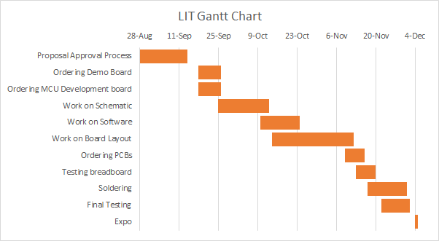

**Figure 5.** Gantt chart showing project timeline.

Using figure 5 for context, the proposal approval process was more difficult than the team had anticipated. Because of the open nature of this project, obtaining final approval for the project required multiple rounds of design and concept changes to discern what the final project would be. The project direction itself was subject to change because of the cost-efficient motivation behind the project and the limitations it imposed on the scope of what could be done. The following steps of ordering the demo and MCU development board did not pose large technical risk and were straightforward tasks, of which Hamim Nigena and Varun Malhotra were responsible. Once the boards arrived, the team began work on the schematic for the PCB and programming the software for the boards a little later. Schematic design posed a moderate degree of technical risk and difficulty. If a functioning schematic could not be designed, the project would be impossible. Once the schematic was nearing completion, software work was able to begin. Programming posed a mild technical risk and moderate difficulty to accomplish. Once these tasks were completed, work on board layout followed. This step provided low-moderate difficulty and mild technical risk to the team. With the layout of the board finalized, the task of ordering the final PCBs was trivial. Testing on the non-flexible breadboard began while waiting for the flexible PCBs to arrive; this was low-risk as the design had already been verified and there was not a great likelihood that a serious design flaw would be discovered. After arrival of the ordered PCBs, soldering and testing work began immediately. These steps were moderately difficult as the team was not extremely experienced in soldering small components onto flexible PCBs, the soldering process was labor-intensive, but relatively low-risk. The team ordered spare flexible PCBs so that in case of device failure, soldering mistakes, or board damage there were extra boards on hand.

# 6. Project Demonstration and Evaluation

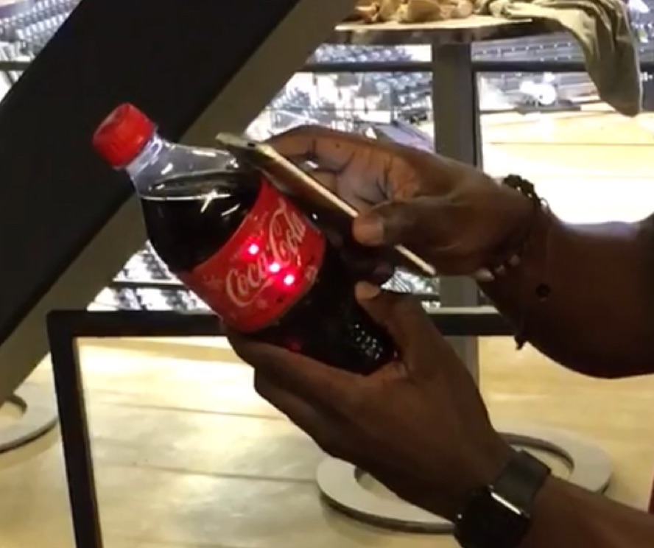

**Figure 6.** Completed prototype interactive bottle during a light-up sequence.

A video of the prototype was featured on the Georgia Tech Twitter page and is available on the team’s website or at [bit.ly/2yiJGQc](http://bit.ly/2yiJGQc).

The prototype behaved as designed: when one of three test NFC signals was sent by a phone held up to the antenna, the nine LEDs lit up in the pattern corresponding to that test signal. The lights were bright red and showed up very clearly in a well-lit room. The prototypes increased the radius of the bottle by about 1mm, within the form factor specification. The additional weight was approximately 10g, within the weight specification. The prototypes were able to withstand several drops from standing height, and had no problems being put on a bottle covered in condensation. Due to time constraints, no testing of battery longevity or extended extreme temperature performance were made, but the specifications of the battery suggest that both of the team’s goals are met. The team was able to approximate the cost to be under $10 at 10,000 unit scales.

# 7. Cost Analysis

## 7.1 Cost Analysis for Prototyping

The design of the interactive light-up bottle consists of a simple circuit which has a 3V semi-flexible Li-MnO2 battery, a microcontroller, an NTAG chip for NFC, red LEDS, and a few capacitors and resistors, all mounted on a flexible printed circuit board. For prototyping, the team was given a budget of up to $1000. This gave the team the freedom to go through 3 different prototyping stages, all totaling a cost of $795. As shown in the breakdown in table 3, this cost includes development boards for the microcontroller and NFC antenna, the link-board for programming, and the cost of successive prototypes. The cost provided in this table is for parts to build individual prototypes - the cost will be significantly lower for Coca-Cola when parts are purchased at production scales.

|  |  |
| --- | --- |
| **Table 3. Components Cost for Prototyping** | |
| Rigid PCBs x 3 | $73 |
| Flexible PCBs x 7 | $250 |
| FR4 sheets x 2 | $44 [14] |
| NTAG demo-kit | $18.69 [3] |
| LPC-Link2 board | $22.48 [11] |
| 3V Li-ion batteries x 15 | $75 [5] |
| Xpresso Development board | $18.75 [12] |
| NXP Microcontrollers | $25 [8] |
| Kapton tape | $65 [13] |
| Components (LEDs, resistors, caps, connectors, fuses...) | $85 |
| **Grand Total (Including shipping)** | **$795** |

## 7.2 Approximate Cost Analysis for Scale Manufacturing

Table 4 shows the cost that the team estimates for making individual prototypes at a manufacturing scale of 10,000 units. Clearly the cost for Coca-Cola manufacturing at million-unit scales will be much lower, and this is the cost that is called for the team to meet in the specifications. The team has no expertise in large scale manufacturing and does not have the reputation to receive accurate quotes on ordering large amounts of products. Table 5 is an attempt at calculating the cost of parts at scale by using only the largest volume price given on the distributor website. These unit numbers are significantly smaller than the million-unit scale requested by Coca-Cola, so one can expect the estimate to be somewhat conservative. However, considering the high likelihood of unforeseen design changes and added costs, the team feels that the $9.4 estimation is sets the project on target to meet the $10 cost specification for 10,000 units. The biggest part of this cost comes from the FR4 sheet used for the PCB and the battery. That’s because the vendor’s website only provided the price for only 1 unit. The faculty advisor of the team mentioned that when purchased in high quantity, the FR4 sheets cost approximately $0.10 per square inch. This brings the cost of the FR4 sheet to $0.50, and the cost of the prototype to $5.852.

|  |  |  |
| --- | --- | --- |
| **Table 4. Approximate Large-Scale Components Cost** | | |
| FR4 sheets (for PCB) | @1 | $20/4 (-1 for approx 10000) = $4 [14] |
| Red LED x 9 | @10,000 | $0.04 x 9 = $0.36 [6] |
| NXP Microcontroller | @10,000 | $0.60 [8] |
| Capacitors, SMD x 7 | @15,000 | $0.002 x 7 = $ 0.014 [9] |
| NTAG chip | @10,000 | $0.35 [10] |
| Li-Ion flat battery | @1 | $5 (-1 for approx 10000) = $4 [5] |
| Resistor, SMD x14 | @15,000 | $0.002 x 14 = $0.028 [7] |
| **Total** | **$9.352** | |

# 

# 8. Leadership Roles

The leadership roles and their descriptions for the project were as follows:

Team Lead: (Varun Malhotra, Hamim Nigena) These team members were responsible for general organization of the team and ensuring that deadlines were met.

Coke Contact: (Varun Malhotra) This group member was responsible for organizing communication with the Coke advisor. He advised Coke of design decisions, communicated team needs, and progress updates.

Expo Coordinator: (Alex Plager) This team member was responsible for preparing the product and team for the Design Expo and the demonstration.

Documentation Coordinator: (Mitcham Tuell) This team member was responsible for managing team and design documents, keeping them updated, centralized, and available.

Webmaster: (Fan Chen) This team member was responsible for maintaining the project website and ensuring that appropriate documentation was available online.

Parts Sourcing: (Hamim Nigena) This team member made sure that all the parts that the team had decided to use in the design were ordered through the proper channels and were made available to the rest of the team for prototyping

# 9. Responsibilities

Design responsibilities for the team were as follows:

|  |  |
| --- | --- |
| **Team Role** | **Team Members Responsible** |
| Flex PCB Design | FC, MT |
| Microcontroller Programming | VM, AP |
| NFC Antenna and IC Design | MT, HN |
| Battery and Lighting | HN, AP |
| Breadboard Prototyping | VM, FC |
| Soldering | MT, HN, AP, FC, VM |

# 

# 10. Conclusion

The objective of this Capstone Design Project was to design an interactive light-up Coke bottle. The team chose to use NFC from a phone to interact with circuit on the Coca Cola bottle. This design had to satisfy a number of requirements, including a cost of not more than $10 at a production scale of 10,000 unit and withstanding a temperature range of 2˚C to 35˚C. The maximum protrusion had to not exceed 2.5mm. A prototype that meets all these requirements was successfully made and demonstrated at the Capstone Design Expo. The team also presented the design to Coca Cola Engineers.

Even though the prototype met the specifications, there is room for improvements. For instance, the alignment of the LEDs used for the prototype is just a 3x3 matrix. This can be changed on the PCB layout and align the LEDs to follow the Coca letter on bottle label. Extensive tests can also be done on the battery to determine the exact lifetime. The lighting patterns used in the demo only lights up one LED at once. Since one LED doesn’t use much power, it is worth looking into the option of using energy harvesting which is support by the NTAG chip that already exists in the design. This would eliminate the battery and significantly reduce the cost. The Android application used for activate the NFC can also be improved to allow more lighting patterns.

# 

# 

# References

1. Medea Vodka (2010)*. How to Program* [Online]. Available: http://medeavodka.com/how-to-program
2. T. Nudd, "Tostitos’ new party bag knows when you’ve been drinking and will even call you an Uber," 2017. [Online]. Available: http://www.adweek.com/creativity/tostitos-new-party-bag-knows-when-youve-been-drinking-and-will-even-call-you-uber-175727/. Accessed: Mar. 6, 2017.
3. “NT3H1101/NT3H1201|NXP", *Nxp.com*, 2017. [Online]. Available: https://www.nxp.com/pages/ntag-ic-energy-harvesting-nfc-forum-type-2-tag-with-field-detection-pin-and-ic-interface:NT3H1101_NT3H1201. [Accessed: 30- Sep- 2017]
4. "LPC81xM", *Nxp.com*, 2017. [Online]. Available: https://www.nxp.com/docs/en/data-sheet/LPC81XM.pdf. [Accessed: 14- Dec- 2017].
5. “Thin Primary Lithium Batteries”, *Powerstream Technology*, 2017. [Online]. Available: <https://www.powerstream.com/thin-primary-lithium.htm>. [Accessed: 13-Dec-2017].
6. S. Co, "BR1101W-TR Stanley Electric Co | Optoelectronics | DigiKey", *Digikey.com*, 2017. [Online]. Available: https://www.digikey.com/product-detail/en/stanley-electric-co/BR1101W-TR/404-1042-1-ND/428853. [Accessed: 13-Dec-2017].
7. “Susumu RS2012P-151-D-T3-5”, *Mouser Electronics,* 2017. [Online]. Available: https://www.mouser.com/ProductDetail/Susumu/RS2012P-151-D-T5-3/?qs=sGAEpiMZZMvdGkrng054t7z4BkURc4LzbzoYaKbcI90NCO6%252beEwTXA%3d%3d. [Accessed: 13-Dec-2017].
8. “ LPC812M101JDH20FP - NXP Semiconductors” , Arrow.com, 2017. [Online]. Available: <https://www.arrow.com/en/products/lpc812m101jdh20fp/nxp-semiconductors>. [Accessed: 13-Dec-2017].
9. “AVX Corporation 0402ZD104KAT2A”, Digikey, 2017. [Online]. Available: <https://www.digikey.com/product-detail/en/avx-corporation/0402ZD104KAT2A/478-1129-2-ND/563239>. [Accessed: 13-Dec-2017].
10. “NT3H1101W0FHKH - NXP Semiconductors”, Arrow.com, 2017. [Online]. Available:<https://www.arrow.com/en/products/nt3h1101w0fhkh/nxp-semiconductors?utm_campaign=arrow_findchips_2017&utm_medium=aggregator&utm_source=findchips&utm_content=inv_listing>. [Accessed: 13-Dec-2017].
11. “NXP USA Inc. OM13054,598”, Digikey, 2017. [Online]. Available: <https://www.digikey.com/products/en?keywords=OM13054%2C598>. [Accessed: 13-Dec-2017].
12. ”OM13053,598 - NXP Semiconductors“, Digikey, 2017. [Online]. Available: <https://www.arrow.com/en/products/om13053598/nxp-semiconductors?utm_term=backorder&utm_campaign=arrow_findchips_2017&utm_medium=aggregator&utm_source=findchips&utm_content=inv_listing>. [Accessed: 13-Dec-2017].
13. “Kapton Tape - 1 Mil, 2" x 36 yds”, Uline, 2017. [Online]. Available: <https://www.uline.com/Product/Detail/S-11731/High-Temperature-Tapes/Kapton-Tape-1-Mil-2-x-36-yds?pricode=WB0218&gadtype=pla&id=S-11731&gclid=EAIaIQobChMIha-liuSH2AIV0Y-zCh07iw_GEAYYBiABEgL9GfD_BwE&gclsrc=aw.ds>. [Accessed: 13-Dec-2017].
14. “MG Chemicals 698”, Digikey, 2017. [Online]. Available:

<https://www.digikey.com/product-detail/en/mg-chemicals/698/473-1022-ND/559716>.[Accessed: 13-Dec-2017].

# 

# Appendix

# 

# Appendix A: Design Files on Website

The following is a list of design files on the team website (<http://ece4012y2017.ece.gatech.edu/fall/sd17f12/>):

* EAGLE PCB layout files (zip)
* Firmware files (zip)

# Appendix B: Bill of Materials

|  |  |  |  |  |  |  |
| --- | --- | --- | --- | --- | --- | --- |
| **Parts** | **Quantity** | **Unit Cost($)** | **Total Cost($)** | **Supplier** | **part number** | **Manucturer** |
| Batteries | 15 | 5 | 75 | Power Stream Technology | CP155050/600mAh/3.0V | Power Stream Technology |
| NTAG I2C demo kit | 1 | 18.69 | 18.69 | Arrow Electronics | OM5569/NT312D,699 | NXP |
| MCU Xpresso dev board | 1 | 18.75 | 18.75 | Mouser | OM13053 | NXP |
| MCUs | 5 | 1.55 | 7.75 | Digi-Key | LPC812M101JD20J | NXP |
| Red LEDs | 50 | 0.32 | 16 | Mouser | HSMC-C170-T0000 | Broadcom/Avago |
| Linker-board | 1 | 22.48 | 22.48 | Digi-Key | OM13054,598 | NXP |
| programming cable | 1 | 7.85 | 7.85 | Amazon Prime |  |  |
| PCB FR4 2 sided sheet | 2 | 21.93 | 43.86 | Digi-Key | 473-1022-ND | MG Chemicals |
| Pin header | 1 | 6.72 | 6.72 | Digi-Key | 1212-1811-ND | Preci-Dip |
| Kapton Tape | 1 | 65 | 65 | ULINE | S-11731 |  |
| Connector header | 10 | 0.48 | 4.8 | Arrow Electronics | 3221-10-0100-00 | CnC Tech LLC |
| MCUs (Different package) | 10 | 1.33 | 13.3 | Digi-Key | LPC812M101JDH20FP | NXP |
| Cable breakout board | 3 | 1.95 | 5.85 | Adafruit | 2743 |  |
| NFC Antena (13.56 Hz) | 3 | 5.07 | 15.21 | Mouser | ANFCA-4545-A01 | ABRACON |
| connector box | 10 | 1.5 | 15 | Adafruit | 752 |  |
| 500mA fuses | 20 | 0.912 | 18.24 | Mouser | 0437.500WRA | Littelfuse |
| Rigid boards | 3 |  | 17 |  |  |  |
| Flexible boards | 7 |  | 250 |  |  |  |
|  |  |  |  |  |  |  |
| Total |  |  | 621.5 |  |  |  |
| **Grand total (Including shipping)** |  |  | **795** |  |  |  |