**Smartphone Solar Tracker**

ECE 4012 L1A Senior Design Project

Project Advisor: Professor Jonathan Christopher James

Team Number: sd17f11

Team Name: Solar Sensei

Chidinma Imala, [chidiimals@gatech.edu](mailto:chidiimals@gatech.edu)

Asier Isayas, [aisayas10@gatech.edu](mailto:aisayas10@gatech.edu)

Yusuf Ziya Kuris, ykuris3@gatech.edu

Gideon Odogwu, o[dogwugideon@gatech.edu](mailto:Odogwugideon@gatech.edu) - Team Leader

Submission Date: 12/13/2017

**Table of Contents**

**Executive Summary**  3

1. **Introduction** 4
   1. Objective 4
   2. Motivation 4
   3. Background 5
2. **Project Description and Goals**  6
3. **Technical Specification & Verification** 7
4. **Design Approach and Details** 8
   1. Design Approach 8
   2. Codes and Standards 12
   3. Constraints, Alternatives, and Tradeoffs 13
5. **Schedule, Tasks, and Milestones** 14
6. **Final Project Demonstration**  15
7. **Marketing and Cost Analysis**  16
   1. Marketing Analysis 16
   2. Cost Analysis 17
8. **Conclusion**  21
9. **Leadership Roles**  22
10. **References**  23

**Appendices**

**Executive Summary**

Smartphone Solar Tracker uses a mobile device to detect sunlight and orient a solar panel for optimal position. The project promotes the utilization of unused devices such as an old smartphone that has been replaced by a newer model. By repurposing the sensors to detect brightness of the sun and the processor to send this data to a motor controller, a low cost and resource-mindful system will be designed. The expected cost of this project is $806.84, assuming no cost for an available old Android smartphone, but including Directed Perception pan and tilt unit PTU-46 [1], a solar panel and frame structure. Detailed cost breakdown is available at the Marketing and Cost Analysis section.

The project has four main components: Smartphone camera, application, pan and tilt unit and acrylic frame holding the solar panel. The camera detects brightness of the sun, the application controls the pan and tilt unit, the unit moves the frame which holds the solar panel and the smartphone. The application will resemble a Graphical User Interface (GUI) and once connected to the solar panel (through a USB cable or Bluetooth) will provide information about the power being generated. There will be a scan button in the application that will increment the pan and tilt unit position until it is roughly facing the sun. There will also be an auto button in the application that will further orient the unit so that the panel is directly facing the sun using the camera on the smartphone. Another option of the application is manual control, sliders will enable the user to orient the solar panels as they wish.

**Smartphone Solar Tracker**

**1. Introduction**

Team Solar Sensei is requesting $806.84 to complete the project Smartphone Solar Tracker. Smartphone Solar Tracker utilizes the processor and the sensors of a smartphone to track the sun, a pan and tilt unit to orient the solar panel. An Android smartphone application was developed to connect the smartphone with the pan and tilt unit.

* 1. **Objective**

The idea that motivates the project is having a self sustaining system that can function in remote areas with no network access. The advantages of the project are its low cost and utilization of available resources. The inspiration behind the project is a maker village, where the inhabitants make equipment and devices from salvaged material. The project promotes sustainability and reuse.

* 1. **Motivation**

The Smartphone Solar Tracker project is intended as a plug-and-play device for households. The Android application will enable users to download it, purchase the kit, and utilize solar power. The project also has potential to be used in small-scale solar power station tracking systems. Industrial solar power stations use proven algorithms and control mechanisms to track the sun and maximize the power being generated. This project will allow similar implementation at a lower cost and resource expenditure. Furthermore, it will familiarize the user with its educational potential. The application will also allow manual control.

* 1. **Background**

Internet Enabled Solar Tracker is a similar project that has a solar panel, DC motors, controllers and a wood structure [2]. It uses an insolation algorithm server to adjust the solar panel. Thus, this project requires to connect to a server that does the angle calculations through Internet. It also has a smartphone application where the user can gather information about the solar panel and manually control the device.

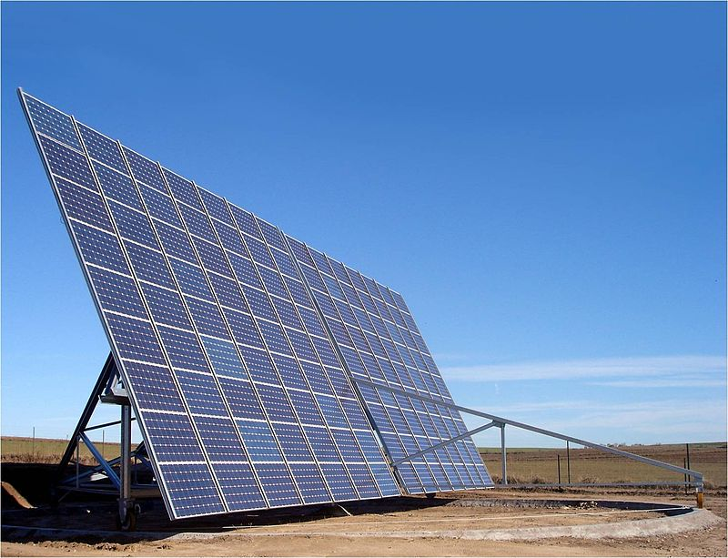

**Figure 1.** Azimuth altitude tracking solar panel.

A solar power station in Toledo, Spain, uses an azimuth-altitude tracker that has 2 degrees of freedom. This system is similar to what we want to implement with our project [3]. The solar panel seen above can rotate relative to the ground and tilt around a central axis parallel to its long edge. This enables the normal vector of the panel to face the sun during insolation. Research on tracker development is available. One of the reference sources we used is a paper published by two Worcester Polytechnic Institute Scholars named Azimuth-Altitude Dual Axis Solar Tracker [4].

This paper details the parts of a two-degrees-of-freedom tracker and MATLAB simulation code for power performance analysis. The main difference between these products and our project is the sensor. While the products find the optimal point by feedback from the power captured from the photovoltaic cells or estimating the sun’s position using trigonometric algorithms, our project will test for the brightness of the sun using the sensors on a mobile device. The key building blocks are the smartphone sensors, Android application that uses the processor to send the signal, and the motor controller circuit that receives the signal and moves the panel.

**2. Project Description and Goals**

The fundamental purpose of this team would be to design a solar panel that can track the sun’s position and intensity in order to increase the efficiency of the solar panel. This solar panel would track the sun by using the smartphone camera and the processor to determine the optimum angle, and position the solar panel by controlling the pan and tilt unit. The goal at the end of this project would be to design a system which could be integrated with an Android device to control a solar panel. The features of this system include:

* **A Solar panel that tracks the sun’s intensity in real time.**
* **Rotation of solar panel platform to the sun's position.**
* **Compatible with Android devices**
* **Phone application :** The phone application uses image processing to issue motion commands.

The targeted user of this product would be adventurers or hikers who want to power up their devices. It could also be used by homeowners who would make use of electricity to perform domestic duties at home. The targeted size of this product is expected to be less than 0.05 m³.

1. **Technical Specifications**

|  |  |  |
| --- | --- | --- |
| **Table 1.** Technical Specifications | | |
| Specification | Target Value | Result Value |
| Weight (kg) | 9.07 | 7.71 |
| Dimensions (m) | 0.38 * 0.38 * 0.38 | 0.36 * 0.24 * 0.25 |
| Solar panel dimensions (m) | 0.28 * 0.22 | 0.27 * 0.25 |
| Solar panel average output | 3 V at 1 W  (average sun conditions) | did not test |
| Azimuth angle range (°) * | 0-360 | 0-318 |
| Zenith angle range (°) ** | 0-90 | 0-120 |
| Azimuth pointing accuracy (°) # | $±$ 0.5° | ~ $±$ 5.1° |
| Zenith pointing accuracy (°) # | $±$ 0.5° | ~ $±$ 6.7° |
| Sensor | Camera (> 5 MP), Ambient light sensor, Accelerometer | Camera |
| Operating System | Android 4.4 KitKat or above | Android 4.5 or above |

*: The angle range assumes that North is 0 degrees, East is 90 degrees and West is 270 degrees.

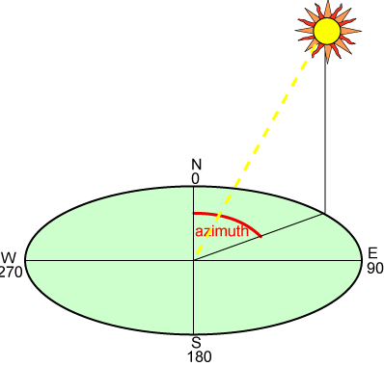

**Figure 2.** Azimuth altitude tracking solar panel.

**: 0 degrees is parallel to ground and 90 degrees is normal to ground.

#: Please check Figure 4 on section 4.1.2 for accuracy calculations

1. **Design Approach and Details**
   1. **Design Approach**

The project has four main components: Smartphone camera, application, pan and tilt unit and acrylic frame holding the solar panel. The camera detects brightness of the sun, the application controls the pan and tilt unit, the pan tilt unit moves the frame which holds the solar panel and the smartphone.

*4.1.1 Smartphone Application*

The Android application was developed in Android Studio. The application is a critical part of the project since it provides the link between the user and the device. The development process continued throughout the project lifetime. The first step in testing was to establish a serial port connection between the phone and the motor controller. For this GitHub user felhr85’s USBSerial library [5] was used for Android Studio. Then, manual control feature was implemented so that the phone can control the motors. Lastly the scan and auto buttons were used to orient the solar panel to the brightest source of illumination and track this source as it varied in position respectively. 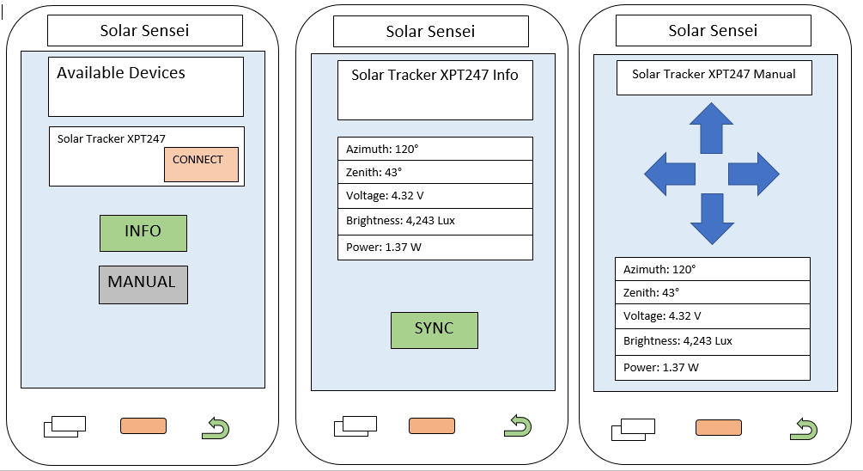

**Figure 3.** Proposed Solar Sensei Android Application Screens.

The application developed had two screens as seen in Figure 4 and lacked solar panel output readings. The features are manual control with sliders, reset to calibrate the device for undesired behaviors due to serial connection glitch, scan for searching for a bright spot and auto for finite pointing on the bright object. When auto or scan are pressed the application switched to the second screen where image processing algorithm and the phone camera were used.

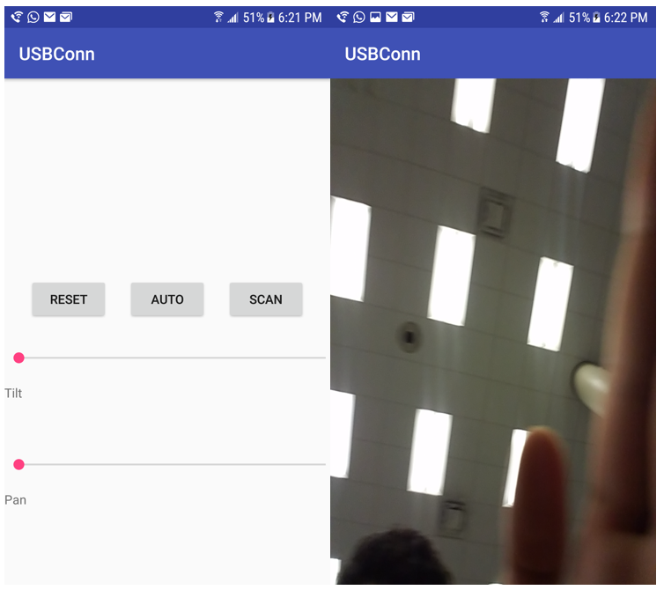

**Figure 4.** USBConn Application Screens.

*4.1.2 Smartphone Camera and Image Processing*

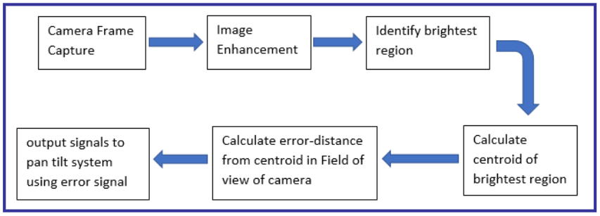

**Figure 5.** Image Processing Flowchart.

Despite proposing to use ambient light sensor and accelerometer, only the camera was used as a sensor. An OpenCV image processing library was used in the smartphone application to detect the brightest spot on the screen [6]. A solar filter was placed on the camera so that the image on the screen was black except the light source. Each frame from the camera was processed in this way: The brightest region in the image was found, the centroid of this region was calculated and the location of the centroid in the original image is the centre of the sun. By checking if the distance from this point is positive or negative, the pan and tilt unit was oriented to place the bright spot in the acceptable region seen in Figure 6.

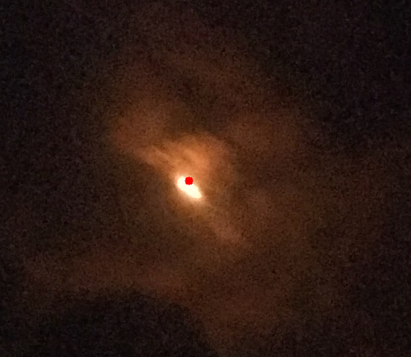

**Figure 7.** Brightest spot detected in an Image

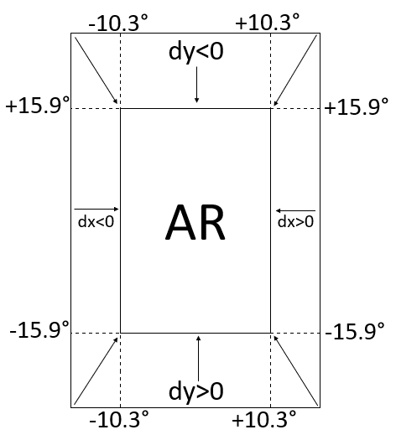

**Figure 8.** Phone screen divided into areas.

For instance, if the bright spot was in the upper left box on Figure 6, then the application commanded the pan and tilt unit to move such that the bright spot moved to the Acceptable Region (AR). This was achieved by moving the frame to the left and up so that the spot moves right and down.

The error calculation in the specification table was performed similarly. A light source was shone at one meter distance to the phone screen such that it fell in the AR. Slowly the light source was moved without changing the distance to the pan and tilt unit. The angle traveled was used as the pointing accuracy for azimuth and zenith.

The angles seen on Figure 6 are different than the pointing accuracy angles seen on the specification table. The angles on Figure 6 are the pan or tilt increments used when the bright spot was not in AR, calculated by translating angle increments to find the pan or tilt resolution.

*4.1.3 Directed Perception PTU-64*

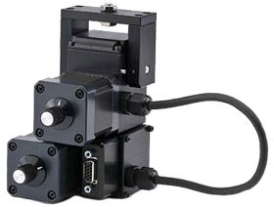

**Figure 9.** Directed Perception PTU-64 (courtesy of flir.com).

Off-the-shelf pan and tilt unit had built in serial communication firmware that enabled us to control it through Tera Term on a computer. We then used USB Serial libraries for Android Studio to send serial commands with a smartphone. By writing the same commands used to control the unit in our code and manipulating the variables, we were able to use the pan and tilt unit to move the frame.

A issue we had with the unit was the torque capacity. At some point we were using a 10 cm rod to connect the unit to the frame and it constricted motion when the rod was parallel to the ground (maximum moment arm). We resolved this problem by decreasing the rod length to 3.8 cm and the tilt speed to restore motion range.

*4.1.4 Acrylic Frame and Solar Panel*

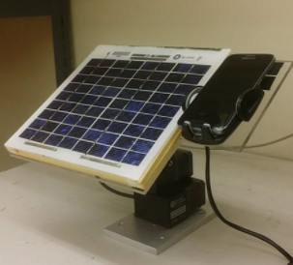

**Figure 10.** Solar Tracker with frame visible on top.

For the frame design, we had to come up with a design that would not hinder the solar cell from receiving sunlight, was light weight to accommodate the pan tilt system which could only accommodate about 2.7 kg and with a wide enough frame to carry both a panel and a phone. Acrylic material was used for the frame because there was a lot of it available in the lab, it is also a light and durable material for the project. For the design process, we drew out a schematic on the Acrylic board then used a jigsaw to cut it out of the board then used a drill press to drill a 0.64 cm hole at the center which was where the rod was inserted. The rod held the frame to the pan tilt system. A double sided tape was also available in the lab so we glued one side to the acrylic frame and the other to the solar panel. A 2.54 cm hole was drilled by the side to insert the the phone holder which was glued to the frame.

**Codes and Standards**

* RS-232: The cable connects the pan and tilt unit to the RS-232 to USB adapter.
* RS-232 to USB adapter: The cable connects RS-232 to USB OTG (On-The-Go) which is a USB female to micro-USB male adapter.
* USB OTG: The cable connects the RS232 to USB adapter to the smartphone to enable host configuration
* Tera Term to PTU-46 serial connection: A 9600 baud, one start bit, eight data bits, one stop bit and no parity connection is used to control the unit with a computer for range testing.
* The software provides an informational interface to the user should carefully convey details about solar energy generation. We will follow Android API guidelines to ensure a good and clear user experience [7].
  1. **Constraints, Alternatives, and Tradeoffs**

Another design alternative that was considered was to attach a magnetometer and photo sensor to a microcontroller so that it could control DC motors on the solar panel. The phone’s primary role would then be to display information from the solar panel. This approach was not selected as the first choice because the goal of the project is to enable the user to use their own, ready-made phone to orient the solar panel versus an externally attached microcontroller and sensors. The usage of the phone provides a more economical and user friendly approach to the design.

Camera: Since a smartphone camera is required to point to the sun, a smartphone is needed for our product. Samsung Galaxy S7 and LG G Flex were used in testing and demonstrations. The smartphone introduced weight and field of sight (camera detection space) constraints.

Pan and tilt unit: The PTU-46 is manufactured by Directed Perception. The unit has 318° azimuth and 120° zenith range. The payload limit is 6 lbs. These ranges and limits affected the weight and motion of our design. For instance, we traded speed with weight by decreasing the tilt speed to prevent the unit from getting stuck. Furthermore we traded rod height with motion range. By decreasing the length of the rod we were able to move the frame to a wider range since the tall rod disabled movement by exceeding the weight limit of the pan and tilt unit.

1. **Schedule, Tasks, and Milestones**

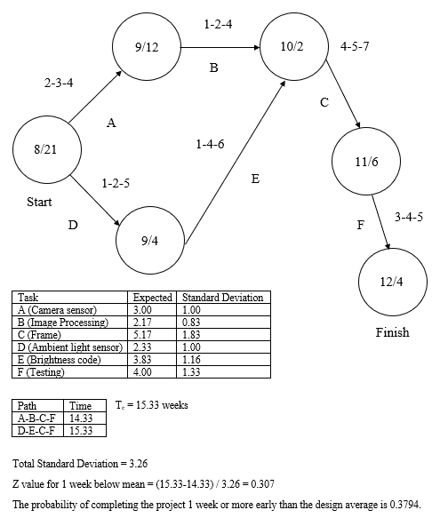

**Figure 9.** PERT chart for Smartphone Solar Tracker.

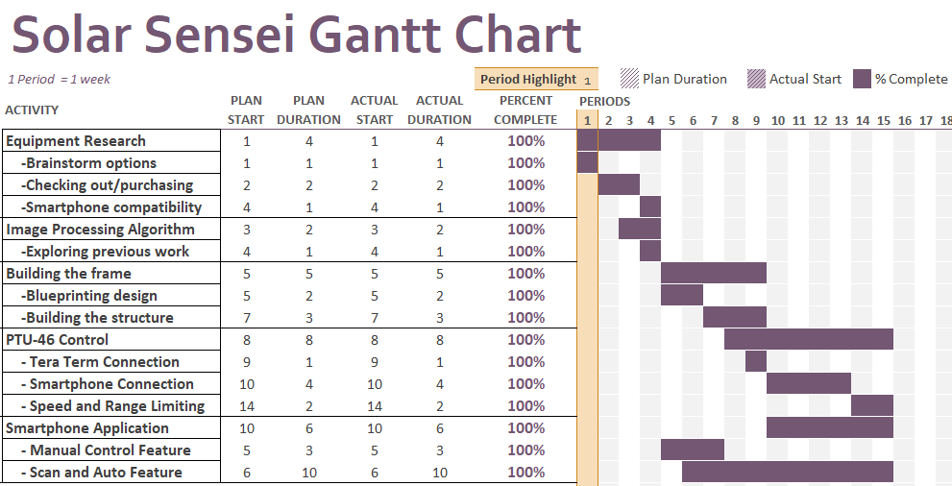

**Figure 10.** GANTT chart for Smartphone Solar Tracker.

|  |  |  |  |  |
| --- | --- | --- | --- | --- |
| **Table 2.** Task Distribution | | | | |
| Member/Task | Application (3) | Image Processing (3) | Pan and Tilt Unit (2) | Frame (2) |
| Asier | X | x |  |  |
| Chidi | x | X | x |  |
| Gideon |  |  | x | X |
| Yusuf |  |  | X | x |

Note: Task difficulty 3: hard, 1: easy, X: main contributor, x: secondary contributor

1. **Project Demonstration**

This project was demonstrated at Van Leer and at the Capstone Design Expo using a source of illumination of varying position. The phone was placed on the frame and the Android application was run. The system was first turned on and then reset using the reset button on the phone

As the position of the light source was varied, the smartphone automatically oriented the solar panel to the direction of the light source by sending position commands to the pan tilt system

The solar tracker would turned on and remotely rotated about its axes using by sending commands from the application.

* The source of illumination would be directed to the solar panel and then constantly changed and the response of the solar tracker to the varying illumination would be recorded
* The response rate of the solar tracker would be varied and the response of the tracker would be tested for varying positional illumination

To read the discussion on proposed and achieved specifications please look for section 8 (Conclusion).

Prototype testing for the pan and tilt unit was done by connecting the unit to a laptop and using Tera Term to run specific motion commands while the load was connected to the unit. By moving the unit to extreme loading positions (maximum moment arm), we were able to determine the speed and motion range to select for the unit.

Prototype testing for the smartphone application was performed by connecting the phone to the pan and tilt unit and use a flashlight to test the response of the application.

Prototype testing for the camera and image processing was done by running the application and exciting the camera with a flashlight and see how other lights in the classroom affected the application. Then the testing process was repeated by putting a solar filter on the camera.

Please use the link below to watch a demonstration test we recorded before the Capstone Design Expo:

<https://drive.google.com/open?id=1UFYNOzRUrrI8ajQRcC_fTFMQMo43i4mE>

1. **Marketing and Cost Analysis**
   1. **Marketing Analysis**

The concept of a solar tracker on a solar panel is not new, there are several existing industries invested in producing solar panels with tracker. Most industries make use of expensive sensors, microcontrollers and smart motors to track the sun’s position. Solar trackers like Zomeworks Passive Tracker and Universal Track Rack UTRF all make use of such expensive methods of tracking the sun.

The concept of a solar tracker on a solar panel is not new, there are several existing industries invested in producing solar panels with tracker. Most industries make use of expensive sensors, microcontrollers and smart motors to track the sun’s position.Solar trackers like Zomeworks Passive Tracker and Universal Track Rack UTRF all make use of such expensive methods of tracking the sun. Making use of such trackers, increases the cost of their product. The team has come up with, redesigning and repurposing a smartphone which many people possess for the sole purpose of tracking the sun which is is a major selling point for our product. This idea, makes the final product cheaper than that of our competitors and also offers a better compact size for the sensors.

|  |  |  |
| --- | --- | --- |
| **Table 2**. Competitor Selling Price Per Unit | | |
|  | **Zomeworks Passive Tracker UTRF-72** | **Universal Track Rack UTRF-090** |
| **Price** | $1,582.88 [8] | $2,050.00 [9] |

* 1. **Cost Analysis**

The total component cost for the project is $568. A breakdown of the parts is shown in Table 5. The total development costs are also shown in Table 4. It takes into consideration the cost of each part and values each hour of work at $40.

|  |  |  |  |
| --- | --- | --- | --- |
| **Table 3.** Cost of Components | | | |
| Product components | Quantity | Price($) | Total Price ($) |
| Phone | 1 | 200 | 200 |
| Acrylic glass | 2 sq feet | 3.42/square foot | 6.84 |
| Pan Tilt Unit | 1 | 400 | 400 |
| USB converter | 1 | 6 | 6 |
| RS232 Cable | 1 | 10 | 10 |
| 1.5 inch Optical Rod | 1 |  | 32 |
| **Total Cost** |  |  | **654.84** |

|  |  |  |  |  |
| --- | --- | --- | --- | --- |
| **Table 4.** Development Costs | | | | |
| **Processes** | **Hours** | **Labor Cost ($)** | **Parts Cost ($)** | **Total Costs** |
| **Mechanical design** |  | | |  |
| CAD Design | 25 | 1200 |  | 1200 |
| Machining of acrylic | 20 | 800 | 6.84 | 806.84 |
| Pan Tilt System |  | | 400 | 400 |
| Frame Assembly | 15 | 600 |  | 600 |
| **Electrical design** |  | | |  |
| Simulation / testing | 30 | 1200 |  | 1200 |
| **App development** |  | | |  |
| Coding | 90 | 3600 |  | 3600 |
| Debugging | 30 | 900 |  | 900 |
| Play Store Developer License |  | | 25 | 25 |
| Group meetings | 50 | 2000 |  | 2000 |
| **Total** |  | | | 9531.84 |

The total development cost of the project including cost of materials, labor, and overhead comes down to $20,877 as shown in Table 5. The overhead for the project is set at 120% and the fringe benefit % of labour is 30%.

|  |  |
| --- | --- |
| **Table 5. Total Development Costs Accounting for Fringe Benefits and Overhead** | |
| **Development Component** | **Cost ($)** |
| Parts | 806.84 |
| Labor | 9,100 |
| Fringe Benefits, % of Labour | 2730 |
| Subtotal | 11830 |
| Overhead, % of Materials, Labor and Fringe Benefits | 12798 |
| **Total** | **12798.2** |

Finally, Table 6. shows the total cost and profit per unit assuming 5000 units would be produced over a period of 5 years. Assuming a discount on the components of the design, as the units produced increase and assuming due to increased efficiency in production and economies of scale, each unit costs $80, and labor costs $40. The sales tax is 6% of the final selling price and the overhead as before is 120 % . The amortized costs accounts for costs spent on developing the product over the five year period. The tables shows a profit of $65.6 which leads to a profit of $328,000 over five years, all things being equal.

|  |  |
| --- | --- |
| **Table 6. Selling Price and Profit Per Unit ( Based on 5,000 unit production)** | |
| **Item** | **Costs ($)** |
| Parts | 80 |
| Assembly & Testing Labor | 40 |
| **Subtotal Labor** | 40 |
| Fringe Benefits | 12 |
| **Subtotal** | 132 |
| Overhead, % of Material, Labor & Fringe | 158.4 |
| **Subtotal** | 290.4 |
| Sales Expense | 24 |
| Amortized Development Costs | 20 |
| **Subtotal, All costs** | 334.4 |
| Profit | **65.6** |
| **Selling Price** | **$400** |

8. **Conclusion**

The project achieved its primary goal but did not accomplish every feature. We are able to demonstrate a prototype that was able to track the flashlight of a smartphone. Once the flashlight was moved the prototype moved to keep the bright spot on the screen at the center. The prototype was not able to transition between auto and scan features efficiently. For instance, once in auto mode if the bright spot left the screen (moved to fast so that the prototype was not able to track it) the unit will not go back to the scan mode to look for the brightest point. Instead a reset was performed to reboot the application. Furthermore we did not include solar panel output readings on our application.

Looking at the specification table we closely matched the angle ranges but did not make the unit accurate enough to match the proposed value of $±$ 0.5°. Our values are ten times more than this. This is due to having a large AR (Figure 4) which tolerates higher angle deviance before motion is triggered. The AR was kept large to avoid repetitive feedback movements. However we were successful in size and weight specifications. Moreover we were able to run our application in the proposed platform of Android 4.5 and above. We only used the camera as a sensor instead of incorporating the ambient light sensor and accelerometer.

Experience in Android Studio is very important for an independent team that wishes to extend our work to the next level. Also background in serial communication will be useful to troubleshoot issues we had controlling the pan and tilt unit.

The project is sustainable since the design idea is to get users who already have a solar panel system use our product to make it more efficient. They will download the application on a smartphone, place the solar panels on a pan and tilt unit and use the tracker.

All in all we created a functional prototype that has appetite for progress.

9. **Leadership Roles**

* Webmaster: Asier
* Expo Coordinator: Gideon
* Documentation Coordinator: Yusuf
* Research Coordinator: Chidi
* Software Advisor: Timothy Baba

10. **References**

[1] "Directed Perception PTU-46-17.5 PAN-TILT Unit with PTU-C46 Controller Set | eBay", Ebay.com, 2017. [Online]. Available: https://www.ebay.com/i/201858610767?chn=ps. [Accessed: 12- Dec- 2017].

[2] MidnightMaker, "Internet Enabled Solar Tracker", *Instructables.com*, 2017. [Online]. Available: https://www.instructables.com/id/Solar-Tracker-in-the-Internet-Cloud/. [Accessed: 04- Mar- 2017].

[3] Ignacio Luque-Heredia et al., "The Sun Tracker in Concentrator Photovoltaics" in Cristobal, A.B.,Martí, A.,and Luque, A. *Next Generation Photovoltaics*, Springer Verlag, 2012 [[ISBN 978-3642233692](https://en.wikipedia.org/wiki/Special:BookSources/9783642233692)]

[4] A. Catarius and M. Christiner, *Azimuth-Altitude Dual Axis Solar Tracker*, 1st ed. Worcester Polytechnic Institute, 2010.

[5] felhr85. (2016). *UsbSerial: A serial port driver library for Android v4.5*. [online] Available at: https://felhr85.net/2014/11/11/usbserial-a-serial-port-driver-library-for-android-v2-0/ [Accessed 13 Dec. 2017].

[6] Opencv.org. (2017). *Android - OpenCV library*. [online] Available at: https://opencv.org/platforms/android/ [Accessed 13 Dec. 2017].

[7] I. Android, "Introduction to Android | Android Developers", *Developer.android.com*, 2017. [Online]. Available: https://developer.android.com/guide/index.html. [Accessed: 14- Apr- 2017].

[8] Zomeworks, UTRF-72. "Zomeworks, Universal Track Rack Passive Tracker, UTRF-72". *Invertersupply.com*. N.p., 2017. Web. 14 Apr. 2017.

[9] LLC, Green. "UTRF090, Universal Track Rack, Passive Solar Tracker, 90 Sq. Ft. Module". *SaveGreenMoney.com*. N.p., 2017. Web. 14 Apr. 2017.