ECE 4011 Senior Design Project

**Smartphone Solar Tracker**

Team Name: Solar Sensei

Project Advisor: Professor Jonathan Christopher James

Chidinma Imala, [chidiimals@gatech.edu](mailto:chidiimals@gatech.edu)

Asier Isayas, [aisayas10@gatech.edu](mailto:aisayas10@gatech.edu)

Yusuf Ziya Kuriş, [ykuris3@gatech.edu](mailto:ykuris3@gatech.edu)

Gideon Odogwu, [odogwugideon@gatech.edu](mailto:odogwugideon@gatech.edu)

Submission Date: 4/14/2017

**Table of Contents**

**Executive Summary (5 pts)** 3

1. **Introduction (5 pts)** 4
   1. Objective 4
   2. Motivation 4
   3. Background 5
2. **Project Description and Goals (15 pts)** 6
3. **Technical Specification (15 pts)** 7
4. **Design Approach and Details (20 pts)** 8
   1. Design Approach 8
   2. Codes and Standards 12
   3. Constraints, Alternatives, and Tradeoffs 13
5. **Schedule, Tasks, and Milestones (10 pts)** 14
6. **Project Demonstration (5 pts)** 15
7. **Marketing and Cost Analysis (5 pts)** 16
   1. Marketing Analysis 16
   2. Cost Analysis 17
8. **Current Status (10 pts)** 21
9. **Leadership Roles (5 pts)**  21
10. **References (5 pts)** 22

**Executive Summary**

This project involves the use of a mobile device to detect sunlight and orient a solar panel for optimal position. Predicting the sun’s trajectory cannot rely solely on local factors such as clouds and humidity, we hope to utilise the camera and ambient light sensor to detect the sun’s position in real time. The project promotes the utilization of unused devices such as an old smartphone that have been replaced by a newer model. By repurposing the sensor to detect brightness of the sun and the processor to send this data to a motor controller, a low cost and resource mindful system will be designed. The expected cost for this project is $568, assuming access to an old smartphone and the hardware which comprises of motors, wood structure with gears, and controller circuitry is $568 (comparable to the cost of a similar project called Internet Enabled Solar Tracker by user MidnightMaker at instructables.com [1]). Detailed cost breakdown is available at the Marketing and Cost Analysis section.

The expected product will have four major parts: An Android smartphone application that the user can download to their old device and the hardware that comprises of the solar panel, wooden structure, DC driver motors and the motor controller. The application will resemble a Graphical User Interface (GUI) and once connected to the solar panel (through a USB cable or Bluetooth) will provide information about the power being generated.

There will be a SYNC button in the application that will prompt the user to place the device on the same plane with the solar panel. Then, using the sensors on the smartphone, the motor controllers will orient the gears so that the panel is facing the sun. Another option of the application is manual control, in which four arrow buttons will enable the user to orient the solar panels by changing the azimuth and elevation angles as they wish.

**Smartphone Solar Tracker**

**1. Introduction**

Team Solar Sensei is requesting $600 to complete the project Smartphone Solar Tracker with an expected cost of $568. Smartphone Solar Tracker uses smartphone sensors and processor to track the sun, a controller circuit and DC drive motors to orient the solar panel. An Android smartphone application will also be developed.

* 1. **Objective**

The idea that motivates the project is having a self-sustaining system that can function in remote areas with no network access. The advantages of the project are its low cost and utilization of available resources. The inspiration behind the project is a maker village, where the inhabitants make equipment and devices from salvaged material. The project promotes sustainability and reuse of equipment.

* 1. **Motivation**

The Smartphone Solar Tracker project is intended as a plug-and-play device for households. The Android application will enable a lot of users to download it, purchase the kit, and utilize solar power. The project also has potential to be used in small-scale solar power station tracking systems. Industrial solar power stations use proven algorithms and control mechanisms to track the sun and maximize the power being generated. This project will allow similar implementation at a lower cost and resource expenditure. Furthermore, it will familiarize the user with its educational potential. Unlike automated systems, the application will provide more control through the option of manual control and relay information regarding the solar panel.

* 1. **Background**

Internet Enabled Solar Tracker is a similar project that has a solar panel, DC motors, controllers and a wood structure [1]. It uses an insolation algorithm server to adjust the solar panel. Thus, this project requires connecting to a server that does the angle calculations through Internet. It also has a smartphone application where the user can gather information about the solar panel and manually control the device.

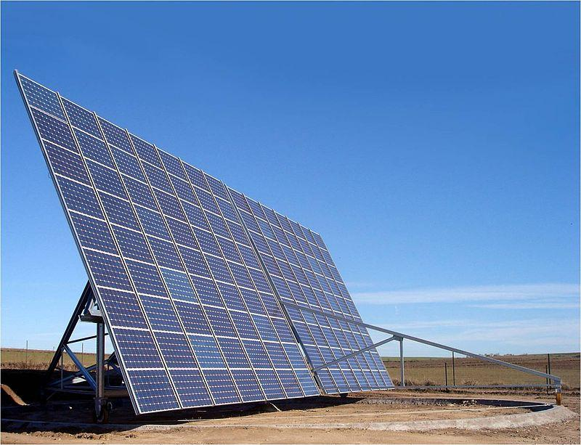

**Figure 1.** Azimuth altitude tracking solar panel.

A solar power station in Toledo, Spain, uses an azimuth-altitude tracker that has 2 degrees of freedom. This system is like what we want to implement with our project [2]. The solar panel seen above can rotate relative to the ground and tilt around a central axis parallel to its long edge. This enables the normal vector of the panel to face the sun during insolation. Research on tracker development is available. One of the reference sources we used is a paper published by two Worchester Polytechnic Institute Scholars called Azimuth-Altitude Dual Axis Solar Tracker [3].

This paper details the parts of a two-degrees-of-freedom tracker and MATLAB simulation code for power performance analysis. The main difference between these products and our project is the sensor. While the products find the optimal point by feedback from the power captured from the photovoltaic cells or estimating the sun’s position using trigonometric algorithms, our project will test for the brightness of the sun using the sensors on a mobile device. The key building blocks are the smartphone sensors, Android application that uses the processor to send the signal, and the motor controller circuit that receives the signal and moves the panel. Smartphone sensors that will be used are Ambient Light Sensor, Camera and possibly Acceleration and Magnetic Field.

**2. Project Description and Goals**

The fundamental purpose of this team would be to design a solar panel that can track the sun’s position and intensity to increase the efficiency of the solar panel. This solar panel would track the sun by making use of the phone's magnetometer, camera and its processor to determine the optimum angle and position the solar panel ought to be to work efficiently. The goal at the end of this project would be to design a system which could be integrated with an Android device to control a solar panel. The features of this system include:

* **A Solar panel that tracks the sun’s position in real time.**
* **Rotation of solar panel platform to the sun's position.**
* **Compatible with Android devices**
* **Phone application:** The phone application would contain information on the performance of the solar panel.
* **Phone charger:** The energy generated from the solar panel could be used to charge the phone operating it and any little gadget requiring power.

The targeted user of this product would be adventurers or hikers who would want to power up their devices. It could also be used by homeowners who make use of electricity to perform domestic duties at home. The targeted size of this product is expected to be less than eight foot cubed (can fit in a cube box with two foot vertices).

1. **Technical Specifications**

Please note that specifications listed below are targeted values. The values are subject to change.

|  |  |
| --- | --- |
| Specification | Value |
| Weight | 20 lbs |
| Dimensions | 15” x 15” x 15” |
| Solar panel dimensions | 11” x 8.5” |
| Solar panel average output | 3 V at 1 W (considering suboptimal sun conditions) |
| Azimuth angle range* | 0 to 360 degrees |
| Zenith angle range** | 0 to 90 degrees |
| Sun pointing accuracy | $±$ 5° |
| Phone hardware required | Camera (5 MP and above), Ambient light sensor, Accelerometer |
| Operating System | Android 4.4 KitKat or above |
|  |  |
|  |  |
|  |  |

*: The angle range assumes that North is 0 degrees, East is 90 degrees and West is 270 degrees.

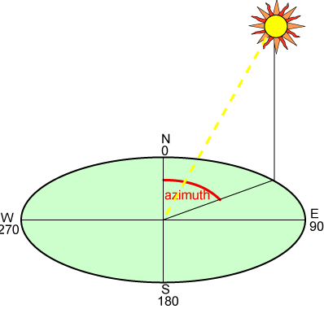

**Figure 2.** Azimuth altitude tracking solar panel.

**: 0 degrees is parallel to ground and 90 degrees is normal to ground.

1. **Design Approach and Details**

Please note that major components listed under respective sections are representative products. The components are subject to change.

* 1. **Design Approach**

The project has four main components: Smartphone sensors, application, motor controller and wood structure. The sensors detect brightness of the sun, the application provides interface and data to the user, the motor moves the solar panel and the controller drives the motor.

*4.1.1 Smartphone Application*

The Android application will be developed by a tool called MIT App Inventor. This software provides a practical interface to produce Android applications by implementing visual blocks that represent code statements [4]. The application is a critical part of the project since it provides the link between the user and the device. The development process takes six weeks to ensure unaccounted problems can be resolved. The first step in testing is to establish a serial port connection between the phone and the motor controller. Then, manual control feature will be implemented so that the phone can control the motors. Lastly, the SYNC feature where the algorithm locates the brightest spot and orients the solar panel will be added.

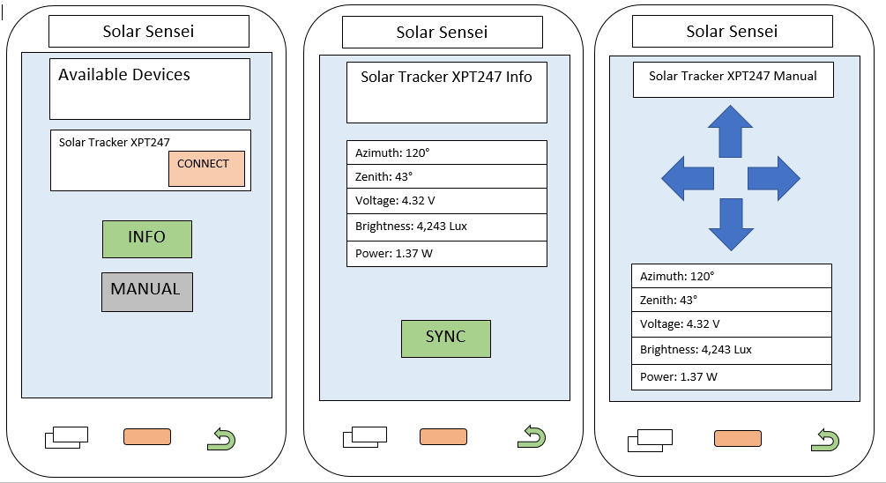

**Figure 2.** Solar Sensei Android Application Screens.

|  |  |
| --- | --- |
| **Table 1.** Specifications for the Smartphone | |
| Smartphone Sensor (Samsung S3) | |
| Item | Specification |
| Temperature Range | -4 to 122 F |
| Battery Capacity | 2100 mAh |
| Ambient Light Sensor (ALS)  Serial Interface | I^2C |
| ALS Dynamic Range | 0.0006 to 32,000 Lux |
| Serial Port (USB 2.0) | 480 Mbit/s |

The application will have three screens. The first screen is the connection setup where the link between the device and the solar panel is established. The second screen is an information display with a synchronization button that will move the panel to the optimal spot using sensor input. The third screen is the manual option to control the solar panel. The connection will be established via an USB or Bluetooth connection.

*4.1.2 Smartphone Sensors*

Samsung Galaxy S5 utilizes an ambient light sensor that adjusts screen brightness. For example, when the phone is used outside where sunlight creates glare on the screen, the adaptive display option increases the screen brightness. We intend to use this input along with the phone camera as a measure of sun’s brightness. Adaptive display option has an ambient light detector component which is an analog circuit that scales received light and represents it as a voltage factor so that the application can adjust lighting depending on the quality of the incident light.

A patent on ambient light sensor describes the device stages as a current amplifier circuit that receives light and a changeover control circuit that responds to the change in the amplified current so that light fluctuation is detected [6]. The way our project will utilize this sensor is that it will take a measurement in a certain position. It will record the brightness and move slightly and record the new brightness. If the new value is brighter it will move in that direction. If the previous value is higher, the panel will move back in the opposite direction and compare values. Once the maximum value is found, the panel will stay at that position. This operation will start once the SYNC button in the Android application is pressed.

Our group is in the process of developing a design for accessing the ambient light sensor through the development program. Our goal is to find the suitable class functions to access the readings from the ambient light sensor from the Android application.

*4.1.3 Motor and Controller*

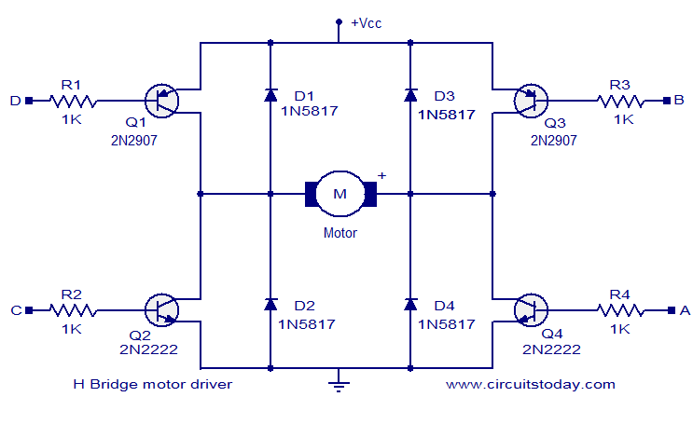

**Fig 3.** H-bridge Circuit.

Two Brushless DC motors would be used for this project. Each motor will be controlled by a H-bridge. A PWM signal is generated by the H-bridge by toggling a switch on the H-bridge. The duty cycle of the pulse determines the average value of the PWM signal. The input generated by the phone would toggle the H-bridge, thus creating an average voltage. Closed loop control for the motors will be achieved by using the quadrature encoders on the motor. The motors must be used to scan the environment for the highest intensity of the sun and must split these regions into smaller regions continually until the error between the angle of the sun and the normal angle to the frame is minimized. When the angle with respect to the solar panel for which the intensity of the sun is highest is found, the control algorithm must calculate the displacement of each axes to orient the frame in the direction of the sun and orient the motors accordingly.

|  |  |
| --- | --- |
| **Table 2.** Specifications for the Motor | |
| DC Motor (Hobby Gear Motor ROS-13302) | |
| Item | Specification |
| Suggested Voltage | 4.5 V DC |
| No Load Speed | 140 rpm |
| No Load Current | 190 mA |
| Max Load Current | 250 mA |
| Max Speed | 200 rpm |
| Torque | 800 gf-cm |

|  |  |
| --- | --- |
| **Table 3.** Specifications for the Motor Driver | |
| H Bridge Motor Driver (L293) | |
| Item | Specification |
| Max Input Voltage | 7 V DC |
| Output Voltage | -3 to 3 V |
| Continuous Output Current | -600 to 600 mA |
| Storage Temperature | -85 to 302 F |

*4.1.4 Wood Structure*

A wood rectangular prism will house the gears and shafts that move the solar panel plate located at the top of the structure. The DC driver motors turn the gears and are located near them. Motor controller circuitry is located at the top of the structure, beneath the solar panel plate. The wood structure will resemble the Internet Enabled Solar Tracker.

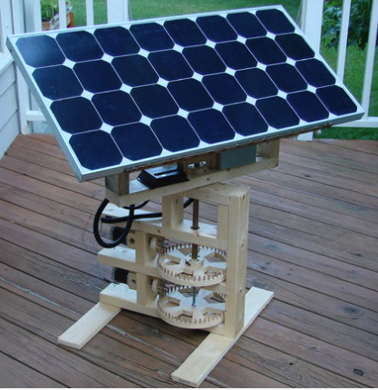

**Figure 4.** Internet Enabled Solar Tracker.

This part of the project will need interdisciplinary expertise in CAD files and wood/metal machinery.

* 1. **Codes and Standards**

The smartphone application should be user friendly.

* The software provides an informational interface to the user should carefully convey details about solar energy generation. We will follow Android API guidelines to ensure a good and clear user experience [7].

A standard that we will try to abide when designing our apparatus is IEEE’s Higher Performance Protocol for the Standard Digital Interface for Programmable Instrumentation [12]. This protocol is aimed at devices that have programmable and non-programmable electronic parts. Our project matches this description and is an instrument to detect sunlight.

* 1. **Constraints, Alternatives, and Tradeoffs**

Another design alternative that was considered was to attach a magnetometer and photo sensor to a microcontroller so that it could control the motors on the solar panel. The phone’s primary role would then be to display information from the solar panel. This approach was not selected as the first choice because the goal of the project is to enable the user to use their own, ready-made phone to orient the solar panel versus an externally attached microcontroller and sensors. The usage of the phone provides a more economical and user friendly approach to the design.

Sensor Cost: Since a smartphone ambient light sensor is required to detect the brightest orientation. A smartphone is needed for testing of the product setup.

Motor cost: In a 2-degrees-of-freedom model where the panel can rotate in z-x and x-y planes, 2 DC motors are required to control motion. The feedback mechanism with the motors introduces a significant cost to the project budget.

Alternatives:

As a contingency plan, the Adafruit Bluetooth LE application will be used in conjunction with a mBed LPC1768 microcontroller to use the device. This application has the manual control interface and buttons that can be received by the mBed and perform certain functions. For instance, the mBed can run a C++ code that synchronizes the solar panel when button number one is pressed from the Bluetooth application.

1. **Schedule, Tasks, and Milestones**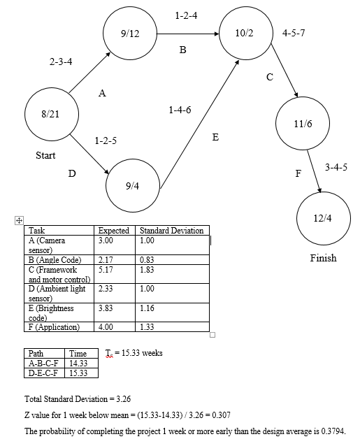

**Figure 5.** PERT chart for Smartphone Solar Tracker.

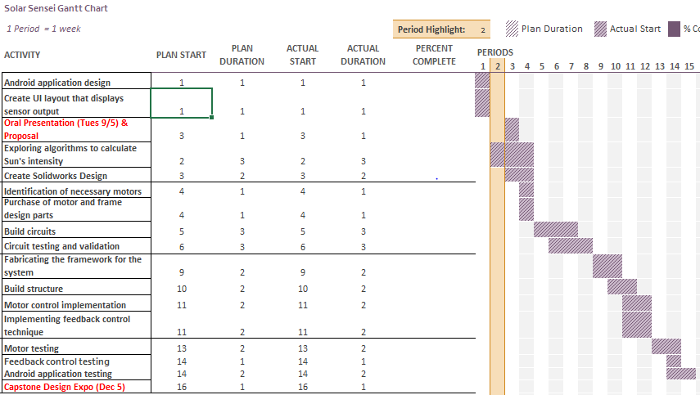

**Figure 6.** GANTT chart for Smartphone Solar Tracker.

1. **Project Demonstration**

This project will be demonstrated by manually changing the orientation and position of the solar panel. The solar panel will readjust itself in order to be oriented towards the position where the sun has maximum intensity. The project would be marked as successful based on the accuracy of the orientation of the solar panel.

The solar tracker would be turned on and remotely rotated about its axes using by sending commands from the application

* The source of illumination would be directed to the solar panel and then constantly changed and the response of the solar tracker to the varying illumination would be recorded
* The response rate of the solar tracker would be varied and the response of the tracker would be tested for varying positional illumination

Prototype testing will be done using sensors on an embedded chip (Texas Instruments/mBed) to control the motors. The motors must respond accordingly to the changing illumination on the light sensors.

1. **Marketing and Cost Analysis**
   1. **Marketing Analysis**

The concept of a solar tracker on a solar panel is not new, there are several existing industries invested in producing solar panels with tracker. Most industries make use of expensive sensors, microcontrollers and smart motors to track the sun’s position. Solar trackers like Zomeworks Passive Tracker and Universal Track Rack UTRF all make use of such expensive methods of tracking the sun. Making use of such trackers, increases the cost of their product. The team has come up with, redesigning and repurposing a smartphone which many people possess for the sole purpose of tracking the sun which is a major selling point for our product. This idea, makes the final product cheaper than that of our competitors and offers a better compact size for the sensors.

|  |  |  |
| --- | --- | --- |
| **Table 4**. Competitor Selling Price Per Unit | | |
|  | **Zomeworks Passive Tracker UTRF-72** | **Universal Track Rack UTRF-090** |
| **Price** | $1,582.88 [8] | $2,050.00 [9] |

* 1. **Cost Analysis**

The total component cost for the project is $568. A breakdown of the parts is shown in Table 5. The total development costs are also shown in Table 6. It takes into consideration the cost of each part and values each hour of work at $40.

|  |  |  |  |
| --- | --- | --- | --- |
| **Table 5.** Cost of Components | | | |
| Product components | Quantity | Price ($) | Total Price ($) |
| Motor driver circuit | 1 | 300 | 300 |
| Phone | 1 | 150 | 150 |
| Micro- Controller | 1 | 60 | 60 |
| Wooden Frame | 20 board feet | 3.25/board foot | 64 |
| Motors | 2 | 56 | 112 |
| Gear Boxes | 2 | 49 | 98 |
| **Total Cost** |  |  | **784** |

|  |  |  |  |  |
| --- | --- | --- | --- | --- |
| **Table 6.** Development Costs | | | | |
| **Processes** | **Hours** | **Labor Cost ($)** | **Parts Cost ($)** | **Total Costs** |
| **Mechanical design** |  | | |  |
| CAD Design | 25 | 1200 |  | 1200 |
| Machining of Wooden Parts | 20 | 800 |  | 400 |
| Wooden frames, and Motors |  | | 176 | 176 |
| Frame Assembly | 15 | 600 |  | 600 |
| **Electrical design** |  | | |  |
| Circuit design | 10 | 400 |  | 400 |
| Board Fabrication | 20 | 800 |  | 800 |
| Motor driver circuit, and microcontroller,sensors |  | | 392 | 392 |
| Simulation / testing | 30 | 1200 |  | 1200 |
| **App development** |  | | |  |
| Coding | 90 | 3600 |  | 3600 |
| Debugging | 30 | 900 |  | 900 |
| Play Store Developer License |  | | 25 | 25 |
| Group meetings | 50 | 2000 |  | 2000 |
| **Total** |  | | | 11,693 |

The total development cost of the project including cost of materials, labor, and overhead comes down to $20,877 as shown in Table 6. The overhead for the project is set at 120% and the fringe benefit % of labour is 30.

|  |  |
| --- | --- |
| **Table 7. Total Development Costs Accounting for Fringe Benefits and Overhead** | |
| **Development Component** | **Cost ($)** |
| Parts | 568 |
| Labor | 11,125 |
| Fringe Benefits, % of Labour | 3,337.5 |
| Subtotal | 14,462.5 |
| Overhead, % of Materials, Labor and Fringe Benefits | 16,687 |
| **Total** | **31,150** |

Finally, Table 8. shows the total cost and profit per unit assuming 5,000 units would be produced over a period of five years. Assuming a discount on the components of the design, as the units produced increase and assuming due to increased efficiency in production and economies of scale, each unit costs $80, and labor costs $40. The sales tax is 6% of the final selling price and the overhead as before is 120% . The amortized costs accounts for costs spent on developing the product over the five-year period. The tables show a profit of $65.6 which leads to a profit of $328,000 over five years, all conditions being equal.

|  |  |
| --- | --- |
| **Table 8. Selling Price and Profit Per Unit (Based on 5,000-unit production)** | |
| **Item** | **Costs ($)** |
| Parts | 80 |
| Assembly & Testing Labor | 40 |
| **Subtotal Labor** | 40 |
| Fringe Benefits | 12 |
| **Subtotal** | 132 |
| Overhead, % of Material, Labor & Fringe | 158.4 |
| **Subtotal** | 290.4 |
| Sales Expense | 24 |
| Amortized Development Costs | 20 |
| **Subtotal, All costs** | 334.4 |
| Profit | **65.6** |
| **Selling Price** | **$400** |

8. **Current Status**

After solidifying the goals for the design, the team has begun identifying ways to extract relevant data from the phone’s magnetometer and camera API to send instructions to the motors and display generated power and temperature info on the app.

9. **Leadership Roles**

The leadership roles on the team are as follows:

* Webmaster: Gideon
* Expo Coordinator: Gideon
* Documentation Coordinators: Yusuf, Gideon
* Photoreceptor Design Lead: Gideon
  + Interpret the sun’s light intensity using the phone’s camera
* Software Design Lead: Asier
  + Display solar panel info such as power generated and temperature
* Mechanical Design Lead: Chidi
  + Motor implementation and maneuverability of the solar panel
* Sensor Integration Lead: Yusuf
  + Consolidate phone’s magnetometer and camera with the motors

11. **References**

[1] MidnightMaker, "Internet Enabled Solar Tracker", *Instructables.com*, 2017. [Online]. Available: https://www.instructables.com/id/Solar-Tracker-in-the-Internet-Cloud/. [Accessed: 04- Mar- 2017].

[2] Ignacio Luque-Heredia et al., "The Sun Tracker in Concentrator Photovoltaics" in Cristobal, A.B.,Martí, A.,and Luque, A. *Next Generation Photovoltaics*, Springer Verlag, 2012 [[ISBN 978-3642233692](https://en.wikipedia.org/wiki/Special:BookSources/9783642233692)]

[3] A. Catarius and M. Christiner, *Azimuth-Altitude Dual Axis Solar Tracker*, 1st ed. Worchester Polytechnic Institute, 2010.

[4] "MIT App Inventor | Explore MIT App Inventor", *Appinventor.mit.edu*, 2017. [Online]. Available: http://appinventor.mit.edu/explore/. [Accessed: 14- Apr- 2017].

[5] D. Graziano, "Choose the right screen mode on the Galaxy S5", *CNET*, 2017. [Online]. Available: https://www.cnet.com/how-to/choose-the-right-screen-mode-on-the-galaxy-s5/. [Accessed: 04- Mar- 2017].

[6] Rohm Co., Ltd., "Ambient light sensor", US 8003930 B2, 2011.

[7] I. Android, "Introduction to Android | Android Developers", *Developer.android.com*, 2017. [Online]. Available: https://developer.android.com/guide/index.html. [Accessed: 14- Apr- 2017].

[8] Zomeworks, UTRF-72. "Zomeworks, Universal Track Rack Passive Tracker, UTRF-72". *Invertersupply.com*. N.p., 2017. Web. 14 Apr. 2017.

[9] LLC, Green. "UTRF090, Universal Track Rack, Passive Solar Tracker, 90 Sq. Ft. Module". *SaveGreenMoney.com*. N.p., 2017. Web. 14 Apr. 2017.

[10] IEEE Guide: Test Procedures for Direct-Current Machines," in *ANSI/IEEE Std 113-1985* , vol., no., pp.1-38, Dec. 21 1984

doi: 10.1109/IEEESTD.1984.81710

keywords: {dc;machines;test},

URL: <http://ieeexplore.ieee.org/stamp/stamp.jsp?tp=&arnumber=574827&isnumber=12443>

[11] Petrow.A, “How to set a price from your woodworking projects from your home workshop”, [Online]. Available:<http://www.rockler.com/how-to/set-price-woodworking-projects-home-workshop/> [Accessed: 14- April-2017]

[12] Standards.ieee.org. (2017). IEEE SA - 60488-1-2004 - IEC/IEEE 60488-1 Ed.1 (IEEE Std 488.1(TM)-2003): Higher Performance Protocol for the Standard Digital Interface for Programmable Instrumentation - Part 1: General. [online] Available at: http://standards.ieee.org/findstds/standard/60488-1-2004.html [Accessed 29 Aug. 2017].