**Light Emitting Navigation System**

Senior Design Final Report

LENS

Dr. James Hamblen

Dr. Brian Gay

Malavika Bindhi

David Clyde

Anushri Dixit

Daniel Fulford

James Fulford

Muhammad Islam

Submitted

May 3, 2017

**Table of Contents**

**Executive Summary**.......................................................................................................... 3

1 **Introduction**......................................................................................................... 4

1.1 Objective................................................................................................................ 4

1.2 Motivation.............................................................................................................. 5

1.3 Background............................................................................................................ 6

2 **Project Description and Goals**................................................................................ 7

**3 Technical Specifications & Verification**................................................................. 8

**4 Design Approach and Details**

4.1 Design Approach................................................................................................... 10

4.2 Codes and Standards.............................................................................................. 18

4.3 Constraints, Alternatives, and Tradeoffs............................................................... 18

**5 Schedule, Tasks, and Milestones**............................................................................ 20

**6 Final Project Demonstration**.................................................................................. 21

**7 Marketing and Cost Analysis**

7.1 Marketing Analysis................................................................................................ 23

7.2Cost Analysis......................................................................................................... 24

**8 Conclusion**................................................................................................................ 27

**9 Leadership Roles**..................................................................................................... 29

**10 References**................................................................................................................ 30

**Appendices**

Appendix A......................................................................................................................... 34

Appendix B......................................................................................................................... 36

Appendix C......................................................................................................................... 37

Appendix D......................................................................................................................... 38

**Executive Summary**

The following report will present a detailed discussion of the Light Emitting Navigational System (LENS) project that was developed on the idea presented by Dr. Brian Gay. This document will provide the reader with a full understanding of the purpose and function for LENS. The background and motivation behind this project will be shown to the reader so that they can quantify this system’s utility. A full description and function of the device will be presented followed by the team’s goals for LENS device. The reader will then be presented the detailed specifications of the components and design for the headgear apparatus. Next, the design scheme of the LENS device is shown to inform the reader of how the components and headgear apparatus are laid out so that a better visual understanding can be had of the device. The code and standards that are used within LENS will also be revealed here. The reader will then be able to follow how the team planned and worked to accomplish the final product that has been explored thus far. A proof of concept is shown through demoing by the public at the Georgia Institute of Technology Design Expo. This event is discussed with the reader to provide a real-life use example of LENS and how well it performs. Next to last, a marketing and cost analysis is performed to reveal the potential customers of LENS and the price tag that comes with the device. Lastly, the document will be re-summarized along with major components of this report being restated.

**Light Emitting Navigation System (LENS) for the Visually Impaired**

**1. Introduction**

The LENS team designed a headgear to be worn by a visually impaired user to provide navigational assistance. Specifically, the device provides real-time audible feedback to alert the user of walkway obstacles, so the user can safely navigate in his or her environment. The team spent a total of $486.98 to develop this prototype.

* 1. **Objective**

The team designed and implemented a prototype headgear that utilizes light detection and ranging, or LIDAR, sensor technology to detect objects and provide sensible feedback to the user in audio format. The wearable headgear housing for all the electronics of the system followed a similar design scheme as seen with virtual reality headsets available today. These headsets normally support cellular phones or tablets and so they provide adequate support and comfort to be worn for extended periods of time. The headgear uses a closed loop system handled by an MBED microcontroller that processes the input from one LIDAR sensor and six time of flight sensors into audio feedback sensed by the user. As the user walks, the headgear provides intuitive feedback using cello notes that alerts the user based on distance to obstacles that allows the user to adjust their walking trajectory appropriately.

* 1. **Motivation**

The most common technology used by the visually impaired today consists of a cane or a dog travel guide. The sponsor for this project, Dr. Brian Gay, recalls an event he once visited that was hosting a visually impaired navigation experience. During this event, they gave patrons like Brian a walking stick and then would turn off the lights in several rooms and allow each patron to navigate in the dark in order to simulate the visually impaired experience. Brian summarized his experience as enlightening and spent his ride home after the event trying to conceptualize an idea that would be commercially cost effective and superior to a walking stick. He finally came up with a basic idea that involved headgear, detection sensors and sound that would alert the user in a superior navigation system compared with a walking stick. Other options for the visually impaired exist that are available and improve walking sticks using ultrasonic sensors [1]. However, low hanging objects still remain a major source of head injury for the visually impaired [2]. The team succeeded in creating a device that can prevent any head injury. Furthermore, expensive visual prosthesis are being developed that seek to provide some actual vision back, but these are not viable for all the visually impaired and cost over 100,000$ [3][4]. The team’s design did not completely remove the need for a cane but the design did succeed in preventing head injuries for the visually impaired.

* 1. **Background**

There are many researchers developing and improving electronic travel aids (ETAs) to help the visually impaired navigate through their surroundings. Benjamin et al created a cane which uses laser beams to detect overhead objects, waist level obstacles, and drop-offs [5]. The Ecole Polytechnique Fédérale de Lausanne (EPFL), is a shoulder-mounted ultrasound system with vibration motors to provide feedback for the user [6]. In the journal article “Multi-Section Sensing and Vibrotactile Perception for Walking Guide of Visually Impaired Person,” an ETA is presented. The system created by Gu-Young Jeong and Kee-Ho Yu, uses only ultrasonic sensors where the user wears on their head. Tactile feedback is provided to the user’s hands using vibration motors. Tests were performed by blind individuals and feasibility was confirmed if sensory distance was increased and a learning period was provided [5]. Most ETA projects implement ultrasound as their range finders [5]. The team’s early testing of sensors led to the assertion that ultrasonic sensors are not sufficiently accurate and are sensitive to circuit and sound interference especially when using more than one sensor. Thus, the team opted for the more accurate and stable readings of LIDAR sensors and time of flight sensors.

1. **Project Description and Goals**

The major goal for this team was to design an autonomous navigational system for people with impaired vision that improves typical navigation and prevents head injuries. The navigational system consists of headgear, microcontroller, LIDAR and time of flight sensors, and speakers. The headgear was designed and fabricated following a similar design scheme as modeled by virtual reality headsets. The headgear is a platform for the system to be installed on. The MBED microcontroller is programmed to take readings from the LIDAR sensor and the time of flight sensors. The initial design was to allow the user to select between vibrotactile and audible feedback but the team found that the vibration motors were too confusing to the user so we opted to remove the haptic feedback completely and only use audio feedback. Distance readings from the sensors tells the microcontroller what volume to play each note and to which speaker. The system uses two speakers one on the right and left side of the headgear. There are seven sensors in total and each sensor will play its own musical note. The sensor array is setup where the sensors on the right side of the headgear will only play notes through the speaker on the right side and the same for the sensors and speaker on the left side.

The Project goals are as follows:

**General**

* The user will feel more comfortable navigating in their environment
* Low cost to enhance affordability

**Range Finding Sensors:**

* One LIDAR sensor and six time of flight sensors for object detection
* An array of sensors to enhance resolution
* Optimized power consumption via cycled pulses

**Audio Feedback**

* Variable volume based on distance
* Play a different musical note based on which sensor is detecting an obstacle

1. **Technical Specifications**

|  |  |  |
| --- | --- | --- |
| **Table 1.** Head Gear and System Housing Specifications | | |
| **Feature** | **Proposed Specification** | **Measured Specification** |
| Dimensions | 17cm x 13cm x 9cm | 24.51cm x 14.02cm x 8.51cm |
| Weight | 450g -550g | 635g |
| Material | Plastic and Aluminum | ABS Plastic |

|  |  |  |
| --- | --- | --- |
| **Table 2.** Lidar and Time of Flight sensor | | |
| **Feature** | **Proposed Specification** | **Measured Specification** |
| Lidar Obstacle detection range | 0.1m – 35m | 0-3m (40m max) |
| Time of Flight detection range | unproposed | 30mm-1.2m |
| LIDAR Sensor Voltage | 4V- 6V | 5V |
| Time of Flight voltage | unproposed | 3.3V |
| Lidar Dimensions | unproposed | 2cm x 4.8cm x 4cm |
| Time of Flight Dimensions | unproposed | 2.1cm x 1.8cm x 0.28cm |

|  |  |  |
| --- | --- | --- |
| **Table 3.** Speakers and amplifier | | |
| **Feature** | **Proposed Specification** | **Measured Specification** |
| Style | earbuds | Loudspeaker |
| Speaker Dimensions | unproposed | 3cm x 7cm x 1.7cm |
| Weight | unproposed | 25g |
| Impedance | > 10 Ω | 4 Ω |
| Amp Gain | unproposed | 6dB (selectable up to 18dB) |
| Amp Dimensions | unproposed | 2.83cm x 2.42cm x 0.3cm |

|  |  |  |
| --- | --- | --- |
| **Table 4.** Battery | | |
| **Feature** | **Proposed Specification** | **Measured Specification** |
| Brand | unproposed | Romoss |
| Dimensions | unproposed | 4.86cm x 8.97cm x 2.14cm |
| Style | unproposed | USB |
| Battery Supply | 7.4V – 8.2V | 2000 mAh – 3000 mAh (Li -ion) | 4000mAh - 5V @ 1A |
| Weight | unproposed | 126.7g |

|  |  |  |
| --- | --- | --- |
| **Table 5.** Closed Feedback System Specifications | | |
| **Feature** | **Proposed Specification** | **Measured Specification** |
| MCU Processing Speed | > 96 MHz | 100 MHz |
| MCU Operating Voltage | 5V | 5V |
| Obstacle detection range | 0.1m – 35m | 0-3m |
| Operating Life | 8 – 12 Hrs (continuous use) | 7 Hrs (continuous use) |
| MBED Dimensions | unproposed | 4.4cm x 2.6cm |
| Codec Dimensions | unproposed | 2.8cm x 5.8cm |
| Codec Voltage | unproposed | 5V |
| MBED Voltage | 5V | 5V |

1. **Design Approach and Details**
   1. **Design Approach**

*System Overview*

The LENS prototype consists of the speakers (Figure 3), a headgear apparatus (Figure 10), mbed microcontroller (Figure 4), Time of Flight sensors (TOF) (Figure 6), LIDAR sensor (Figure 5), DSP codec chip for audio (Figure 2), and rechargeable battery pack (Figure 7). Figure 1 displays the entire LENS feedback system.

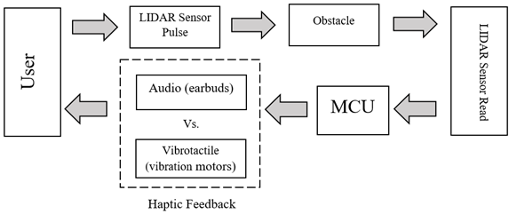

**Figure 1.** Block diagram for closed loop navigation system LENS using audio feedback.

The LENS project uses auditory feedback. With audio feedback, a cello note will be played. Each note will be played constantly while varying the volume of the note produced. The note volume will be played at a linear rate in relation to varying distance. The volume will be increased as the object draws closer. As the object moves away, the volume will decrease to silence outside 10 feet. The cello note will be sent to left and right speakers for hearing. The array of 7 sensors will play individual distinct notes. Outer TOF sensors (Figure 6) play a low C note. Middle TOF sensors play an E note. The center most TOF sensors play a G note. Finally, the LIDAR sensor (Figure 5) will play a high C note. Depending on which sensor is activated, response notes are played on the corresponding side speaker, either left or right. Center LIDAR activation will play a response on both speakers (Figure 3). The cello notes are produced from MIDI files stored on the VS1053 Codec as seen in Figure 2. The MIDI files stored on the Codec are much like the sounds found on an electric keyboard, thus resulting in pleasing tones.

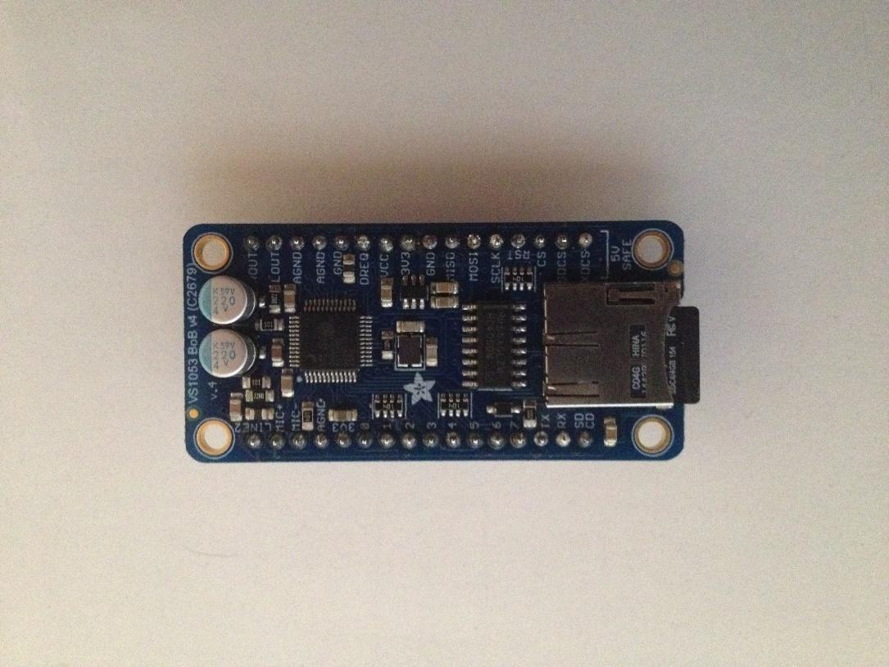

**Figure 2.** Adafruit VS1053 Codec used to decode saved sound files on a MircoSD card

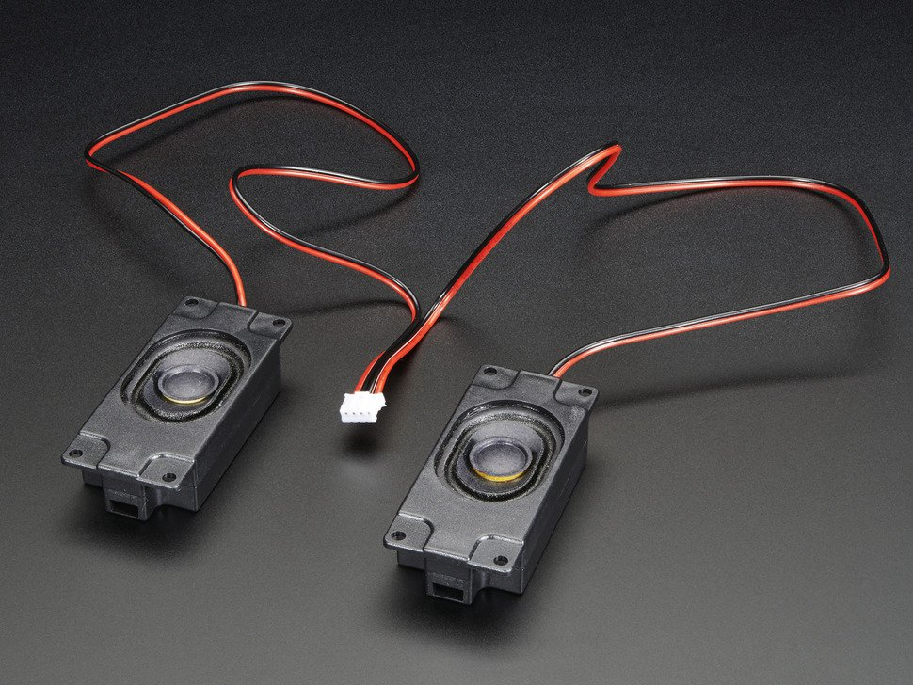

**Figure 3.** Stereo speakers used for audio feedback

Figure 9 displays the internal hardware components for the feedback system. Sensor orientation was calculated and modeled in SolidWorks. The main housing and sensor housing (Figures 10 and 11) were 3D printed in similar dimensions to the original VR-based prototype. The main LIDAR sensor is positioned in the middle with three time of flight sensors mounted to the left and right. This was the final sensor array after excluding ultrasonic sensors. The final prototype made use of three PCB’s to finalize the feedback circuit. The internal circuit boards connected the mbed microcontroller, audio codec, audio amplifier, volume control buttons, micro USB breakout, and all of the range finding sensors. Those boards were then fitted into the main housing.

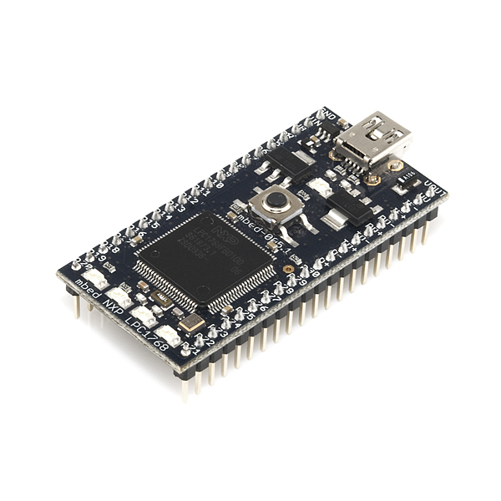

**Figure 4.** MBED microcontroller used to handle system processing

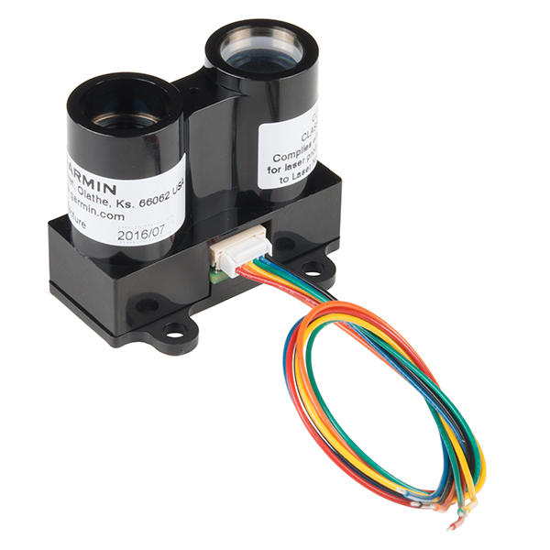

**Figure 5**. LIDAR long ranging sensor

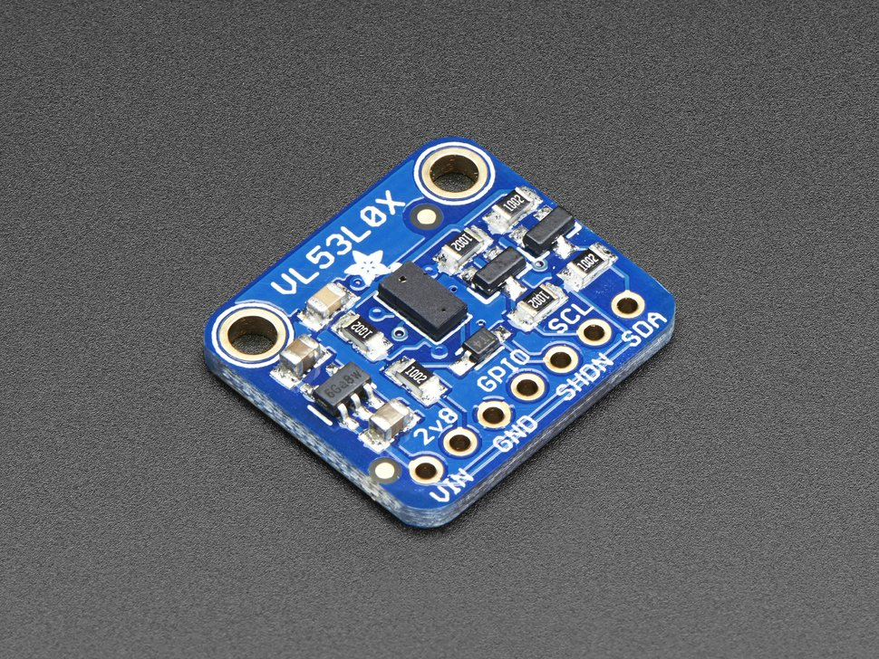

**Figure 6.** VL53L0X LIDAR based Time of Flight Sensor

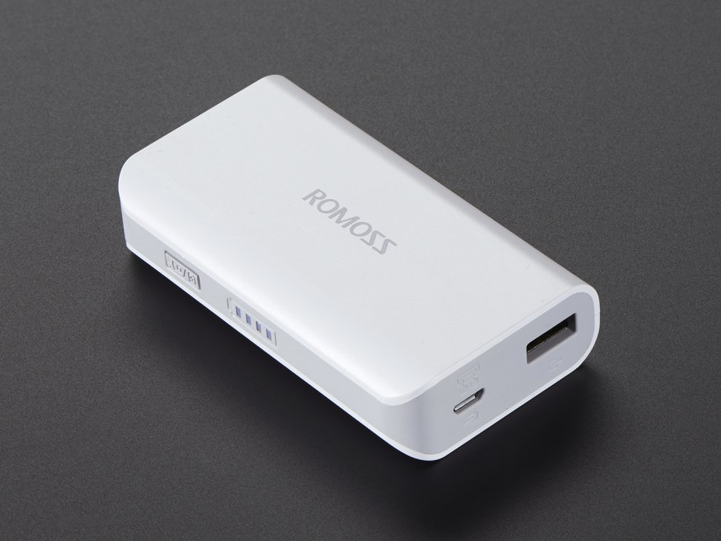

**Figure 7.** Romoss USB Battery Pack 5V 4000 mAh

The sensor array is connected by soldering header pins where jumper wires were connected. These header pins are connected to their corresponding pins on the microcontroller. The sensor array was installed in the front cover. The front cover was then attached to the main housing with two screws on the top and bottom.

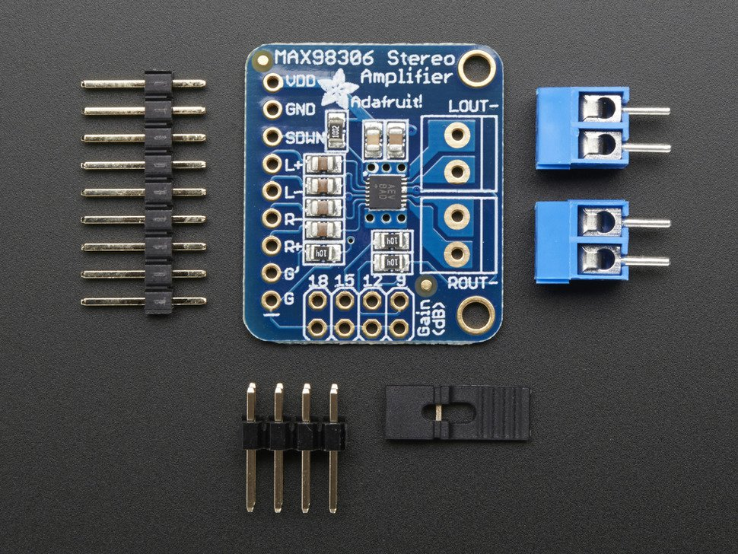

**Figure 8.** MAX98306 Stereo Amplifier

The micro USB breakout is where the battery connected. The battery wire was fed down through a hole into the main housing where the micro USB breakout was installed (Figure 10). The micro USB breakout supplied power to the Mbed microcontroller and audio power amplifier separately (Figure 8). This was done to prevent the microcontroller from shutting down when the amplifier began to draw too much current.

The VS1053 Codec and amplifier were installed on the second separate PCB board. The two buttons were soldered on a mini “Tic Tac” PCB as shown to the far right of Figure 3. The three PCBs used in this system were all connected using cut to length, 22 gage wire, where grounds, voltages, and digital pins were linked to their necessary ports.

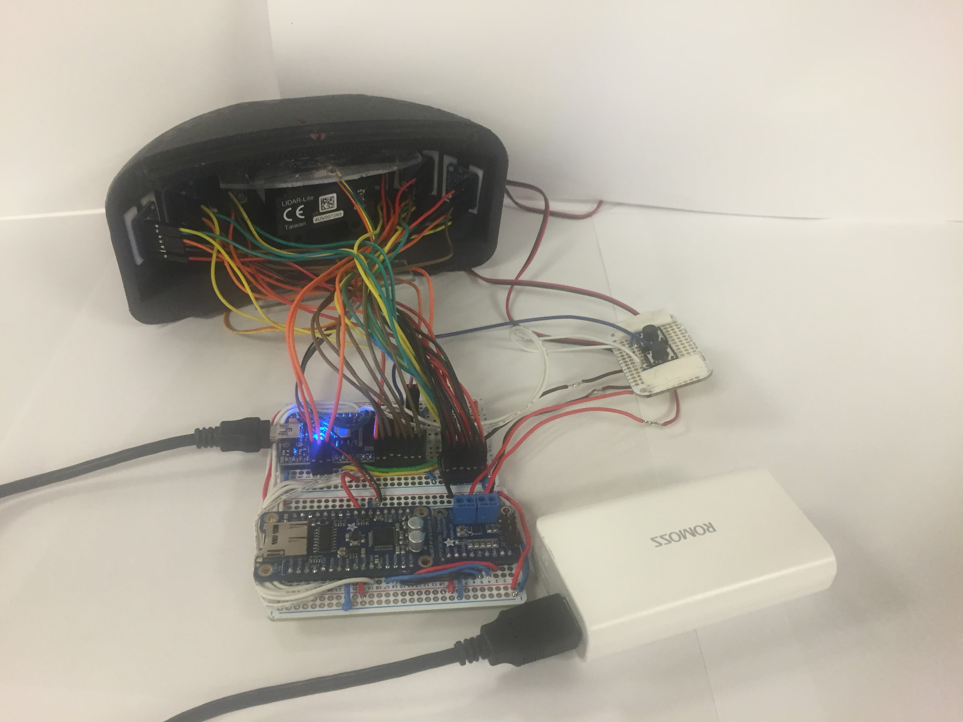

Codec

Class D Amp

MBED

Battery

Volume Buttons

LIDAR

TOF

**Figure 9.** All internal circuit components underlying LENS feedback system.

Figures 10 and 11 displays the final assembled prototype. The battery pack was mounted to the rear of the headset to help counterbalance the weight in the front. Speakers were mounted externally in custom fabricated side wings attached to the main housing. Headset straps contained extra padding compared to previous prototypes to enhance user comfort.

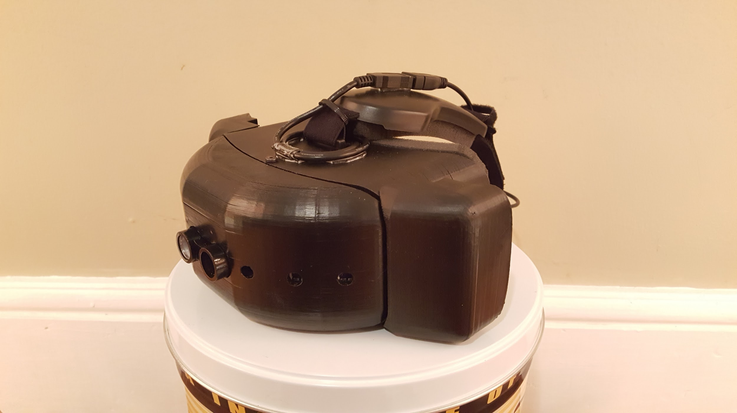

**Figure 10.** ¾ view of prototype showing sensors mounted and speaker side wings.

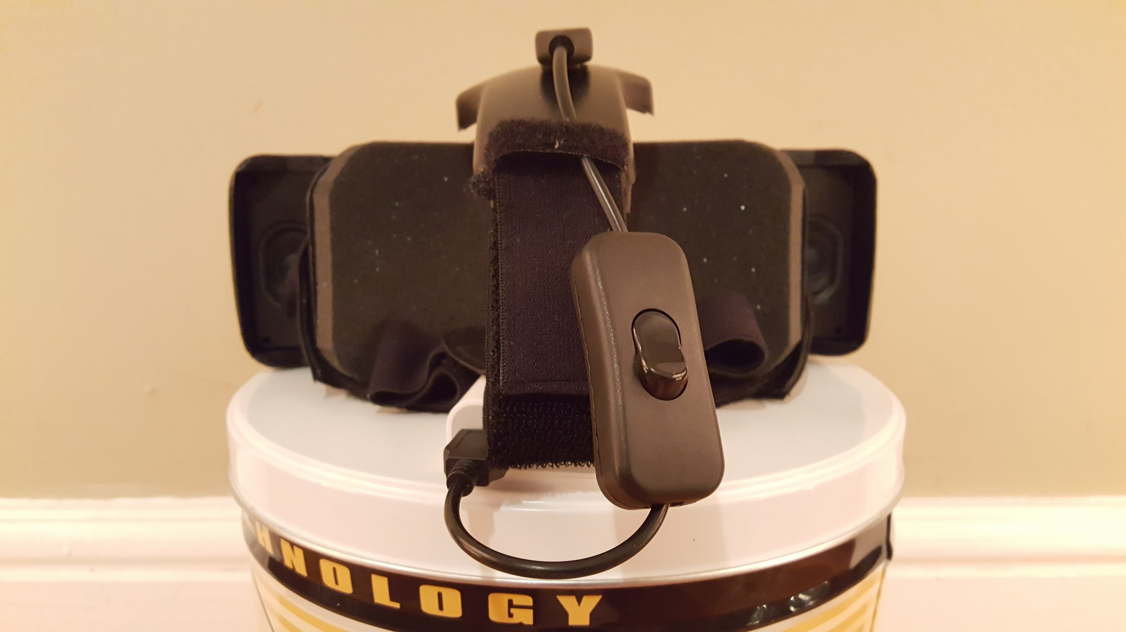

**Figure 11.** Rear view of LENS system displaying power switch, foam padding, and headstrap.

* 1. **Codes and Standards**

**I­2C Communication Protocol**

* A serial protocol to share data between the LIDAR sensor and microcontroller.
* Allows multiple slave integrated chips to communicate with multiple masters [7].
* I2C bus specification details the connections, protocols, formats, addresses, and procedures that define the rules on the bus.
* Also used for communication between Time of Flight sensor and microcontroller.

**Universal Serial Bus (USB)**

* For communication between microcontroller and PC.
* This was used to transfer the software from PC to microcontroller.
* High-speed signaling bit rate of 480Mbps [8].

**Inter-IC Sound (I2S)**

* Serial bus interface standard used for communication with VS1053 [9].
* This interface is used to only handle external DAC.

**Serial Peripheral Interface Bus (SPI)**

* For communication between VS1053 Codec and Mbed microcontroller.
* SPI this bus operates with a single master and one or multiple slaves.
* This interface forces the communication between the microcontroller and codec to be in sync with regards to the clock and data.

**Musical Instrument Digital Interface (MIDI)**

* Standard that describes protocol for communication between electronic musical instruments and computers [10].
* MIDI sounds were utilized to provide feedback to user.
  1. **Constraints, Alternatives, and Tradeoffs**

An alternative to the Time of Flight (ToF) sensor was the ultrasonic sensor. The team used the ToF sensors in addition to the main sensor, LIDAR so that the device would have a greater field of view. For this purpose, the team also considered using ultrasonic sensors that were easier to interface. However, the ToF sensors proved to be far superior in terms of distance measurement. They were less susceptible to crosstalk. Hence, the ToF sensors proved to be a better choice for the device despite the range of the ultrasonic sensor being higher than that of the ToF sensor.

In addition to audio feedback, the team also considered using vibrational haptic feedback. The haptic driver was easier to use than the MIDI files for audio feedback. However, the address for the haptic driver could not be changed at all. If the team wanted to use multiple haptic drivers through the same I2C line, an I2C multiplexer would be needed. An I2C multiplexer would slow down the device feedback. Due to this, vibrational feedback was not used at all. It should be noted, however, that in the future, there is a possibility of including vibrational feedback in addition to audio feedback if need be.

1. **Schedule, Tasks, and Milestones**

Team LENS completed the project during spring 2017. Appendix A shows the task breakdown and person in charge of each task along with difficulty/ risk level of the task. As seen in this table, the amount of work was almost equally distributed and everyone was given tasks for each week. A GANTT chart describing the timeline and milestones is shown in Appendix B. This also shows the critical path and durations of each task.

1. **Project Demonstration**

Criteria for demonstration:

* Successful navigation through an unknown environment,
* Successful navigation by multiple people,
* Longevity of headgear (7 – 9 hours of regular use)

The demonstration of the prototype was done at the Capstone Design Expo. The main criterion for evaluation was ease of navigation through any indoor environment. All the people who stopped by at the expo to find out more about the device were encouraged to wear it and try to navigate through the setting. This was a continuously changing environment because people were moving through halls at all times. This allowed the users to be completely unaware of who was around them. However, it was noted that because the setting was so crowded, there was a lot of noise in the background and the readings (audio feedback) were changing too quickly.

The team set up an environment that would emulate an indoor, quieter setting by using indoor privacy walls to separate the user from the crowded environment. The task was to navigate through the two privacy walls to the outside, crowded hall and continue navigating till the user came across an obstacle. If at the end of the task, the user had walked through the walls without colliding with an obstacle, the test was considered successful. [Here](https://mobile.twitter.com/GeorgiaTech/status/856991317997494272?ref_src=twsrc%5Egoogle%7Ctwcamp%5Eserp%7Ctwgr%5Etweet) is a link to the successful navigation by a completely unbiased user, from Georgia Tech’s social media staff. The longevity of the device was another criterion for successful demonstration. To test the lifespan, the device was aimed at a wall just barely within range for audio so it continuously played a “High C” note for all seven hours. Furthermore, it was aimed in the path of a high traffic area so it often produced other sounds. It is unlikely that device will be used continuously for more than seven hours. Thus, the team is confident that the device would last a full eight hours of normal use or more.

In addition to the aforementioned criteria, there were some changes from the proposed technical specifications. Mainly, the device was supposed to detect obstacles up to 35m. However, the device measures only up to 3m because this range seems to be more than enough to detect obstacles in the way and allow accurate navigation. The team also decided to use loudspeakers for audio feedback instead of ear buds because this allows the user to still be aware of his/her surroundings, which is not the case with ear buds.

1. **Marketing and Cost Analysis**
   1. **Marketing Analysis**

285 million people are estimated to be visually impaired worldwide according to statistics provided by the World Health Organization [11].  Out of this, 39 million are blind, while the other 246 million have low vision. LENS would be targeting this population, to provide them better quality of life. Some similar products have been developed to assist visually impaired people with navigation. Haptic Assisted Location of Obstacles (HALO) is a device developed by Steve Strubing and uses vibrations as the output, informing the user about the presence of an obstacle in his/her path [12]. This device uses an Arduino MEGA 2560 microcontroller. The product is still in the development stage, but the current testing results show the discomfort and confusion caused by haptic feedback. A similar commercial product, called iGlasses Ultrasonic Mobility Aid, is also available and costs $130. This product is developed as a secondary assistive device which would complement a traditional cane or guide dog [13]. The use of musical notes instead of haptic feedback differentiates these products from LENS. Musical notes, which are more soothing to the ears, would remove the discomfort caused by vibrations. The use of Cello notes for a musical feedback is more pleasing to the user. The proposed design for LENS was intended to be used independently. Due to the limitation of detecting holes on the ground, the current design would be more appropriate if used with a cane or a guide dog. Thus, this product would help with avoiding any collisions of the upper body with obstacles. Another similar project is an object detection and guidance system for the visually impaired by Al-Shehabi et al. [14]. They use a Microsoft Kinect Sensor, a tablet PC and an ATMEL XMEGA A1 microcontroller to develop a headgear for the visually impaired. The use of Kinect causes portability issues. Smaller sensors used in LENS eliminate this problem.

* 1. **Cost Analysis**

*Parts and Materials*

The materials needed to create a headgear prototype are given in Table 1 along with their unit costs. The most significant cost was that of the LIDAR. The prices given for fabrication materials and circuit materials are approximate.

**Table 1. Component costs for prototype**

|  |  |
| --- | --- |
| **Parts** | **Cost** |
| Microcontroller [15] | $60.66 |
| LIDAR sensor [16] | $149.99 |
| Codec [17] | $40.99 |
| Time of Flight sensors (x6) [18] | $107.88 |
| Battery and Speaker + Amplifier [19][20][21] | $57.46 |
| Circuit components (resistors, capacitors, wires, PCB, etc.) | $30 |
| Fabrication and packaging materials (plastics, etc.) | $40 |
| **Total** | **$486.98** |

*Development Costs*

The total development cost of the headgear was $63,534. The team consisted of 6 members, and the estimated hours worked on the project by each member are given in Table 2. Assuming a labor cost of $40/hour, the total development costs have been calculated in Table 3.

**Table 2. Development hours for the group**

|  |  |  |  |
| --- | --- | --- | --- |
| **Tasks** | **Labor hours per person** | **Labor cost per person** | **Total cost for six members** |
| Weekly meetings and reports | 30 | $1,200 | $8,400 |
| Presentations | 1 | $40 | $240 |
| Building circuit | 25 | $1,000 | $6,000 |
| Circuit testing | 10 | $400 | $2,400 |
| Software development | 20 | $800 | $4,800 |
| Code debugging | 5 | $200 | $1,200 |
| **TOTAL** | **91** | **$3,640** | **$21,840** |

With 30% fringe benefits and the overhead costs of materials and labor 120%, the total development cost was calculated as shown in Table 3. The total is $63,534.

**Table 3. Total development costs**

|  |  |
| --- | --- |
| **Development Component** | **Cost** |
| Parts | $487 |
| Labor | $21,840 |
| Fringe benefits, % of labor | $6,552 |
| Subtotal | $28,879 |
| Overhead, % of material, Labor, and Fringe benefits | $34,655 |
| **Total Development Cost** | **$63,534** |

If 5000 units are sold over a 5-year period, the profits are calculated as shown in Table 4. When bought in bulk, the total parts cost is reduced to $450. If the headgear were sold for $1200 per unit, a profit of $42 per unit would be made. With technicians working on assembly and testing for $30/hour, and advertisement costing 5% of the selling price, the subtotal is $1076 for each unit. While $1200/unit is much higher than the cost of similar headgears available in the market currently, this is the only headgear that provides full autonomy without a cane.

It should also be noted that the team sponsor, Dr. Brian Gay, wants to sell this product potentially without making a profit. In this case, the price would be reduced to $1158/unit.

**Table 4. Selling Price and Profit per unit**

|  |  |
| --- | --- |
| **Parts Cost** | **$450** |
| Assembly labor | $20 |
| Testing labor | $10 |
| Total labor | $30 |
| Fringe benefits, % of labor | $9 |
| Subtotal | $489 |
| Overhead, % of material, Labor, and Fringe benefits | $587 |
| Subtotal, input costs | $1076 |
| Sales expense | $53.8 |
| Amortized development cost | $28 |
| Subtotal, all costs | $1158 |
| **Profit** | **$42** |
| **Selling Price** | **$1200** |

1. **Conclusion** The course of this project originated with its beginnings starting in the summer of 2016 with Fulford brothers James and Daniel. Dr. Brian Gay enlisted these members with the intent of hopefully discovering how to make what has finally been developed. The fourth prototype in the lineup is the system that targets all of Dr. Gay’s original design requirements. One of the greatest challenges involved the codec and finally interfacing with it appropriately, which was accomplished by audio expert for the team, David. Furthermore, with the third prototype we were presented with another challenge due to Dr. Gay’s request for continuous notes instead of piano pulses with that iteration. The team overcame this by utilizing cello strings in the MIDI files. However, it took investigating to finally learn how to achieve this without the codec and mbed becoming out of sync. This was accomplished with a hardware wait of 5ms on the mbed to allow the codec to become available for new commands. I minor detail, but it resolved major syncing issues in which notes would eventually stop playing. In addition, there was a memory overflow with TOF sensors freeing memory with “malloc()” function calls for memory allocation and they would eventually cause the mbed to lock up from running out of RAM. Finally, the greatest challenge was a power issue centered around the attempt at convenience from the usb battery. In summary, the power for three of the primary components was tied to 5V VU from the mbed. These include the LIDAR, class D power amplifier, codec. This setup was convenient since we could plug into the mbed with mini usb cable to either the battery or a computer for reprogramming. The problem was that the mbed’s current regulation for protection, and upon initial start up there is too much current draw and the mbed’s fail safe triggers and will not turn on. To circumvent this problem, we connected the battery in circuit with each of these components separately and also attached to the Vin pin on mbed. With this implementation, the system has not had any major issues. The only thing that appears to happen occasionally when the device is sitting still is what appears to be minor cross talk between TOF sensors. These events were observed during the battery test when the device sat stationary. This is an unlikely scenario, but correcting it will enhance the robustness and lessen some power consumption. This will easily be corrected by not ranging continuously as they currently are and instead ranging periodically and out of sync with one another.

Dr. Brian Gay has extended his gratitude for finally completing his dream device exactly as he envisioned. He plans to explore avenues of start up to get this device to market someday. A provisional patent was applied for before the design expo. The final prototype is to be delivered to Dr. Brian Gay soon after the end of the current semester.

1. **Leadership Roles**

Please refer to Appendix A for an exhaustive look at roles and tasks completed by each member. The following brief list observes leadership roles:

* Group Leader – Daniel Fulford
* Webmaster – James Fulford
* Expo Coordinator – James Fulford
* Document Coordinator – Daniel Fulford
* TOF Sensor Expert – Malavika Bindhi
* Haptic Expert – Anushri Dixit
* Audio Expert – David Clyde
* LIDAR Expert – James Fulford

1. **References**

[1] M. Senthilingam, “Sonar sticks use ultrasound to guide blind people,” in *CNN,* CNN, 2014. [Online]. Available: <http://www.cnn.com/2014/06/20/tech/innovation/sonar-sticks-use-ultrasound-blind/>. Accessed: Nov. 20, 2016.

[2] Roberto Manduchi PhD and Sri Kurniawan PhD, "Mobility-Related Accidents Experienced by People with Visual Impairment," *Insight: Research and Practice in Visual Impairment and Blindness*, vol. 4, no. 2, Feb. 2011. [Online]. Available: <https://users.soe.ucsc.edu/~manduchi/papers/MobilityAccidents.pdf>. Accessed: Nov. 20, 2016.

[3] D. Graham-Rowe, "A Bionic eye comes to market," MIT Technology Review, 2012. [Online]. Available: <https://www.technologyreview.com/s/423216/a-bionic-eye-comes-to-market/>. Accessed: Nov. 20, 2016.

[4] P. Lewis, H. Ackland, A. Lowery, and J. Rosenfeld, "Restoration of vision in blind individuals using bionic devices: A review with a focus on cortical visual prostheses," *Brain Research*, vol. 1595, pp. 51–73, Nov. 2014. [Online]. Available: <http://www.sciencedirect.com/science/article/pii/S0006899314015674>. Accessed: Nov. 20, 2016.

[5] G.-Y. Jeong and K.-H. Yu, "Multi-section sensing and Vibrotactile perception for walking guide of visually impaired person," vol. 16, no. 7, Jul. 2016. [Online]. Available: <https://www.ncbi.nlm.nih.gov/pmc/articles/PMC4970117/>. Accessed: Nov. 20, 2016.

[6] S. Cardin, D. Thalmann, and F. Vexo, "Wearable System for Mobility Improvement of Visually Impaired People,". [Online]. Available: <https://pdfs.semanticscholar.org/e86d/49f813622d4a918abc201dbbf38cfd444e46.pdf>. Accessed: Nov. 20, 2016.

[7] Contributors, "I2C,". [Online]. Available: <https://learn.sparkfun.com/tutorials/i2c>. Accessed: Nov. 20, 2016.

[8] *Universal Serial Bus Specification*, Revision 2.0 ed. Hewlett Packard, 2000. [Online]. Available: <http://sdphca.ucsd.edu/lab_equip_manuals/usb_20.pdf>. Accessed: Nov. 20, 2016.

[9] "VS1053b - Ogg Vorbis/MP3/AAC/WMA/MIDI AUDIO CODEC," *VS1053b*, vol. Version 1.01, May 2008. [Online]. Available: <https://www.sparkfun.com/datasheets/Components/SMD/vs1053.pdf>. Accessed: Nov. 20, 2016.

[10] *MIDI 1.0 Detailed Specification*, Version 4.2 ed. L.A. California: MIDI manufacturers Association, 1995. [Online]. Available: <http://oktopus.hu/uploaded/Tudastar/MIDI%201.0%20Detailed%20Specification.pdf>. Accessed: Nov. 20, 2016.

[11] WHO, "Visual impairment and blindness," in *World Health Organization*, World Health Organization, 2016. [Online]. Available: <http://www.who.int/mediacentre/factsheets/fs282/en/>. Accessed: Nov. 20, 2016.

[12] N. Khan, "HALO for the visually impaired," Walyou, 2010. [Online]. Available: <http://walyou.com/haptic-assistance-for-the-blind/>. Accessed: Nov. 20, 2016.

[13] Ambutech, "IGlasses ultrasonic mobility aid- clear lens," 1986. [Online]. Available: <https://www.maxiaids.com/iglasses-ultrasonic-mobility-aid-clear-lens>. Accessed: Nov. 20, 2016.

[14] M. Al-Shehabi et al., "An Obstacle Detection and Guidance System for Mobility of Visually Impaired in Unfamiliar Indoor Environments", *IJCEE*, vol. 6, no. 4, pp. 337-341, 2014.

[15] “mbed - LPC1768 (Cortex-M3),” *DEV-09564 - SparkFun Electronics*. [Online]. Available: <https://www.sparkfun.com/products/9564>. [Accessed: 01-May-2017].

[16] “LIDAR-Lite v3,” *SEN-14032 - SparkFun Electronics*. [Online]. Available: <https://www.sparkfun.com/products/14032>. [Accessed: 01-May-2017].

[17] A. Industries, “VS1053 Codec MicroSD Breakout - MP3/WAV/MIDI/OGG Play Record,” *adafruit industries blog RSS*. [Online]. Available: <https://www.adafruit.com/product/1381>. [Accessed: 01-May-2017].

[18] A. Industries, “Adafruit VL53L0X Time of Flight Distance Sensor - ~30 to 1000mm,” *adafruit industries blog RSS*. [Online]. Available: <https://www.adafruit.com/product/3317>. [Accessed: 01-May-2017].

[19] A. Industries, “USB Battery Pack for Raspberry Pi - 4000mAh - 5V @ 1A,” *adafruit industries blog RSS*. [Online]. Available: <https://www.adafruit.com/product/1565>. [Accessed: 01-May-2017].

[20] A. Industries, “Stereo Enclosed Speaker Set - 3W 4 Ohm,” *adafruit industries blog RSS*. [Online]. Available: <https://www.adafruit.com/product/1669>. [Accessed: 01-May-2017].

[21] A. Industries, “Stereo 3.7W Class D Audio Amplifier - MAX98306,” *adafruit industries blog RSS*. [Online]. Available: <https://www.adafruit.com/product/987>. [Accessed: 01-May-2017].

**Appendix A: Tasks, Person Assigned, and Risk/Difficulty Level**

|  |  |  |
| --- | --- | --- |
| Task Name | Person in charge | Risk / Difficulty Level |
| **Obstacle Detection** |  |  |
| Interfacing LIDAR sensor with MBED | JF | High |
| Interfacing Time of Flight Sensor with MBED | DF | High |
| Processing the received sensor data from LIDAR, and ToF | DF, JF | Low |
| Communicating with multiple ToF sensors through single I2C line | MB, AD | High |
| **Sound Feedback** |  |  |
| Interfacing speaker modules with microcontroller | DC | Medium |
| Determining sound patterns for feedback | DC | High |
| Utilizing mapped sensor information to match sound patterns | DC | Medium |
| **Haptic Feedback (Alternative Feedback Option)** |  |  |
| Interfacing haptic feedback sensor with microcontroller | AD, MB | Medium |
| Determining vibration patterns for feedback | AD, MB | Low |
| Haptic feedback based on mapped sensor data | AD, MB | Low |
| **Assembly of Device** |  |  |
| Design the overall system assembly | MI | High |
| Assemble device | DF, JF, MI | Medium |
| **Testing** |  |  |
| Test the functionality of  assembled device | All | Medium |
| Improvements | All | Medium |
| **Documentations and Presentations** |  |  |
| Expo Setup | All | Medium |
| Presentation and Final Demo | All | Medium |
| Final Project Report | All | Medium |
| Project Proposal | All | Medium |
| **Webmaster** | JF | Medium |
| **Document Coordinator** | DF | Medium |
| **Expo Coordinator** | JF | Medium |
| **Group Leader** | DF | Medium |

**Appendix B: GANTT Chart**

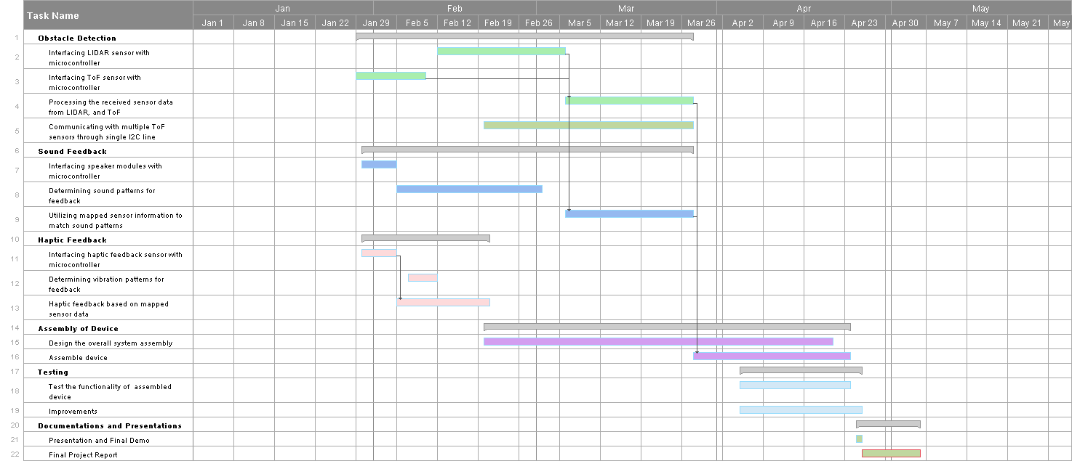

**Appendix C: PERT Chart**

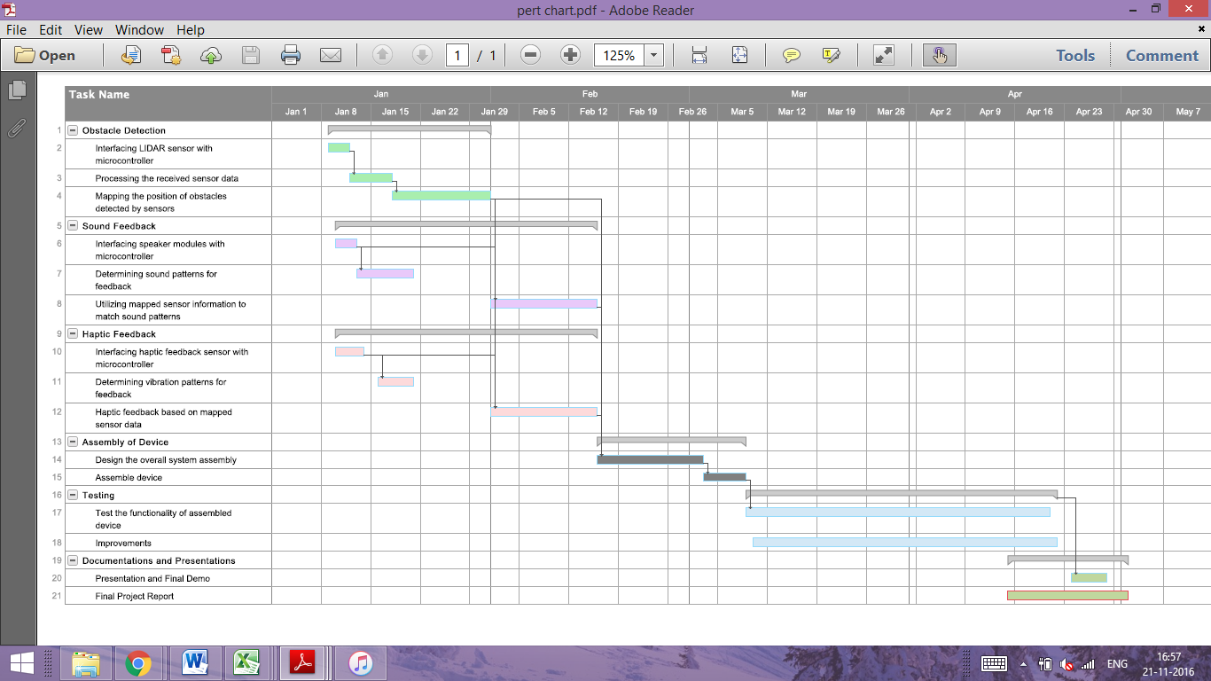

**Appendix D: Supplemental Materials and Documents**

Refer to the following links for datasheets on the major components used in this system:

**Class D Amplifier**

* <https://www.adafruit.com/product/987>

**VS1053 Codec**

* <https://www.adafruit.com/product/1381>

**Garmin LIDAR Sensor**

* <https://www.sparkfun.com/products/14032>

**Romoss USB Battery**

* <https://www.adafruit.com/product/1565>

**Speakers**

* <https://www.adafruit.com/product/1669>

**Time of Flight Sensors**

* <https://www.adafruit.com/product/3317>

For CAD design files and all other supplemental information pertaining to this product including a brief video please refer to the team website:

**LENS Website**

* <http://ece4012y2017.ece.gatech.edu/spring/sd17sJaH4/>