Learning Device for the Visually Impaired

ECE4012 Senior Design Project

Section L8A, Blind Assistive Technologies
Project Advisor, Dr. Ayanna Howard

Victoria Tuck, vtuck3@gatech.edu, Team Leader
Alexander Booth, abooth7@gatech.edu
Connor Napolitano, connap@gatech.edu
Felipe Gonzalez, fgonzalez30@gatech.edu
Azra Ismail, aismail30@gatech.edu
Nhi Nguyen, nnguyen45@gatech.edu

Submitted

December 13, 2017
Table of Contents

Executive Summary 3

- Introduction………………………………………………………………………….. 4

  - Objective 4
  - Motivation 5
  - Background 5
    - Taptilo 5
    - BrailleNote 6

- Project Description and Goals…………………………………………………….... 7

2.1 Project Description 7
2.2 Initial Project Goals 8
2.3 Achieved Project Goals 9
2.4 Unachieved Project Goals 10
2.5 Future Project Goals 11

- Technical Specification and Verification………………………………………….. 12

- Design Approach and Details…………………………………………………….... 13

  - Design Approach 13
  - Electrical Architecture 17
  - Mechanical Architecture 20
    - Electromechanical Button Design 21
    - Casing and Hinge Design 27
  - Software Architecture 30
  - Codes and Standards 33
  - Constraints, Alternatives, and Tradeoffs 34

- Schedule, Tasks, and Milestones………………………………………………….... 35

- Project Demonstration……………………………………………………............... 35

- Marketing and Cost Analysis………………………………………………………. 36

  - Marketing Analysis 36
  - Cost Analysis 38

- Summary and Conclusions……………………………………………………....... 40

- Leadership Roles……………………………………………………........................ 42

- References……………………………………………………................................... 43

Appendix A: Gantt Chart 45

Appendix B: Pert Chart 48

Appendix C: Detailed Cost Analysis 50
Executive Summary
Most of the current learning devices that exist for the visually impaired are bulky and expensive. Any handheld system available presumes some visual perception and is primarily based on magnified visual input with peripherals added to help the visually impaired. They are also generally built to perform a specific task. The Blind Assistive Technologies (B.A.T.) Team designed and prototyped a flexible system called the Braille Assistive Teacher that transitions from teaching visually impaired students how to read braille using the 3x2 format to utilizing the more modern “keyboard” format of the computer input interface, using the inline six-dot system, found on many popular devices. Many of the devices that fall under the braille keyboard category were designed on the assumption that the user knows and is comfortable with using the keyboard format, not taking into account that there is a learning curve involved in moving from the standard braille alphabet to the six-dot inline system. The Braille Assistive Teacher includes an audio feedback system that guides students while using the system. It will assist in progressing a student through their school curriculum because of the opportunity for additional braille practice at home with the help of their parents. The prototype costs approximately $968.
Learning Device for the Visually Impaired
1. Introduction
The Blind Assistive Technologies (B.A.T.) Team designed a learning device called the Braille Assistive Teacher that utilized both hardware and software to teach young visually impaired students written braille as well as shows them how to input the characters onto a computer interface. The team requested $306 for parts to develop a prototype of the system, receiving a budget of $500. The prototype is able to move between the six-dot braille and the inline button keyboard format. It also includes six retractable pushbuttons and uses audio as a form of feedback to help students learn the alphanumeric characters.
  - Objective
The team designed and prototyped a system that helps teach visually impaired students how to write braille using the six-dot braille syntax. This system also helps teach students how to utilize the more modern “keyboard” format of the computer input interface found on many popular devices. Character input is accomplished through the use of six retractable pushbuttons, using audio as a form of feedback to help them learn the alphanumeric characters. The device is portable with sturdy components that can withstand rough use in the hands of younger children. It also functions with little to no lag time between the user’s input and the audio feedback. Having such a device will allow for a faster progression through the curriculum since students can accomplish learning at home with the help of their parents.

  - Motivation
Many of the current learning devices that exist for the visually impaired are bulky and expensive. Handheld electronic systems available in the total market are based majorly on visual output. Even so, devices designed specifically for the visually impaired have only one function and, when applicable, work under the assumption that the user knows braille. There is a need for a system that teaches braille in many formats so that those who are visually-impaired/blind can effectively utilize all the devices in the market. Another need that can be satisfied is having the device be usable for those who aren’t visually impaired, such as the parents of those who are. That way, the learning process becomes smoother and much more productive.
  - Background
1.3.1 Taptilo
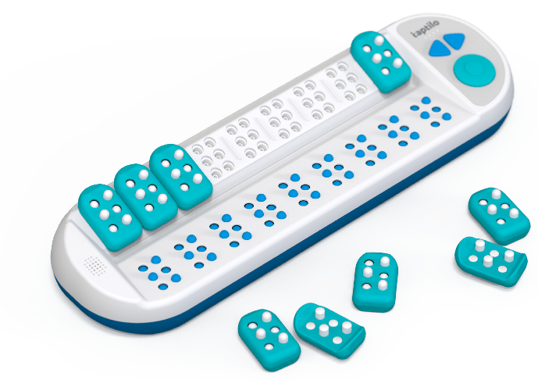
Figure 1. Taptilo Learning Device
Taptilo is a learning device shown (Figure 1) that teaches braille through the use of an app and a tactile device that functions with bluetooth and/or Wi-Fi. This device was first introduced just this year at the beginning of March and was released in the US in July. A package for one individual costs $900 and comes with the Taptilo station, nine blocks, a mobile application, a carrying case, and a power adapter with cable [1]. One of the most basic functions of the device is learning to read/write braille. To use this function, students will have another individual use the app, usually a teacher or parent, to select words that they can spell out using the blocks. Selecting the words on the app will have the bottom panel generate braille characters that students will then feel. They will then try to mimic the character on the block by clicking the pins and mounting it onto the station. Once the blocks are mounted onto the station, pressing the button on the station itself will prompt feedback on whether or not the input was correct [2].
1.3.2 BrailleNote
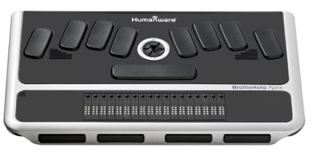
Figure 2. BrailleNote Apex BT 18 Braille Notetaker
BrailleNote (Figure 2) is a device that is created by Humanware, first introduced in 2000. Since then, Humanware has produced three different versions of the BrailleNote, the classic being the first and the apex being the most recent. It is a combination notetaker and computer screen reader. When not connected to any other device, it allows users to take notes easily with the braille keyboard or record audio as needed. The BrailleNote itself has several ports that allow users to interact with a computer by connecting a screen, usb peripheral, or SDHC card. The thumb keys grant users the ease of reading with the possibility of navigating line by line. The starting cost for this device is $1,995 and goes up to $2,995 on newer models [3].
2. Project Description and Goals
2.1 Project Description
The team completed their design of the Braille Assistive Teacher, an electrical handheld system designed to assist visually impaired grade school children with practicing braille in reading and typing format. The final prototype included two custom-built casings connected via a hinge with six buttons, three buttons inline per each casing. The total six buttons are arranged in three rows, two columns format. The buttons are designed correspond to the six “bumps” in the braille alphabet. There was an additional button installed as a ‘submit answer’ button as well as a button used for differentiating between reading and typing format. The purpose of the hinge was to allow the user to learn braille that is used in print (in a 3x2 bump format) and then allow the device to fold 180 degrees outward to learn braille that is used for typing electronically. Because the two sets of buttons in each enclosure are built-in the case, the two columns of buttons swing outward from one another so that the user may also use this as a device for learning how to type braille (Giving a 1x6 inline bump format). When the device is closed (3x2 format), one of the two additional buttons installed is designed to be pressed, allowing the device to differentiate between reading and tying braille. Internally, in one of the two project enclosures, the team installed a custom printed circuit board (PCB) that housed one MBED microcontroller, one text-to-speech module, one SD card reader, one speaker, the two additional submit and orientation buttons, and a custom set of three electromechanical buttons that acted as the ‘bumps’ of the braille characters. Each electromechanical button has an electronic momentary switch and a micro servo attached to it. Inside the second project enclosure, there is a 6000 mAh DC power supply and three identical electromechanical buttons. The MBED microcontroller is designed to receive input from the electromechanical buttons, send output signals to the micro servos, control custom lesson plans loaded on the micro SD card, and control the text-to speech module. MBED controls the text to speech module such that text-based lesson plans, instructions, and feedback are read audibly though the speaker or external headphones to the user operating the overall prototype. The device asks the user to input a certain letter of the braille alphabet or short word, depending on the reading or typing orientation, and audibly gives feedback on the accuracy of the user's input.

2.2 Initial Project Goals
Project goals initially included the following:
General
- Cost $981 after accounting for potential overhead costs
- Device that assists the visually impaired with learning and practice braille
User Interaction
- Intuitive user interaction
- Involve parents in the learning process
- Provide feedback on learning progress
Physical
- Portable
- Zero exposed wires or electronics
Electrical
- Low power usage
- Operates for 4 hours constant usage

2.3 Achieved Project Goals
Project goals that have been achieved include:
General
- Cost less than $981 (currently $967.77) after accounting for potential overhead costs
- Device that assists the visually impaired with learning and practice braille
The device is slightly cheaper than anticipated, and a better mechanical design would decrease the cost further. This device has been minimally tested with sighted users not looking at the device, and users have been able to later identify and remember some characters.
User Interaction
- Provide feedback on learning progress
Feedback is provided as the user moves through the lesson on incorrect pin presses.
Physical
- Portable
The device can be easily carried around and is battery powered. Currently, the device must be opened to switch out or recharge the battery, but it would not be difficult to add a panel-mount charging port to the outside of the casing in future iterations.
Electrical
- Low power usage
- Operates for 4+ hours constant usage
The battery being used to to power the device did not need to be swapped out or recharged after multiple days of use and testing.

2.4 Unachieved Project Goals
Project goals that have not yet been achieved include:
User Interaction
- Intuitive user interaction
- Involve parents in the learning process
Many users struggled to use the device the first time at the design expo because the demo did not have enough of an explanation of how to use the device. This was done mainly to keep the demo short but still substantive, but a tutorial and user studies would need to be done to improve user interaction. Without an application to assist the parents, it is unclear whether or not parents would be involved in the learning process with the current device.
Physical
- Zero exposed wires or electronics
Some wires are still exposed through the hinge.

2.5 Future Project Goals
Future project goals include:
General
- Support for all braille letters, numbers, contractions, symbols, and other languages
- Includes set of pre-made lesson plans following the Mangold Braille Program
User Interaction
- Mobile application
- Reports on student progress through mobile application
- Versatile system for teachers adding lessons through the application
Electrical
- Smoothly running system with no power issues when servos are actuated
Physical
- Buttons close enough to be operated by a child
Software
- Contains entire program on one microprocessor
- Contains system to connect to a mobile application

Over the course of the project duration, a series of customer discovery and minimum viable product (MVP) testing was conducted in order to determine the exact product-market fit. An ideal product-market fit is defined as finding a market of eager customers before completely designing the product. It is nonideal to make the product before knowing the customer and it will most likely lead to a waste of time and capital.
The customer discovery portion is an iterative series of experiments that are designed to thoroughly learn about three main components of the customer segment: customer jobs, customer pains, and customer gains. The value proposition is what the product or service offers to the market, consisting of three factors: Products and services, pain relievers, and gain creators. These three factors are designed to assist the customer segment. Once the customer segment is more known, a minimum viable product (MVP) will be implemented in order to determine the most ideal set of features and shapes of the overall product. The customer discovery conducted so far has been three visits to the Atlanta Center for the Visually Impaired (CVI); however, recurring contact and feedback is intended for the future of the prototype and future iterations.
- Technical Specifications and Verification
Table 1. Specifications for the interactive braille learning device.
Item | Specification | Measured Value
Size | 6in x 4.5in x 2in - folded position | 7.44in x 5.38in x 3.69in - folded position
Weight | 700 grams | 3.86 kg
Supply Voltage | 6V | 5V
Battery Life | 4+ hours of run time | 4+ hours of run time

Major features:
- 8GB internal SD card for firmware and storage
- Stereo speakers for family interactions and 3.5 mm headphone jack for personal use
- Rechargeable batteries
- 6 large retractable buttons for user input
- 1 submit button for the entire system
- 1 mode button to switch between typing and reading modes
- Large custom hinge designed to house all electronics internally for secure handling
- Design Approach and Details
  - Design Approach
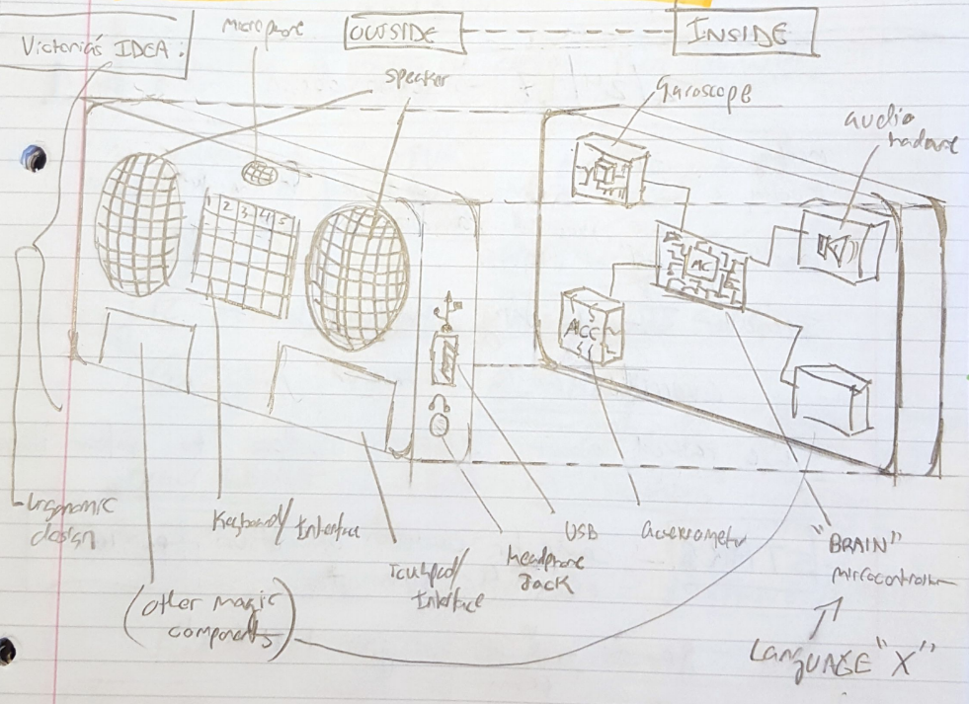
Figure 3. Original design idea before customer discovery
The original design approach (Figure 3) was theorized to be a small handheld device intended to be a mobile gaming and learning device with approximately 11 external and internal features. The original design consisted of a rounded frame with seven external features which included large speakers, a microphone, a keyboard interface, a touchpad, a 3.5mm headphone jack, a USB port, and another additional interface option. The original design internally consisted of at least 4 components. These components included a gyroscope, a microcontroller, an accelerometer, and an audio circuit, with flexibility to add additional components if needed.
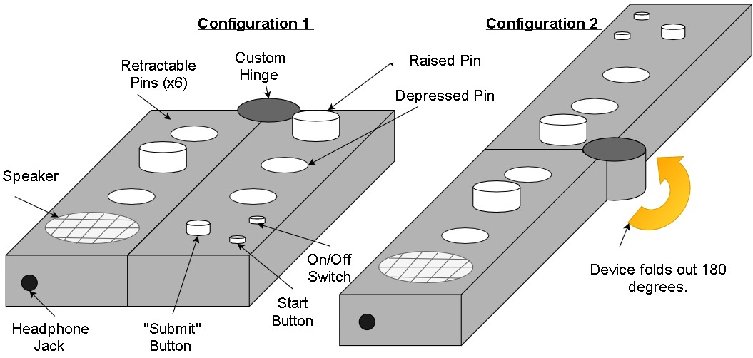
Figure 4. Proposed post-customer discovery design of the learning device. (CONFIGURATION 1): The prototype is folded to display the braille alphabet input interface. (CONFIGURATION 2): The prototype is folded out for the configuration to display the inline computer input interface. The final design will have smooth corners and edges throughout the design for comfort and safety purposes.
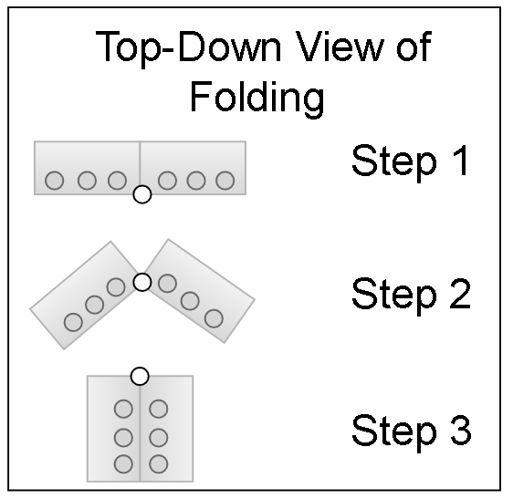
Figure 5. A top-down description of the folding design of the device in (Figure 4). Step 1 displays configuration 2 found in (Figure 4). Step 2 is in the process of folding to configuration 1. Step 3 displays configuration 1 found in (Figure 4).
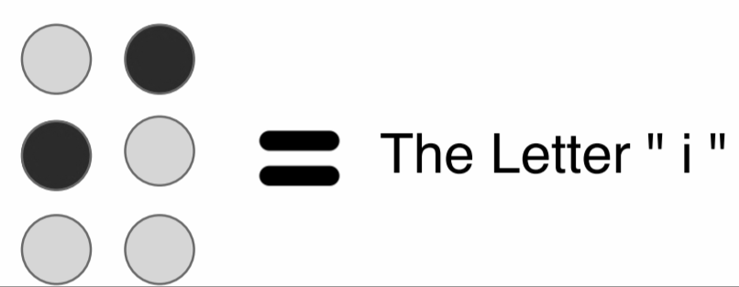
Figure 6. The elevated pins in (Figure 4) depict a alphanumeric character in braille notation. The darker dots represent the raised pins. Different combinations of pins relate to different alphanumeric characters.
Two sessions of customer discovery located at the Atlanta Center for the Visually Impaired changed the perception on what would give visually impaired or partially visually impaired students the most value possible. The purpose of the customer discovery is summarized in section 2 under “Project Description and Goals”. In order to make a popular and useful product, it is important to know the customer to a great extent. One major trend of the available devices already on the market is that there are several devices in the electronic and non-electronic spectrum; however, each device is single-purpose. This prototype is designed to be flexible to assist learning and thus serve at least two purposes. The first purpose being for alphabetic braille practice, and the second is to give users practice inputting electronic braille.
Features of the design include two main enclosures connected to a hinge (Figure 4). The two enclosures will be designed with smooth edges to for safety and ergonomic purposes. The hinge will serve a dual purpose of allowing the two main enclosures to rotate about the hinge axis as well as acting as a conduit for flexible wires to travel though it internally. The hinge will be designed to have friction to ensure the device stays in the intended configuration while handling it (Figure 5). The amount of friction it contains is not determined yet. One side of the device will have a start button, a submit button, and a power switch. The purpose of the start button is to prompt the microcontroller to begin the lesson that is selected. The submit button will be to indicate to the system that the user has finished inputting a letter. Each side of the prototype will include three retractable buttons. The six total buttons or pins will be used for braille syntax, which is ordered in a 3x2 matrix (Figure 6). For learning computer-based input, instead of the 3x2 matrix of pins, the syntax folds into a 1x6 matrix. Products such as a Braillenote (Figure 2) use this 1x6 button syntax as a standard or a 1x8 matrix button syntax depending on the quantity of the inputs it supports. It is not yet determined how the retractable pins will mechanically operate. The buttons must start in a depressed state, flush to the front face of the enclosures. When a button is pressed, it must slightly depress more than spring up on release and stay in a raised position until the user uses the submit/reset button . For the reset, it is desired that there is a universal reset button to depress all buttons simultaneously to the original depressed state. This desired feature is to reduce confusion in learning braille characters and to increase the speed of the input. There are current ideas for fabricating custom spring-loaded mechanical buttons that press an electronic switch for the button signal. No official plans are currently present regarding buttons that meet these sets of parameters. One speaker will be included to audibly describe alphanumeric characters and additional learning material. The exact design and specifications of the speaker and internal electronics are not yet known and require additional research. For additional flexibility, the current plan is to also install a 3.5mm auxiliary headphone jack on the side of the project enclosure (Figure 4). The headphone jack will allow use in more private or popular environments, where using a speaker is not appropriate or possible.
  - Electrical Architecture
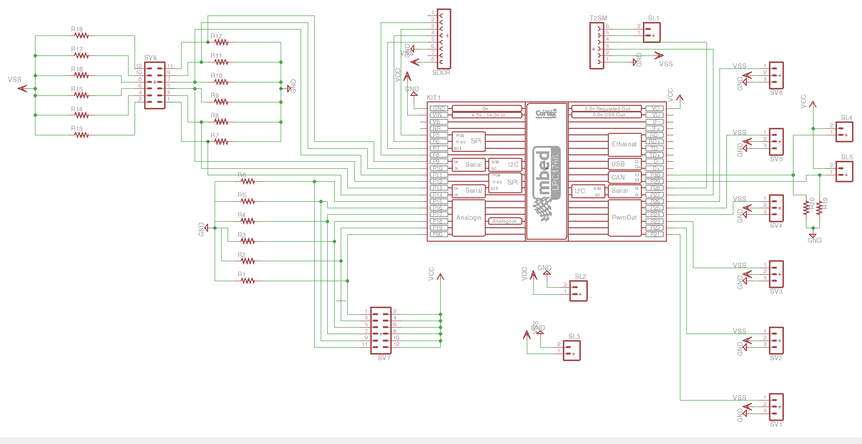
Figure 7. Device schematic built in EAGLE to create the PCB. The schematic highlights each component intended to be used which includes: mbed microprocessor, SD Card Reader module (SDCR), Text-to-Speech module (T2SM), eight push buttons (SV7, SL4, and SL5), six potentiometers (SV8), six servos (SV1-6), and the three voltage rails required which are the 3.3V from the mbed (VCC) and two separate 5V sources from the battery pack (VDD and VSS).
Once the required components in the device was decided on, the PCB was designed to cater to all of the requirements. Above in figure 7, the separate modules and connections required are clearly visible. The resistors labeled R1-6, R19, and R20 were all 200 Ohms and were connected to the side of each push button to allow for proper logic. The resistors surrounding the potentiometers were going to be designed to give the device feedback of when the buttons were approximately 33% pushed down to alert the controller a button was being pushed, but not yet hitting the push button at the bottom of the enclosure. This feature was later determined to not be necessary after we learned how the typing mode should function, however they were on the PCB after this decision, leaving R7-18 open pads. The two separate 5V sources were necessary because the servos pulled too much current instantaneously when multiple were actuated at once if they were only on one overall 5V source. This overcurrent would cause the mbed to turn off whenever multiple servos actuated which is unacceptable for proper operation. Simply putting the mbed on its own source solved the issue since the battery pack outputs are voltage regulated.
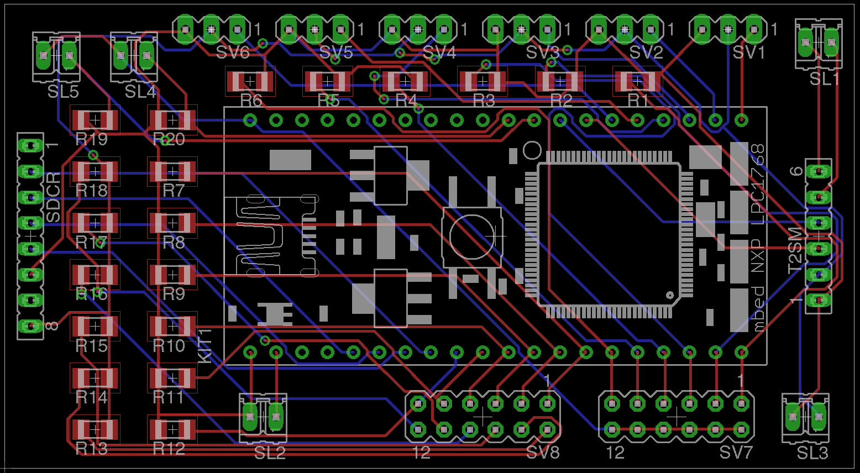
Figure 8. Screenshot of the device *.brd file with all components laid out and traced in EAGLE.
The mbed, SD card reader, and text-to-speech modules are inserted into female headers soldered to the board to allow them to be replaceable if any component fries for any reason. The buttons, servos, and potentiometers are all jumped to male header pins soldered to the board for easy debugging since certain issues could be caused by a single servo frying that would cause the entire device to not function properly. In the final design, the potentiometers were unused, so the SV8 male jumper was left open, but the ability to access these pins in the future could be useful if more digital inputs are needed or access to these pins is desired. In future iterations, the layout would change to cater more to the locations of components in the device and improve functionality. A minor change that would immediately help would the performance of the audio module is to put the text-to-speech module power supply onto the same supply as the mbed. In prototype testing, the mbed still functioned appropriately with this set up, and currently if any servo overcurrents, the text-to-speech module changes voices without being commanded to do so because it lost power briefly. Also, in the current device servos four, five, and six are on the side with the PCB, so moving those male header pins to the end of the board further from the hinge, closer to the text to speech module, would help with the strain on the cables moving through the hinge. Doing the same with the buttons and power cables that go through the hinge will additionally improve functionality of the device. Lastly, the unused resistors and jumpers could be removed from the PCB to make it a bit smaller. Overall, the electronic design did not take into consideration the organization of the device when it was designed, but with the device put together, there is clear room for improvement that would lower the price and improve functionality of the device.
  - Mechanical Architecture
The team fabricated custom buttons that were designed to lock and unlock in the reading 3x2 button format as well as as custom laser printed 0.22in thick acrylic cases custom fit for holding the electrical hardware, power supply, and mechanical buttons. Similar to the original design approach of the proposed design, the concept of having two separate project enclosures each holding half of the mechanical buttons was maintained so a hinge could connect both of them and thus allow a multifunctional element of both reading and typing braille practice.

    - Electromechanical Button Design
The largest design challenge for the team was to create a mechanical button that operated under the required design specifications for helping users both practice reading and typing braille. For the two fundamental modes that the final prototype contained was the reading braille mode (the mode where the buttons are in a 3x2 format for alphabetic characters or CONFIGURATION 1) and the typing mode (the mode where the buttons are in an inline 1x6 format or CONFIGURATION 2). The method that the correct order of buttons are transitioned to the 1x6 format without being mixed up is the standard explained in section 4.1. In the reading braille mode, the buttons were required to operate where they would either spring up or stay in a locked down position, similar to a pen mechanism. The buttons needed to start in a position where they were all locked down initially, and then the user is prompted to push them and they spring up. When pressing in reverse operation, the user pushes the button again down and the button locks down after it is pressed. In the Typing braille mode, the buttons were required to operate where they would act like a regular keyboard, where the button should always spring up after the user is complete pushing it. The team was not able to research a push button that could sometimes operate in the locking down method and sometimes operate in the spring-up keyboard method depending on the desired application. The team decided to begin with prototyping design from scratch.

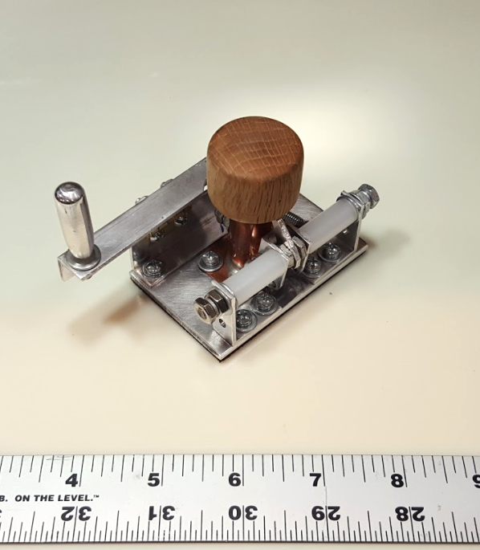
Figure 9. The first fully-mechanical button prototype. The design contained a locking mechanism (right side) and a reset lever (far left). The reset lever was designed in advance if multiple buttons could be in line, and one lever could theoretically push all buttons down at once. This prototype could not operate with all the design requirements in mind and was later revised.
The first prototype considered was a full mechanical solution which had a copper housing that held a aluminum pin and a spring in place. a small screw was tapped into the aluminum pin and collided with a locking mechanism that allowed the pin to lock in a pushed-down position. The approximate volume dimensions this design took was a 3in length, 1.5in width, and a 2.5in height. This design was able to either work like the typing keyboard mode or the lock down mode, but did not have any solution for physically switching between the two modes. No further modifications or additions were added and te theam decided to attempt a different solution. This button prototype was then revised with the button prototype.
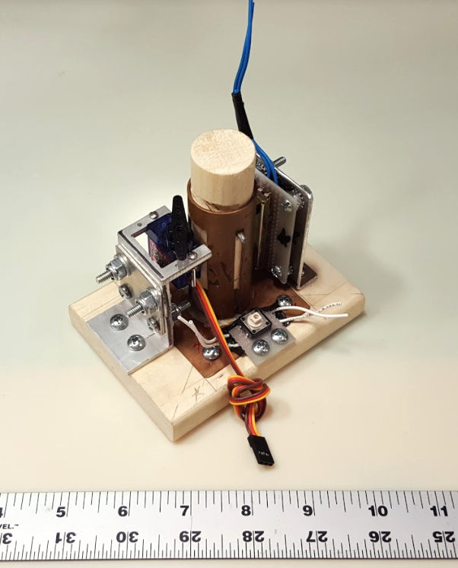
Figure 10. The second button prototype with an electromechanical approach. The locking mechanism was replaced with a micro servo (left-front) to move between a slot in the copper housing and the wooden pin. This design was able to meet the design criteria for both requited modes. The next challenge was to miniaturize the whole architecture.
The next button prototype was an electromechanical solution that met all design criteria for both modes of the overall prototype design requirements. The copper pin housing was designed similar to the previous button prototype with a spring underneath the wooden pin allowing the button to spring up when not being pressed or locked down. The method that allowed the design to alternate between the two modes was to program a micro servo to move a small arm into a slot in the wooden pin that would either lock or unlock the pin depending on what be button state was in. When in the typing mode, the servo would be controlled to “do nothing” simply to allow the pin to spring up and down freely.
The solution used to control the micro servo was to have the wooden pin push a small momentary electrical switch. The signal of the switch would tell the MBED to send a PWM signal to the servo, making the servo arm turn quickly into the slot of the wooden pin, thus locking the pin in a pushed-down position. Then as the electrical switch was pushed again, the MBED would send s PWM signal to move the servo to the previous orientation, thus unlocking the pin and making it spring up. The approximate volume dimensions this design took was a 4in length, 2.5in width, and a 4.5in height. A linear potentiometer (right-behind in figure 10) was connected directly to the pin which outputted an analog signal representing where exactly the pin was on the z-axis (how far pushed down/pushed up was it)
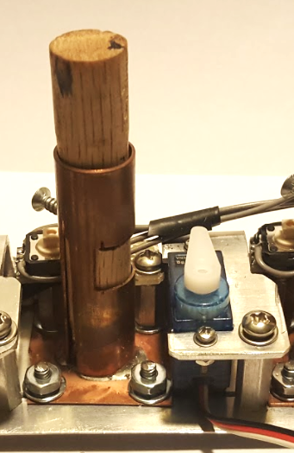
Figure 11. Final miniaturized design of the electromechanical button design with the copper housing and pin (left) and the servo and its mount (right). This design was fundamentally the same that the previous/second overall button design.
The last button prototype ended up as the final design approach for the final prototype. The functionality of this final design works the same as the second button prototype. The size of the architecture was decreased to the extent of the total volume that each button took was approximately 1.75in length, 2in width, and a 2.25in height. As seen in figure 11, The screw (sticking out of the wooden pin/copper housing) is attached to the wooden pin and moves with the pin. This screw pushes the momentary electrical switch (behind). The size overall was reduced and solutions were made regarding how to fabricate five additional copies for the final design. The only other major change on the design other than the size is that the linear potentiometers were discontinued and did not become incorporated in the final prototype design. This was because the potentiometers did not not serve an absolute necessary purpose for the button state machine and the space constraints of the project enclosures were too strict.
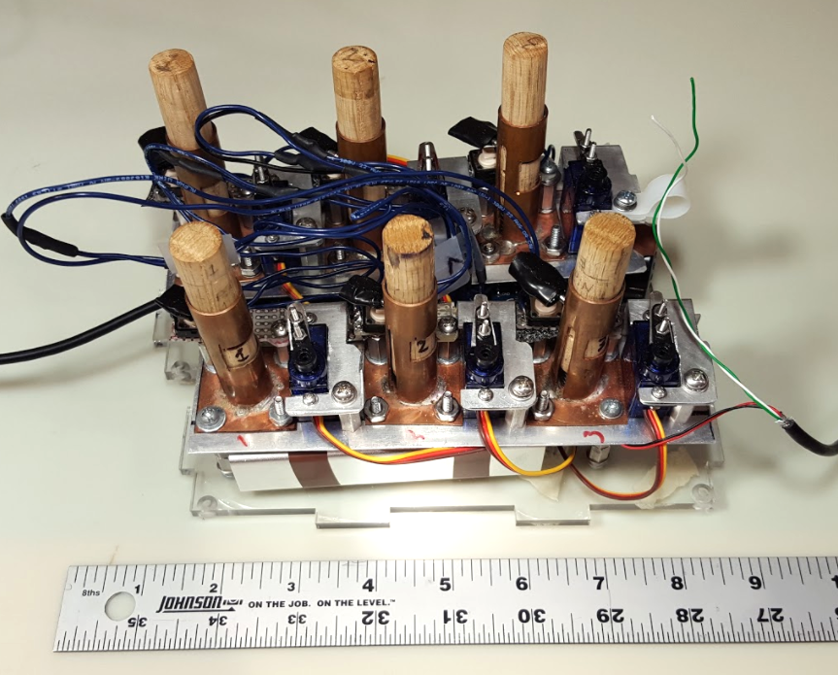
Figure 12. All six buttons bolted in pairs of three. Both pairs of #6 hex standoffs in order for the electronic hardware and power supply to rest underneath the design. The front pair of three has the power supply underneath and the behind pair of three has the remaining hardware underneath.
The final button architecture was simply to fabricate 5 copies of the button design and bolt them together inline with pairs of three. The purpose of having the buttons in pairs of three is for each project enclosure. When the two project enclosures are next to each other in the reading braille mode, the overall braille alphabetic character is spelled out in the 3x2 button format. The inline three button system was 6.75in length, 2in width, and a 2.25in height. After completion of fabricating all six buttons, the pairs of buttons were then bolted to the base of the project enclosure for easy access. In order to place the electronics underneath the mechanical buttons, #6 hex standalls were used to create a lower shelf of space between the base of the project enclosure and the base of the pairs of buttons.
The team is considering future iterations of the overall prototype with future button design considerations. With the functionality of the buttons solved from multiple prototyping, the team is considering more economic solutions. The largest problem with the current design is the weight. The buttons are made from aluminum, copper, wood, and various steel nuts, bolts, and washers. These material choices added up in weight when all six buttons were fabricated. One future improvement would be to replace the button housings, micro servo mount, button base, button pin, and any steel hardware with 3D printed or injection-molded plastic parts. With 3D printing, the overall size, weight, and number of parts would be reduced considerably because of decrease in complexity of assembly and fabrication. Instead of several dozen parts per each set of three buttons, a 3D printed future design could potentially be one single part (with the exception of the the three pins that are designed to be moving parts). The team is also considering more possibilities with designing new button mechanisms as well. A purely mechanical button, similar to the figure 9 design, has the potential to increase durability while decreasing power consumption overall because the mechanical solution would not require micro servos which have a high current dependency.
    - Casing and Hinge Design
The casing and hinge design were designed and completed after completing the electronic hardware assembly and electromechanical button design and fabrication. The Project enclosure is made from 0.22in thick acrylic sheet material. The minimum inside volume that was permitted was 7in length, 2.25in width, and a 3.25in height (this accounts for the buttons sticking outside the top of the enclosure) per each project enclosure. accounting for the thickness of the material, the total outside volume was was 7.44in length, 2.69in width, and a 3.69in height. Once the measurements were finalized, two copies of the front, sides, top, and bottom were made in AutoCAD and then laser cut to specifications. 1in by 0.22in dovetails were incorporated in the design in order for the project to fit together more easily like a puzzle set and give the enclosure additional rigidity.
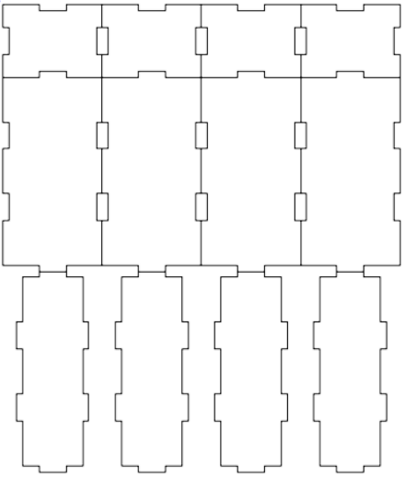
Figure 13. Screenshot of the CAD file used for laser printing. The little notches are the dovetails designed for rigidity and greater ease when putting the enclosure together. The front/backs (top row) are overall 3.69in x 2.39in, the sides (second from top row) are 7.44in x 3.69in, and the tops/bottoms (bottom row) are 7.44in x 2.39in.
Once all parts were laser cut, one 3.25in #6 hex standoff was glued to each of the sides, front, and back which made up the corners of the project enclosures. The purpose of the standoffs in the corners was to provide a solution where the enclosure could be easily taken apart. Holes were drilled in the top and bottom to allow screws to be placed though and fasten to the standoffs glued to the sides of the enclosure. The combination of the dovetails and the screws in the vertices of the enclosure gave a rigid, easy to take apart design for presentation purposes. Large washers gave greater clamping properties and strength to the enclosures. If this prototype was to become a consumer product, these dovetails and acrylic would most likely be replaced with more economic methods. This design assisted in making the prototype easy to take apart in the event of required repairs.
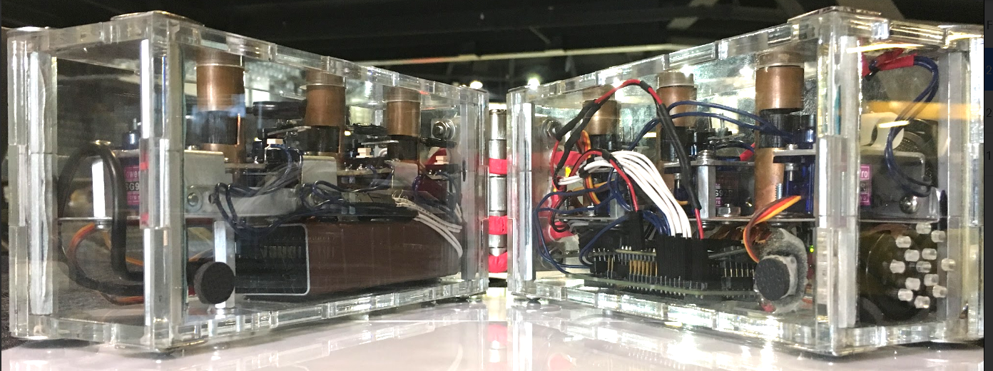
Figure 14. Image of the final prototype side view. In each corner of the project enclosure, there are standoffs that the top and bottoms connect to, clamping all sides together without the need for gluing parts together. The hardware was designed to be placed underneath the electromechanical button architecture.
The main focus for the hinge is to aid in making the two project enclosures one unit and have them rotate about the top corners to allow the translation between reading mode and typing mode. The original idea for the hinge as well was to act as an electrical conduit for the signal and power cables as well as provide the structural support for both modes. The team was not able to design a custom hinge with internal wires for this current prototype. The hinge for this prototype is a three inch tall hinge bolted to the backs of the project enclosures. There is a gap between the hinge and the acrylic which allows wires to run in between the two parts so the wires to not have to impede with the hinge folding in the configuration for typing mode.
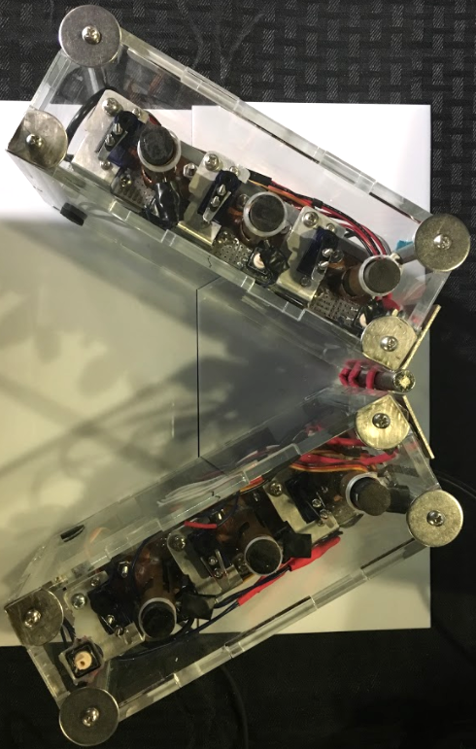
Figure 15. Top view of the project enclosures with all hardware installed. Wires in the middle (red) electrically connect the two halves together, sending signals and power to both sides.
The team is considering future iterations of the overall prototype with casing design considerations. The most likely future iteration would be to eliminate the clear acrylic dovetail casing design and replace it with a 3D printed solid case or an injection-molded plastic case. There will most likely be only one side that opens for placing internal hardware instead of the multiple openings that the current design holds. These future possibilities have the potential to decrease the cost and complexity of the design. The hinge that connects the two halves of the design will also be part of the casing and designed for the wires to safely travel through inside without pinching or exposure to the elements or user.
  - Software Architecture
Figure 16. Architecture of the software program developed for the device. This flowchart demonstrates both the reading and typing modes for teaching letters and words in braille.
The fundamental computing aspects of our prototype that we identified as being critical to meeting our project goals and constraints were interfacing and compatibility between the various peripherals and the microcontroller as well as the architecture, memory size, power management and low voltage and number of I/O pins on the microcontroller. One of the deciding factors for choosing the mbed lpc1768 was the number of pins and interfaces available. The mbed could support all peripherals without the need for extension boards. While the RAM memory on the mbed was not quite sufficient to demonstrate all the features in one program once we added the drivers for the peripherals and the buttons, we determined that it would suffice for an initial prototype because of the other benefits of using an mbed. Instead, we developed three separate programs for each of the features we wanted to demonstrate i.e. reading letters, typing letter, and typing words. The ARM Cortex M3 was able to provide the performance desired and we did not face latency issues. However, the 5V output provided by the microcontroller was unable to handle the high current draw by the servos. To deal with this issue, we included two separate 5V rails on the printed circuit board. These rails were powered through two separate USB ports on the battery pack. One rail powered the mbed and the other powered all other components.
To interface with the peripherals, the SPI and Serial interfaces were used. SPI was used to interface with the SD card reader and read the lesson plan text file on the microSD card. The text to be translated to speech by the Text-to-speech module were sent as Serial print commands by the microcontroller. We choose to include the text-to-speech module over playing recorded speech to allow for flexibility in the speech content. Recording each speech snippet would also take up memory and this approach may add latency issues because of microcontroller having to read the SD card each time. Reading the audio file each time would further take up space in RAM memory.With the text-to-speech module, the microcontroller could just send a serial print command and the work is offloaded to the text-to-speech module.
In terms of the code structure, our primary focus during the software development was to modularize the code as much as possible in order to allow future developers to easily understand the code and build upon it. We also created a separate device driver to communicate with the custom button we built as well as a driver to communicate with all six buttons. This allows for new applications to be developed with our buttons very easily. All six buttons can also be setup and interfaced with concurrently. Due to running into memory constraints on the mbed, we were unable to demonstrate all the features in one program and instead developed three separate programs to perform each of the features we wanted to demonstrate - reading letters, typing letters, and typing words.
Figure 16 demonstrates the software architecture of the programs developed. The program begins by prompting a user to enter into reading or typing mode and progresses only if the device is in the right orientation. Once the user is determined to be in the correct mode, all the servos in the custom buttons are setup to either move freely (typing mode) or latch down/up after pressing down (reading mode). After this step, the program parses the lesson plan text file on the SD card to determine the braille characters and words to be taught. Placing the words and letters in a separate text file allows for greater flexibility for teachers as the file can be easily updated according to the student’s needs. For letters, the device states what buttons need to be pressed. If the wrong buttons are pressed, then the device provides corrections. For words, the device tells the user how to spell the word. If the word is spelled wrong then this information is communicated to the user. In both cases, the device asks for the user to attempt a letter or word and does not move to the next one on the lesson plan text file until it is correct.
Future improvements would include further modularization once a microcontroller with higher memory constraints is obtained. This will include integrating the three separate programs into one compact program, reducing the need to reload a program each time a specific device functionality is needed. More memory will also enable more flexibility through the addition of a larger alphabet, numbers, contractions, and symbols, thus allowing further customization within a curriculum.

  - Codes and Standards
Since the core user group for our product were children, we followed the ASTM F 963-11 Standard Consumer Safety Specification for Toy Safety which addresses numerous hazards that have been identified with toys [11]. This standard influenced our choice of materials for the casing as well as our design decision to encase structures such as small parts within the casing and avoid sharp edges that could pose danger to children. While there are no official standards for accessible content, we also followed the guidelines laid out in the Web Content Accessibility Guidelines (WCAG) 2.0 to guide our design of the flow and structure of the lesson plan content [12]. We followed the Unified English Braille codes in our product which is followed by schools in North America [13]. We also consulted the Expanded Core Curriculum for schools in Georgia which resulted in the development of flexible lesson plans that allow teachers to ensure that the product keeps pace with the learning objectives of a child with visual impairment [14].
At a hardware level, our device was battery powered and followed the IEEE 1625 - 2008 Standard for Rechargeable Batteries for Multi-Cell Mobile Computing Devices that specifies subsystem interface design responsibilities for each subsystem manufacturer/supplier to reduce the possibility of battery failure [15]. For communication between the different I/O units, we primarily used SPI and I2C communication standards.

  - Constraints, Alternatives, and Tradeoffs
For building a handheld learning device for school-aged children, we considered constraints such as power, portability, safety, and cost. The constraints that we had defined for our device were are follows. The battery of the device should last at least 4 hours to get through an afternoon of working on assignments while fitting in our smaller casing for the device. The device would use rechargeable batteries so that the device can be used again with ease. For the device to be comfortably carried in a school bag, it would hold the internal components in a relatively small casing while staying under 700 grams. Since the device will be handled by children, it should have a safe and comfortable to use design with rounded edges. In addition to these design constraints, to be competitive with other products in the market, the price point needed to be below that of our competitors which affected our choice of components. All components were chosen such that they fulfilled the above requirements while keeping the overall cost at a minimum.
We also had to make tradeoffs between complexity and usability during the design process. While our original idea was to build a gaming device with more functions, the current design plan addresses a specific problem in learning. After customer discovery sessions with the Center for the Visually Impaired we decided to focus the device on solving how visually impaired children learn Braille. A simple system based off of existing systems such as the one in the final design are anticipated to not have a significant learning curve associated with it for the user and fit well with their existing syllabus. The current plan also afforded time for improving user experience and incorporating user suggestions.

- Schedule, Tasks, and Milestones
A GANTT Chart describing the project timeline is included (see Appendix A). A PERT Chart describing the project timeline is included (see Appendix B).
- Project Demonstration
After completing the final prototype, the mechanical aspects of the device were taken. The dimensions are 7.44in x 5.38in x 3.69in, bigger than our target dimension of 6in x 4.5in x 2in due to modifications of the design. As the electrical components now rest below the mechanical buttons, the height of the device needed to be increased. The weight of the device is 3.86kg, rather than the 700g target of our original design. This is a result of the materials used to construct the prototype (steel, copper, acrylic, etc.) The formal demonstration consisted of one person doing the following:
- The user inputs several characters with or without sight into the device, one at a time using the 3x2 format on the prototype to demonstrate the braille learning function. Users receive audio instructions on what alphanumeric character to input and audio feedback after inputting the alphanumeric character.
- The user then “opens” the prototype to transform the 3x2 into a 1x6 format using the hinges.
- With this new format, the user receives new audio instructions to construct words out of the letters they learned in step one, which should also receive audio feedback.
The functionality of the device will be demonstrated as below:
- Speaker: The speaker is connected to the text-to-speech module, utilizing software to provide instructions and feedback to the user. It will consist of simple commands and corrections such as “To write the letter M, press pins one, three, and four” and “Please, try again.”
- Retractable Buttons: The six servo motors linked to the retractable buttons will lock in place when a press triggers a push button, thus sending a signal to the device.
- Hinge: The prototype is placed within the hinged casing, allowing for transitions from a 3x2 to a 1x6 format with the wires running through the hinging itself.
- Battery Life: The device ran continuously for more than four hours.
- Marketing and Cost Analysis
  - Marketing Analysis
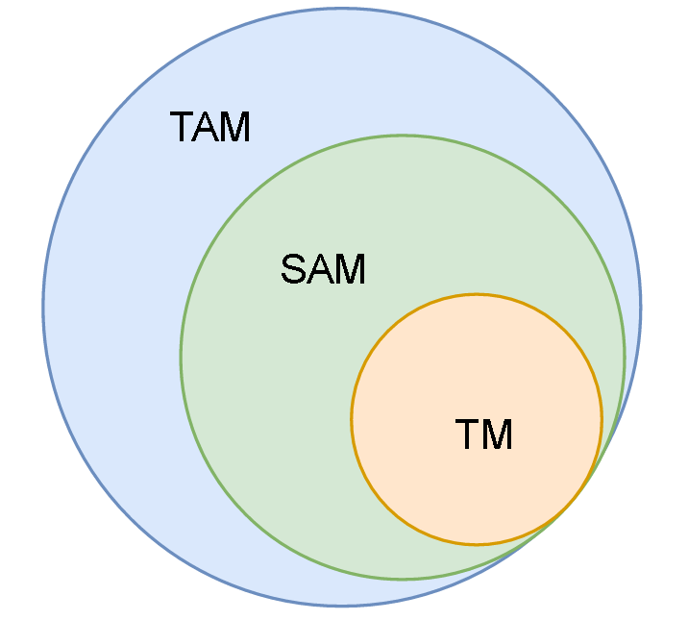
Figure 17. Diagram of the Total Available Market (TAM), Scalable Available Market (SAM), and Target Market (TM).
The current intended goal was to firstly engage in a deep analysis of the market and determine the ideal target market for the proposed product (Figure 17). the TAM consisted of the approximate population of all visually impaired people on earth, approximately 250 million [16]. The SAM was the approximate blind population in the United States, about 7 million [17]. The TM was approximately 61,739 students in the targeted age range in the United States [17]. This was researched information regarding current products and services that were already in the market. The products that were in direct competition with the proposed product were electronic and paperback book versions for learning braille. The purpose of the proposed product was to combine ease of learning alphanumeric braille with ease of teaching braille in order to encourage more parent/child relationships in braille education outside the classroom at home. One example topic for learning braille was the idea or counting like in DK’s DK Braille: Counting, which was a textured book that was designed to present numbers of high-contrast everyday objects on each page [7]. Another example topic for learning braille was learning the braille alphabet. Along with books like Q is for Quack : an interactive alphabet book [8], there were a large variety of books that taught the braille alphabet for all ages and all levels of visual impairment. Counting and learning the alphabet in braille were common in the scope of books. In order to make an electronic product that was able to compete with a variety of paperback learning devices, the electronic device required a library of learning features that alone surpassed the content of multiple books.
Other mediums for learning braille were also present in regard to inputting braille alphanumeric characters either mechanically or electronically. One device was the Perkins Brailler, which was essentially a typewriter that inputted braille syntax and outputted embossed braille on paper [9]. One more advanced type of brailler was the Braillenote (Figure 2) [10]. The Braillenote was a portable computer designed to connect to computers and replaced the standard keyboard or touch screen used in most everyday electronics. The Braillenote used the same typing syntax as the Perkins Brailler. This device was intended for older customer segments of the population and therefore does not directly conflict with the target market of choice. Devices that were more in contact with the proposed product were devices like the Taptilo station mentioned in section 1.3.1. The proposed product was intended to be foldable to teach reading standard braille and unfoldable to assist with developing braille typing skills.
The next step determined the market for the proposed product and what the market desired in general. In order to have an effective market strategy, the first goal was to accomplish the product-market fit condition, which was summarized in section 2 under “Project Description and Goals”.
7.2 Cost Analysis
The parts used in the development of this project are listed in Table 2 [4][5][18][19]. The cost per unit was calculated by accounting for the cost of the parts and the overhead including labor, marketing, sales, distribution and support. The overhead was 200 percent of the non-recurring costs, so the unit price was estimated to be three times the total amount of the unit cost (see Table 4). Table 3 shows specific information on related activities and hours allocated to work on the development, assessment and testing of the prototype of the device. The labor costs were included in the overhead amount. We found the median starting salaries for graduates from Georgia Tech in Computer Engineering ($75,000) and Electrical Engineering ($70,150) [6]. Considering this was an undergraduate project piloting a new product, and assuming that there was minimal financial backing for the project, the salaries were reduced by 25%. For the cost analysis over a four-year time period see Appendix C. Based on our results from the market analysis, we estimated the sales volume of units sold per year in order to carry out the analysis.

Table 2. Prototype Components
Item | Cost
Microcontroller | $59.95
SD Card Reader | $4.95
Speaker | $1.95
Push buttons | $0.25 x 8 = $2.00
Text-to-Speech Module (incl. Headphone Jack) | $59.95
Casing | $15.00
Flash Memory Micro SD | $19.95
Servo Motor | $6.975 x 6 = $41.85
Hinge | $3.00
Printed Circuit Board (PCB) | $26.00
Battery Pack | $10.99
Other Hardware Parts (such as wires, nuts, washers, etc.) | $55.00
Total | $300.59

Table 3. Development Hours per Engineer for the period of four months (one semester)
Activity | Hours
Lab | 85
Meetings | 42
Reports | 20
Total | 147

Table 4. Estimated Cost per Unit
Production Component | Cost
Parts Total | $300.59
Assembly | $10.00
Packaging | $1.00
Testing | $11.00
Total Cost | $322.59
*Accounting for overhead costs, the initial cost was triple the total cost per unit starting at $967.77
- Summary and Conclusions
The current Braille Assistive Teacher device has two modes, reading and typing, as originally specified, so that this device can assist students with learning both and specifically with transitioning from reading to typing. The device is versatile because it parses lesson text files to know what words the teacher wants the student to work through instead of having pre-programmed lessons on the device as was previously planned. The device has three different programs - one for reading letters, one for typing letters, and one for typing words. Currently, the programs must be loaded onto the device and run separately due to RAM issues on the mbed being used. The current lesson plans that are programmed and have been tested teach reading and typing the letters O and M and typing the words MOM and DAD.
The device functions as planned but did not meet all specifications specified. The current device did not meet the originally specified height and weight requirements because the buttons that were finally designed were much larger than expected. In addition, the materials used (mainly copper and metal) added quite a bit of weight compared to a plastic design that might have met the original weight specified. However, focus was put on the usability of the device over the size and weight because the size and weight do not appear to hinder use of the device. A concern was that the buttons might be too difficult for a child to press, but the springs do not appear to be too stiff for a child to be unable to operate. However, the buttons are too far apart; this was not specified in the original goals, but the distance between the buttons would need to be altered in order to make the device usable by a child.
Future plans include pursuing a startup company surrounding this project. However, in order for this device to be successful, significant changes need to be made. The current microprocessor being used does not have enough RAM, so a microprocessor with more RAM or a microcomputer will be necessary for full functionality and future improvements. Planned improvements include adding a Wi-Fi or Bluetooth module so that the device could connect to a phone application. The phone application would be for a parent or teacher to use to choose or create lesson plans for the child or student. In addition, the device could then collect and send data to the phone, which could be displayed in the form of reports, for the parent or teacher to use for assessing improvement. Further research needs to occur concerning the best format of the lesson feedback and introductions to use the device, so that it can easily be used by students, parents, and teachers; this research may be performed by continued contact with the Center for the Visually Impaired (CVI). The mechanical design of the device will need to be improved to reduce weight and simplify manufacturing in order to allow for scalability. In addition, the current device is using electro-mechanical buttons because a mechanical solution was not found; this problem could be revisited as mechanical buttons might provide a simpler system overall. However, the current servo system has a hidden pro in that visually impaired students like devices that have interesting sounds and/or touch features, and the servos movement as well as the slightly vibration caused to the button might be interesting to a visually impaired child. Finally, the braille alphabet and lesson set on the device needs to be expanded; these expansions would include adding support for numbers, contractions, and symbols in addition to creating lesson plans in other languages and creating plans that follow the Mangold Braille Program, a program that has been shown to reduce errors in tactile perception, braille letter recognitions, backtracking behaviors, and scrubbing behaviors [20].
- Leadership Roles
Leadership roles for this team during ECE 4011 and ECE 4012 members are detailed in Table 5 below.
Table 5. Leadership Roles
 | Roles
Names | ECE 4011 | ECE 4012
Victoria Tuck | Project Manager
Alexander Booth | Market Research | Documentation | Mechanical Lead
Felipe Gonzalez | Documentation | Integration & Testing Lead | Expo Coordinator
Nhi Nguyen | Timeline Logistics | Webmaster
Azra Ismail | Design Lead | Software Lead
Connor Napolitano | Technical Lead | Hardware Lead

- References
[1] D. Brauner. (2017, February 16). Taptilo: New Smart Device to Teach Braille [Online]. Available: http://www.perkinselearning.org/technology/posts/taptilo-new-smart-device-teach-braille
[2] OHFA Tech, Inc. (2017, February 26). Play Taptilo! Smart Braille Education [Online]. Available: https://taptilo.com
[3] Humanware. BrailleNote Apex BT 18 Braille Notetaker [Online]. Available: http://store.humanware.com/hus/braillenote-apex-bt-18-braille-notetaker.html
[4] Spark Fun Electronics [Online]. Available: https://www.sparkfun.com/products/10649
[5] Arduino [Online]. Available: https://store.arduino.cc/usa/?geolocation=usa
[6] Georgia Institute of Technology :: Salary Reports. [Online]. Available: https://webapps.gatech.edu/cfcampus/adors/commencement/salary_report.cfm. [Accessed: 14-Apr-2017].
[7] DK, DK Braille: Counting, 1st ed. London, United Kingdom: DK, 2016.
[8] Ripley, Q is for Quack : an interactive alphabet book, 1st ed. MaxiAids.
[9] "Braillers - Perkins Solutions", Perkinsproducts.org, 2017. [Online]. Available: http://www.perkinsproducts.org/store/en/3-braillers. [Accessed: 14- Apr- 2017].
[10] "Humanware - Home - Low Vision Aids for Macular Degeneration", Humanware.com, 2017. [Online]. Available: http://www.humanware.com/en-usa/products/blindness/braillenotes. [Accessed: 14- Apr- 2017].
[11] “Toy Safety,” CPSC.gov, 03-Apr-2017. [Online]. Available: https://www.cpsc.gov/Business--Manufacturing/Business-Education/Toy-Safety. [Accessed: 14-Apr-2017].
[12] “Web Content Accessibility Guidelines (WCAG) 2.0” [Online]. Available: https://www.w3.org/TR/WCAG20/.
[13] “Resources,” Supporting Students with Disabilities. [Online]. Available: http://www.ccsso.org/Resources/Programs/Supporting_Students_with_Disabilities.html. [Accessed: 14-Apr-2017].
[14] “The Expanded Core Curriculum for Blind and Visually Impaired Children and Youths,” The Expanded Core Curriculum for Blind and Visually Impaired Children and Youths - American Foundation for the Blind. [Online]. Available: http://www.afb.org/info/programs-and-services/professional-development/teachers/expanded-core-curriculum/the-expanded-core-curriculum/12345. [Accessed: 14-Apr-2017].
[15] “1625-2008 - IEEE Standard for Rechargeable Batteries for Multi-Cell Mobile Computing Devices,” IEEE SA - 1625-2008 - IEEE Standard for Rechargeable Batteries for Multi-Cell Mobile Computing Devices, 06-Jul-2009. [Online]. Available: https://standards.ieee.org/findstds/standard/1625-2008.html. [Accessed: 14-Apr-2017]
[16] "Visual impairment and blindness", World Health Organization, 2017. [Online]. Available:
http://www.who.int/mediacentre/factsheets/fs282/en/. [Accessed: 15- Apr- 2017].
[17] "Blindness Statistics | National Federation of the Blind", Nfb.org, 2017. [Online]. Available:
https://nfb.org/blindness-statistics. [Accessed: 15- Apr- 2017].
[18] AliExpress [Online]. Available: https://www.aliexpress.com/item/10Pcs
-White-Locking-Latching-Push-Button-Switch-For-Car-Trucks-Boat-12mm/32635518218.html
[19] Georgia Tech [Online]. Available: http://inventionstudio.gatech.edu/3d-print-job-submittal/
[20] S. Mangold, Sally. (1978). Tactile Perception and Braille Letter Recognition: Effects of Developmental Teaching. Journal of Visual Impairment and Blindness. pp 72.

Appendix A
GANTT Chart

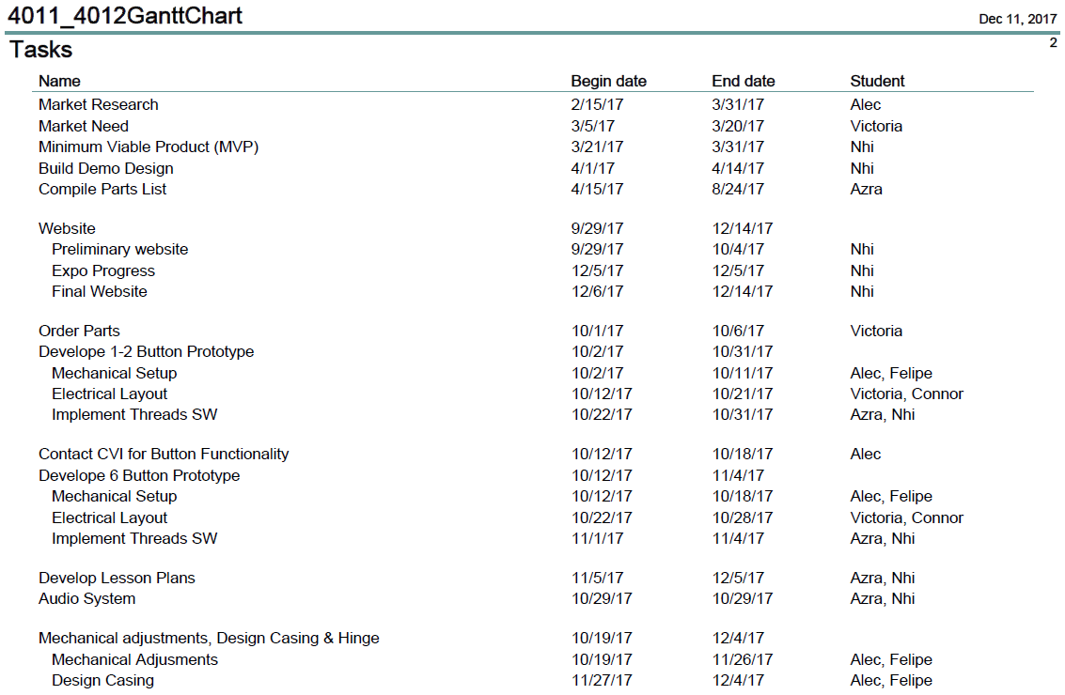
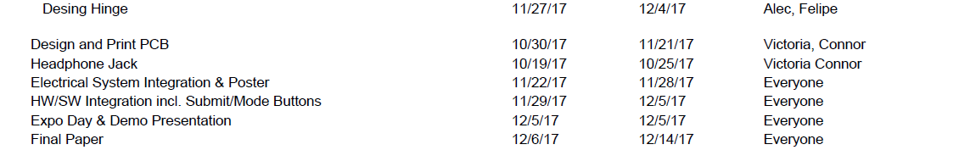
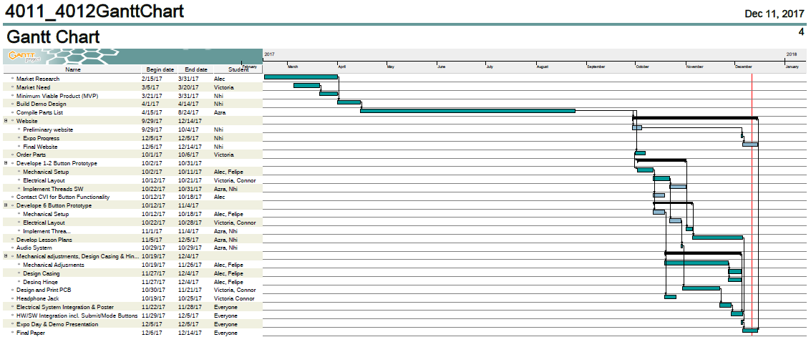

Appendix B
PERT Chart

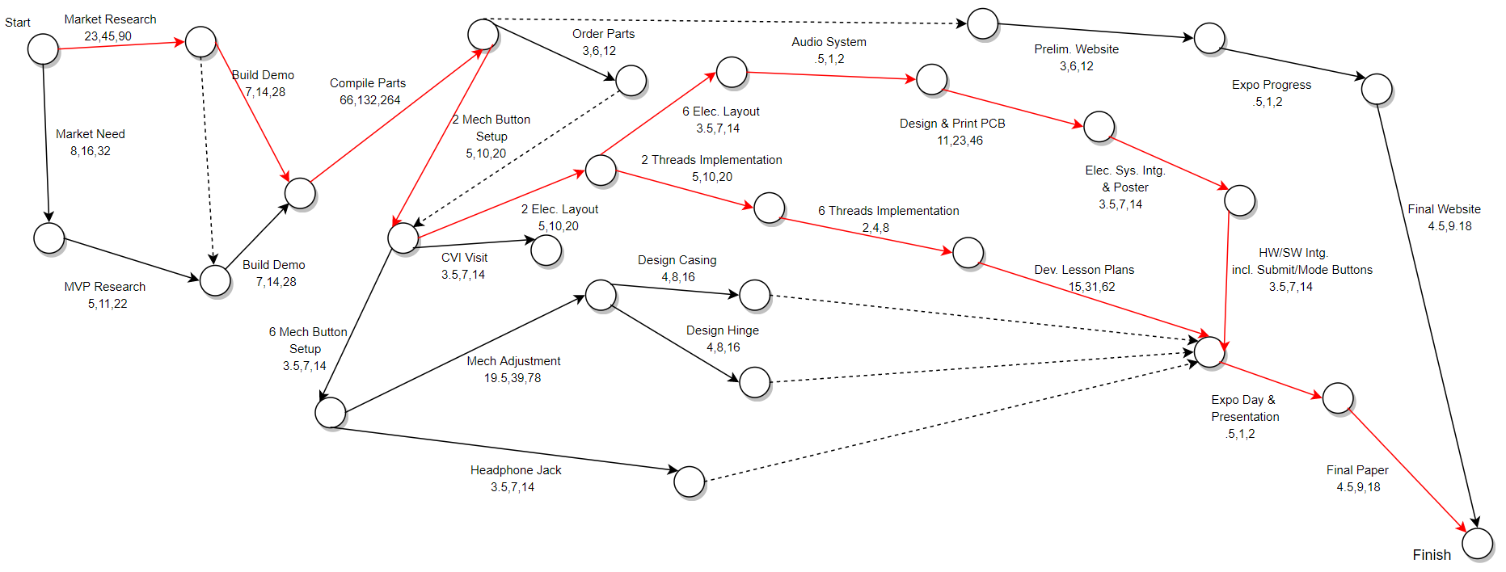

Appendix C
Detailed Cost Analysis

