Learning Device for the Visually Impaired

ECE4011 Senior Design Project

Blind Assistive Technologies
Dr. Ayanna Howard

Victoria Tuck, vtuck3@gatech.edu
Alexander Booth, abooth7@gatech.edu
Connor Napolitano, connap@gatech.edu
Felipe Gonzalez, fgonzalez30@gatech.edu
Azra Ismail, aismail30@gatech.edu
Nhi Nguyen, nnguyen45@gatech.edu

Submitted

September 1, 2017

Table of Contents

Executive Summary 3

- Introduction 4

  - Objective 4
  - Motivation 4
  - Background 5
    - Taptilo 5
    - BrailleNote 6

- Project Description and Goals 7

- Technical Specification 9

- Design Approach and Details 10

  - Design Approach 10
  - Codes and Standards 14
  - Constraints, Alternatives, and Tradeoffs 15

- Schedule, Tasks, and Milestones 16

- Project Demonstration 16

- Marketing and Cost Analysis 17

  - Marketing Analysis 17
  - Cost Analysis 19

- Current Status 21

- Leadership Roles 22
- References 23

Appendix A: Gantt Chart 25

Appendix B: Pert Chart 28

Appendix C: Detailed Cost Analysis 30

Executive Summary
Most of the current learning devices that exist for the visually impaired are bulky and expensive. Any handheld system available presumes some visual perception and is primarily based on magnified visual input with peripherals added to help the visually impaired. They are also generally built to perform a specific task. The Blind Assistive Technologies (B.A.T.) Team will design and prototype a flexible system that transitions from teaching visually impaired students how to type braille using the inline six-dot system, utilizing the more modern “keyboard” format of the computer input interface found on many popular devices. Many of the devices that fall under the braille keyboard category were designed on the assumption that the user knows and is comfortable with using the keyboard format, not taking into account that there is a learning curve involved in moving from the standard braille alphabet to the six-dot inline system. The proposed device will include an audio feedback system that will guide students while using the system. It will assist in progressing a student through their school curriculum because of the opportunity for additional braille practice at home with the help of their parents. The expected outcome of the design is a fully functional prototype that will cost approximately $981.
Learning Device for the Visually Impaired
1. Introduction
The Blind Assistive Technologies (B.A.T.) Team will design a learning device that utilizes both hardware and software to teach young visually impaired students braille. It will also show them how to input the characters onto a computer interface. The team is requesting $306 for parts to develop a prototype of the system. The prototype will be able to move between the six-dot braille and the inline button keyboard format. It will include six retractable pushbuttons and use audio as a form of feedback to help students learn the alphanumeric characters.
  - Objective
The team will design and prototype a system that will help teach visually impaired students how to write braille using the six-dot braille syntax. This system will also help teach students how to utilize the more modern “keyboard” format of the computer input interface found on many popular devices. Character input is accomplished through the use of six retractable pushbuttons, using audio as a form of feedback to help them learn the alphanumeric characters. The device will be portable with sturdy components that can withstand rough use in the hands of younger children. It will also function with little to no lag time between the user’s input and the audio feedback. Having such a device will allow for a faster progression through the curriculum since students can accomplish learning at home with the help of their parents.

  - Motivation
Many of the current learning devices that exist for the visually impaired are bulky and expensive. Handheld electronic systems available in the total market are based majorly on visual output. Even so, devices designed specifically for the visually impaired have only one function and, when applicable, work under the assumption that the user knows braille. There is a need for a system that teaches braille in many formats so that those who are visually-impaired/blind can effectively utilize all the devices in the market. Another need that can be satisfied is having the device be usable for those who aren’t visually impaired, such as the parents of those who are. That way, the learning process becomes smoother and much more productive.
  - Background
1.3.1 Taptilo
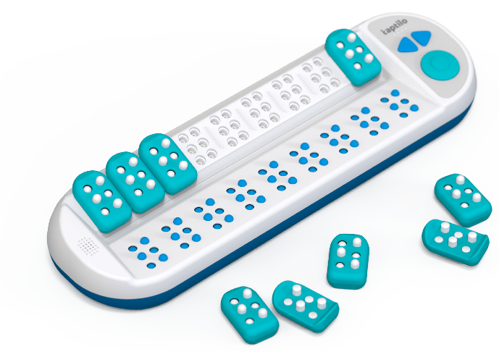
Figure 1. Taptilo Learning Device
Taptilo is a learning device shown (Figure 1) that teaches braille through the use of an app and a tactile device that functions with bluetooth and/or wi-fi. This device was first introduced just this year at the beginning of March and will release in the US sometime during May-June. A package for one individual cost about $1,200 and comes with the Taptilo station, nine blocks, the app, a carrying case, and a power adapter with cable [1]. One of the most basic functions of the device is learning to read/write braille. To use this function, students will have another individual use the app, usually a teacher or parent, to select words that they can spell out using the blocks. Selecting the words on the app will have the bottom panel generate braille characters that students will then feel. They will then try to mimic the character on the block by clicking the pins and mounting it onto the station. Once the blocks are mounted onto the station, pressing the button on the station itself will prompt feedback on whether or not the input was correct [2].
1.3.2 BrailleNote
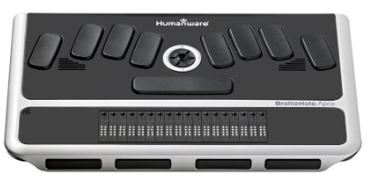
Figure 2. BrailleNote Apex BT 18 Braille Notetaker
BrailleNote (Figure 2) is a device that is created by Humanware, first introduced in 2000. Since then, Humanware has produced in general three different versions of the BrailleNote, the classic being the first and the apex being the most recent. It is a combination notetaker and computer screen reader. When not connected to any other device, it allows users to take notes easily with the braille keyboard or record audio as needed. The BrailleNote itself has several ports that allow users to interact with a computer by connecting a screen, usb peripheral, or SDHC card. The thumb keys grant users the ease of reading with the possibility of navigating line by line. The starting cost for this device is $1,995 and
can run up to $2,995 on newer models [3].
2. Project Description and Goals
The team will design a system to teach a user braille. The device will include a casing with six buttons in three rows and two columns. The buttons will correspond to the six "pins" in the braille alphabet. There will be two other buttons for submit and start. In addition, there will be an on/off switch. There will be a hinge in the center of the device. The purpose of the hinge is to allow users to learn braille that is used in print (in a 3x2 bump format) and then allow the device to fold 180 degrees outward to learn braille that is used for typing electronically (in a 1x6 inline bump format). The two columns of buttons swing outward from one another so that the user may also use this as a device for learning how to type braille. Internally, there will be a microcontroller receiving input from the buttons; the microcontroller will also transmit back information about the current activities of the user. The device will ask the user to input a certain letter of the braille alphabet and will then give feedback on the accuracy of the user's input. Project goals include the following:

General
- Cost $981 after accounting for potential overhead costs
- Device that assists the visually impaired with learning and practice braille
User Interaction
- Intuitive user interaction
- Involve parents in the learning process
- Provide feedback on learning progress
Physical
- Portable
- Zero exposed wires or electronics
Electrical
- Low power usage
- Operates for 4 hours constant usage
Over the course of the project duration, a series of customer discovery and minimum viable product (MVP) testing will be conducted in order to determine the exact product-market fit. An ideal product-market fit is defined as finding a market of eager customers before completely designing the product. It is nonideal to make the product before knowing the customer and it will most likely lead to a waste of time and capital.
The customer discovery portion is an iterative series of experiments that are designed to thoroughly learn about three main components of the customer segment: customer jobs, customer pains, and customer gains. The value proposition is what the product or service offers to the market, consisting of three factors: Products and services, pain relievers, and gain creators. These three factors are designed to assist the customer segment. Once the customer segment is more known, a minimum viable product (MVP) will be implemented in order to determine the most ideal set of features and shapes of the overall product. The customer discovery conducted so far has been two visits to the Atlanta Center for the Visually Impaired (CVI), however recurring contact and feedback is intended throughout the design and prototyping process.
- Technical Specifications
Table 1. Specifications for the interactive braille learning device.
Item | Specification
Size | 6 in x 4.5 in x 2 in a folded position
Weight | 700 grams
Supply Voltage | 6V
Battery Life | 4 hours of run time
Major features:
- 32GB internal SD card for firmware and storage
- Stereo speakers for family interactions and 3.5 mm headphone jack for personal use
- Rechargeable batteries
- 6 large retractable buttons for user input
- 1 reset button for the entire system
- Rounded edges for comfortable handling by children
- Large custom hinge designed to house all electronics internally for secure handling
- Design Approach and Details
  - Design Approach
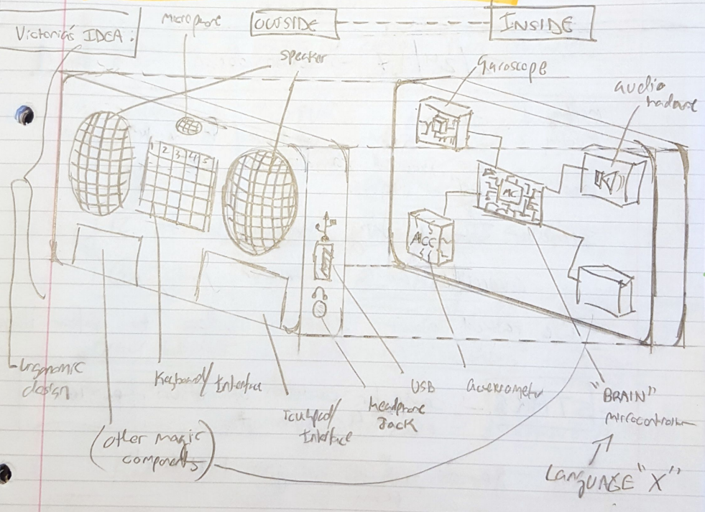
Figure 3. Original design idea before customer discovery
The original design approach (Figure 3) was theorized to be a small handheld device intended to be a mobile gaming and learning device with approximately 11 external and internal features. The original design consisted of a rounded frame with seven external features which included large speakers, a microphone, a keyboard interface, a touch pad, a 3.5mm headphone jack, a USB port, and another additional interface option. The original design internally consisted of at least 4 components. These components included a gyroscope, a microcontroller, an accelerometer, and an audio circuit, with flexibility to add additional components if needed.
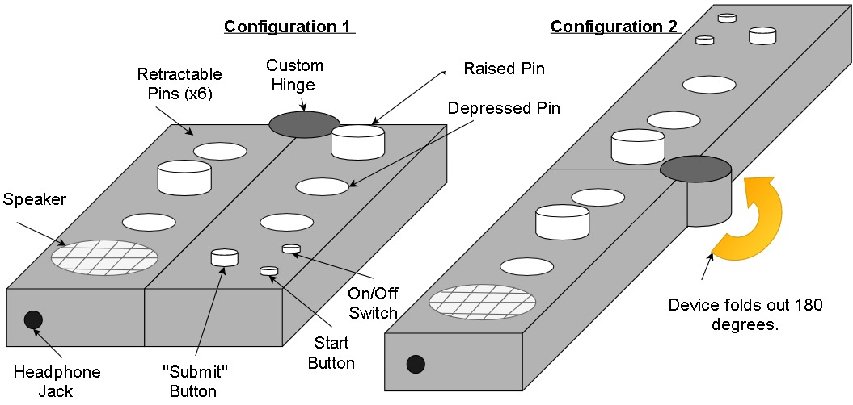
Figure 4. Proposed post-customer discovery design of the learning device. (CONFIGURATION 1): The prototype is folded to display the braille alphabet input interface. (CONFIGURATION 2): The prototype is folded out for the configuration to display the inline computer input interface. The final design will have smooth corners and edges throughout the design for comfort and safety purposes.
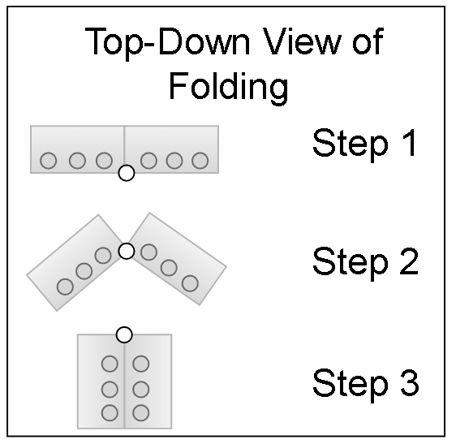
Figure 5. A top-down description of the folding design of the device in (Figure 4). Step 1 displays configuration 2 found in (Figure 4). Step 2 is in the process of folding to configuration 1. Step 3 displays configuration 1 found in (Figure 4).
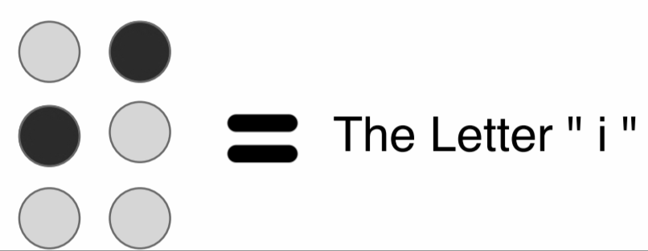
Figure 6. The elevated pins in (Figure 4) depict a alphanumeric character in braille notation. The darker dots represent the raised pins. Different combinations of pins relate to different alphanumeric characters.

Two sessions of customer discovery located at the Atlanta Center for the Visually Impaired changed the perception on what would give visually impaired or partially visually impaired students the most value possible. The purpose of the customer discovery is summarized in section 2 under “Project Description and Goals”. In order to make a popular and useful product, it is important to know the customer to a great extent. One major trend of the available devices already on the market is that there are several devices in the electronic and non electronic spectrum, however each device is single-purpose. This prototype is designed to be flexible to assist learning and thus serve at least two purposes. The first purpose being for alphabetic braille practice, and the second is to give users practice inputting electronic braille.
Features of the design include two main enclosures connected to a hinge (Figure 4). The two enclosures will be designed with smooth edges to for safety and ergonomic purposes. The hinge will serve a dual purpose of allowing the two main enclosures to rotate about the hinge axis as well as acting as a conduit for flexible wires to travel though it internally. The hinge will be designed to have friction to ensure the device stays in the intended configuration while handling it (Figure 5). The amount of friction it contains is not determined yet. One side of the device will have a start button, a submit button, and a power switch. The purpose of the start button is to prompt the microcontroller to begin the lesson that is selected. The submit button will be to indicate to the system that the user has finished inputting a letter. Each side of the prototype will include three retractable buttons. The six total buttons or pins will be used for braille syntax, which is ordered in a 3x2 matrix (Figure 6). For learning computer-based input, instead of the 3x2 matrix of pins, the syntax folds into a 1x6 matrix. Products such as a Braillenote (Figure 2) use this 1x6 button syntax as a standard or a 1x8 matrix button syntax depending on the quantity of the inputs it supports. It is not yet determined how the retractable pins will mechanically operate. The buttons must start in a depressed state, flush to the front face of the enclosures. When a button is pressed, it must slightly depress more then spring up on release and stay in a raised position until the user uses the submit/reset button . For the reset, it is desired that there is a universal reset button to depress all buttons simultaneously to the original depressed state. This desired feature is to reduce confusion in learning braille characters and to increase the speed of the input. There are current ideas for fabricating custom spring-loaded mechanical buttons that press an electronic switch for the button signal. No official plans are currently present regarding buttons that meet these sets of parameters. One speaker will be included to audibly describe alphanumeric characters and additional learning material. The exact design and specifications of the speaker and internal electronics are not yet known and require additional research. For additional flexibility, the current plan is to also install a 3.5 mm auxiliary headphone jack on the side of the project enclosure (Figure 4). The headphone jack will allow use in more private or popular environments, where using a speaker is not appropriate or possible.
  - Codes and Standards
Since the core user group for our product will be children, we will follow the ASTM F 963-11 Standard Consumer Safety Specification for Toy Safety which addresses numerous hazards that have been identified with toys [11]. This standard influences our choice of materials for the casing as well as the design to avoid structures such as small parts that could pose danger to children. While there are no official standards for accessible content, we will also follow the guidelines laid out in the Web Content Accessibility Guidelines (WCAG) 2.0 to guide our design of the flow and structure of the content [12]. We will follow the Unified English Braille codes in our product which is followed by schools in North America [13]. We also closely follow the Expanded Core Curriculum for schools in Georgia to ensure that the product keeps pace with the learning objectives of a child with visual impairment [14].
At a hardware level, our device will be battery powered and follow the IEEE 1625 - 2008 Standard for Rechargeable Batteries for Multi-Cell Mobile Computing Devices that specifies subsystem interface design responsibilities for each subsystem manufacturer/supplier to reduce the possibility of battery failure [15]. For communication between the different I/O units, we will primarily use SPI and RS232 whose standards depend on the specific part.
  - Constraints, Alternatives, and Tradeoffs
For building a handheld learning device for school-aged children, we need to consider constraints such as power, portability, safety, and cost. The battery of the device should last at least 4 hours to get through an afternoon of working on assignments while fitting in our smaller casing for the device. The device will use rechargeable batteries so that the device can be used again with ease. For the device to be comfortably carried in a school bag, it needs to hold the internal components in a relatively small casing while staying under 700 grams. Since the device will be handled by children, it should have a safe and comfortable to use design with rounded edges. In addition to these design constraints, to be competitive with other products in the market, the price point needs to be below that of our competitors which affects our choice of components. All components must be chosen such that they fulfill the above requirements while keeping the overall cost at a minimum.
We also had to make tradeoffs between complexity and usability during the design process. While our original idea was to build a gaming device with more functions, the current design plan addresses a specific problem in learning. After customer discovery sessions with the Center for the Visually Impaired we decided to focus the device on solving how visually impaired children learn Braille. A simple system based off of existing systems such as the one in the final design are anticipated to not have a significant learning curve associated with it for the user and fit well with their existing syllabus. The current plan will allow time for improving user experience and incorporating user suggestions.
- Schedule, Tasks, and Milestones
A GANTT Chart describing the project timeline is included (see Appendix A). A PERT Chart describing the project timeline is included (see Appendix B).
- Project Demonstration
We will measure the mechanical aspects of the final prototype i.e. dimensions and weight, to ensure that we have met our specifications and the device is portable. To test functionality throughout the development phase, a PC will be connected to the system while interfacing with peripherals and executing the lesson plan. The formal demonstration will consist of one person doing the following:
- The user will input several characters without sight of the device, one at a time using the 3x2 format on the prototype to demonstrate the braille learning function. Users should receive audio instructions on what alphanumeric character to input and audio feedback after inputting the alphanumeric character.
- The user will then “open” the prototype to transform the 3x2 into a 1x6 format using the hinges.
- With this new format, the user will repeat what they did in step one, which should also receive audio feedback.
The functionality of the device will be demonstrated as below:
- Speaker: The speaker will be tested using sound files that consist of simple commands and confirmations such as “Type the letter A” and “Please, try again.”
- Retractable Buttons: With the PC connected to the device, pushing a button will send a signal that indicates whether the correct connection is made.
- Hinge: Towards the end of the project, when the prototype is placed within the hinged casing, transitioning from a 3x2 to a 1x6 format will test if the hinge acts as an internal conduit for the wires as expected.
- Battery Life: Run the device continuously for four hours.
- Marketing and Cost Analysis
  - Marketing Analysis
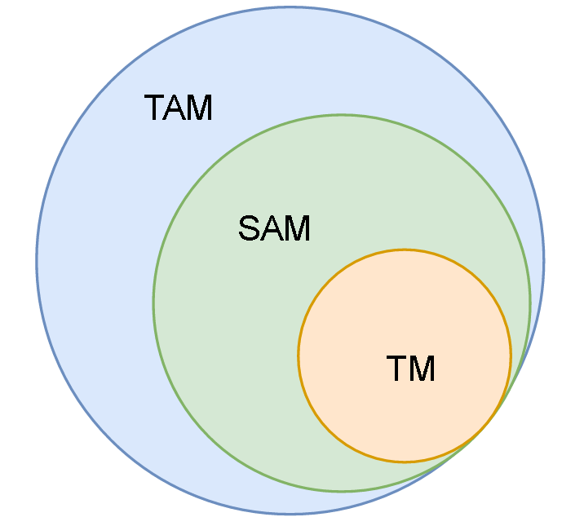
Figure 7. Diagram of the Total Available Market (TAM), Scalable Available Market (SAM), and Target Market (TM).
The current intended goal is to firstly engage in a deep analysis of the market and determine the ideal target market for the proposed product (Figure 7). the TAM consists of the approximate population of all visually impaired people on earth, approximately 250 million [16]. The SAM is the approximate blind population in the United States, about 7 million [17]. The Target Market is approximately 61,739 students in the target age range in the United States [17]. This is researched information regarding current products and services that are already in the market. The products that are in direct competition with the proposed product are electronic and paperback book versions for learning braille. The purpose of the proposed product is to combine ease of learning alphanumeric braille with ease of teaching braille in order to encourage more parent/child relationships in braille education outside the classroom at home. One example topic for learning braille is the idea or counting like in DK’s DK Braille: Counting, which is a textured book that is designed to present numbers of high-contrast everyday objects on each page [7]. Another example topic for learning braille is learning the braille alphabet. Along with books like Q is for Quack : an interactive alphabet book [8], there are a large variety of books that teach the braille alphabet for all ages and all levels of visual impairment. Counting and learning the alphabet in braille are common in the scope of books. In order to make an electronic product that is able to compete with a variety of paperback learning devices, the electronic device will require a library of learning features that alone surpass the content of multiple books.
Other mediums for learning braille are also present in regards to inputting braille alphanumeric characters either mechanically or electronically. One device is the Perkins Brailler, which is essentially a typewriter that inputs braille syntax and outputs embossed braille on paper [9]. The proposed product is intended to be foldable and teach standard braille to visually impaired users rather than a direct competitor, the proposed product will assist in teaching brailler typing. One more advanced type of brailler is the Braillenote (Figure 2) [10]. The Braillenote is a portable computer designed to connect to computers and replace the standard keyboard or touch screen used in most everyday electronics. The Braillenote uses the same typing syntax as the Perkins Brailler. This device is intended for older customer segments and therefore does not directly conflict with the target market of choice. Devices that are more in contact with the proposed product are devices like the Taptilo station mentioned in section 1.3.1. The next step determine who exactly the market is for the product presented, and what the market desires in general. In order to have an effective market strategy, the first goal is to accomplish the product-market fit condition, which is summarized in section 2 under “Project Description and Goals”.
7.2 Cost Analysis
The parts needed in the development of this project are listed in Table 2 [4][5][18][19]. The estimated cost per unit was calculated by accounting for the cost of the parts and the overhead including labor, marketing, sales, distribution and support. The overhead is 200 percent of the non recurring costs so the unit price is estimated to be around 3 times the total amount of the unit cost (see Table 4). Table 3 shows specific information on related activities and hours allocated to work on the development, assessment and testing of the prototype of the device. The labor costs are included in the overhead amount. We found the median starting salaries for graduates from Georgia Tech in Computer Engineering ($75,000) and Electrical Engineering ($70,150) [6]. Considering that this is an undergraduate project piloting a new product, and assuming that there is minimal financial backing for the project, the salaries were reduced by 25%. For the cost analysis over a four-year time period see Appendix C. Based on our results from the market analysis, we estimated the sales volume of units sold per year in order to carry out the analysis.
Table 2. Prototype Components
Item | Cost
Microcontroller | $49.99
SD Card Reader | $12.95
Speaker | $1.95
Push buttons | $0.20 x 10 = 2.00
Headphone Jack | $3.95
Casing | $229.5
Ribbon Cable | $0.95 (10 wire, 3ft)
Sensors | $3.95
Total | $305.24

Table 3. Development Hours per Engineer for the period of four months (one semester)
Activity | Hours
Lab | 78
Meetings | 13
Reports | 16
Total | 107

Table 4. Estimated Cost per Unit
Production Component | Cost
Parts Total | $305.24
Assembly | $10.00
Packaging | $1.00
Testing | $11.00
Total Cost | $327.24
*Accounting for overhead costs, the initial cost is triple the total cost per unit starting at $981.72
- Current Status
Currently, the team has re-established contact with the Center for the Visually Impaired (CVI). The team will have presented the proposal to our advisor and submitted the revised versions of both the proposal and project summary by September 1st.
The biggest problem that the team has run into is the functionality of the buttons for the device. What the team is trying to accomplish requires the buttons to have two separate functions, one for each configuration. As such a button doesn’t exist in the market, the team is currently looking into other solutions and the feasibility of designing such a button ourselves. Pending the status of that research, the team may opt to alter the device’s design.

- Leadership Roles
Leadership roles for this team during ECE 4011 and ECE 4012 members are detailed in Table 5 below.
Table 5. Leadership Roles
 | Roles
Names | ECE 4011 | ECE 4012
Victoria Tuck | Project Manager
Alexander Booth | Market Research | Documentation
Felipe Gonzalez | Documentation | Integration & Testing Lead | Expo Coordinator
Nhi Nguyen | Timeline Logistics | Webmaster
Azra Ismail | Design Lead | Software Lead
Connor Napolitano | Technical Lead | Hardware Lead

- References
[1] D. Brauner. (2017, February 16). Taptilo: New Smart Device to Teach Braille [Online]. Available: http://www.perkinselearning.org/technology/posts/taptilo-new-smart-device-teach-braille
[2] OHFA Tech, Inc. (2017, February 26). Play Taptilo! Smart Braille Education [Online]. Available: https://taptilo.com
[3] Humanware. BrailleNote Apex BT 18 Braille Notetaker [Online]. Available: http://store.humanware.com/hus/braillenote-apex-bt-18-braille-notetaker.html
[4] Spark Fun Electronics [Online]. Available: https://www.sparkfun.com/products/10649
[5] Arduino [Online]. Available: https://store.arduino.cc/usa/?geolocation=usa
[6] Georgia Institute of Technology :: Salary Reports. [Online]. Available: https://webapps.gatech.edu/cfcampus/adors/commencement/salary_report.cfm. [Accessed: 14-Apr-2017].
[7] DK, DK Braille: Counting, 1st ed. London, United Kingdom: DK, 2016.
[8] Ripley, Q is for Quack : an interactive alphabet book, 1st ed. MaxiAids.
[9] "Braillers - Perkins Solutions", Perkinsproducts.org, 2017. [Online]. Available: http://www.perkinsproducts.org/store/en/3-braillers. [Accessed: 14- Apr- 2017].
[10] "Humanware - Home - Low Vision Aids for Macular Degeneration", Humanware.com, 2017. [Online]. Available: http://www.humanware.com/en-usa/products/blindness/braillenotes. [Accessed: 14- Apr- 2017].
[11] “Toy Safety,” CPSC.gov, 03-Apr-2017. [Online]. Available: https://www.cpsc.gov/Business--Manufacturing/Business-Education/Toy-Safety. [Accessed: 14-Apr-2017].
[12] “Web Content Accessibility Guidelines (WCAG) 2.0” [Online]. Available: https://www.w3.org/TR/WCAG20/.
[13] “Resources,” Supporting Students with Disabilities. [Online]. Available: http://www.ccsso.org/Resources/Programs/Supporting_Students_with_Disabilities.html. [Accessed: 14-Apr-2017].
[14] “The Expanded Core Curriculum for Blind and Visually Impaired Children and Youths,” The Expanded Core Curriculum for Blind and Visually Impaired Children and Youths - American Foundation for the Blind. [Online]. Available: http://www.afb.org/info/programs-and-services/professional-development/teachers/expanded-core-curriculum/the-expanded-core-curriculum/12345. [Accessed: 14-Apr-2017].
[15] “1625-2008 - IEEE Standard for Rechargeable Batteries for Multi-Cell Mobile Computing Devices,” IEEE SA - 1625-2008 - IEEE Standard for Rechargeable Batteries for Multi-Cell Mobile Computing Devices, 06-Jul-2009. [Online]. Available: https://standards.ieee.org/findstds/standard/1625-2008.html. [Accessed: 14-Apr-2017]
[16] "Visual impairment and blindness", World Health Organization, 2017. [Online]. Available:
http://www.who.int/mediacentre/factsheets/fs282/en/. [Accessed: 15- Apr- 2017].
[17] "Blindness Statistics | National Federation of the Blind", Nfb.org, 2017. [Online]. Available:
https://nfb.org/blindness-statistics. [Accessed: 15- Apr- 2017].
[18] AliExpress [Online]. Available: https://www.aliexpress.com/item/10Pcs
-White-Locking-Latching-Push-Button-Switch-For-Car-Trucks-Boat-12mm/32635518218.html
[19] Georgia Tech [Online]. Available: http://inventionstudio.gatech.edu/3d-print-job-submittal/

Appendix A
GANTT Chart

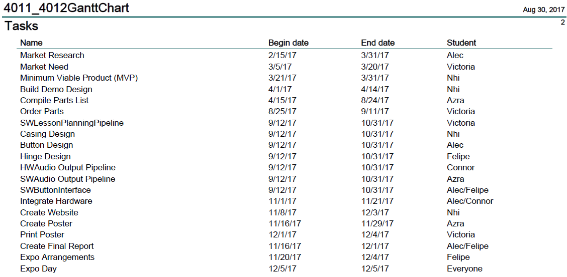
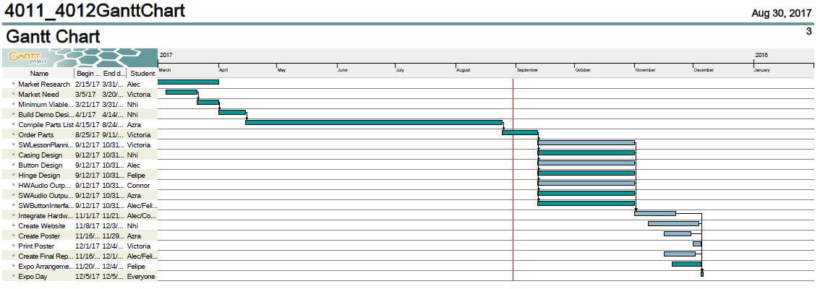

Appendix B
PERT Chart

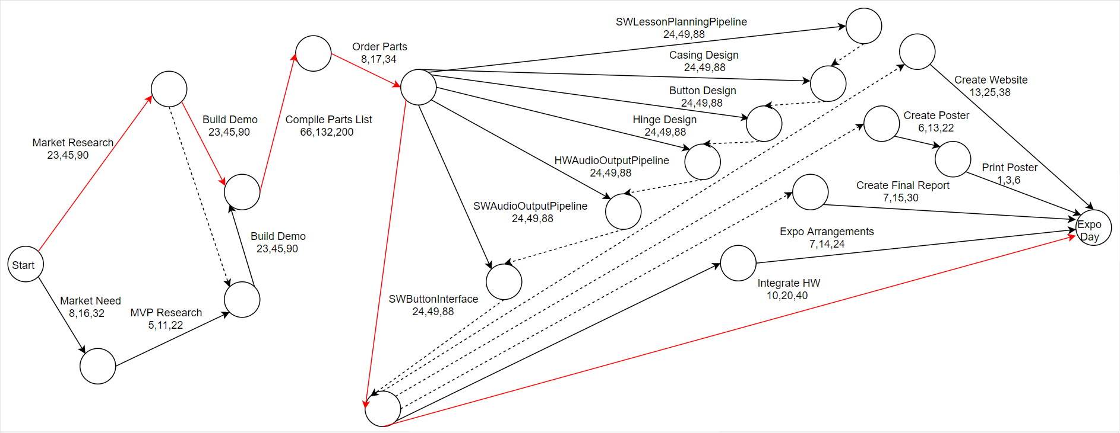

Appendix C
Detailed Cost Analysis
